Foundation 2 Weekly Timetable Week Commencing 09.03.26
To contact your child’s class teacher, please email schooloffice@dawpool.wirral.sch.uk or phone 0151 648 3412
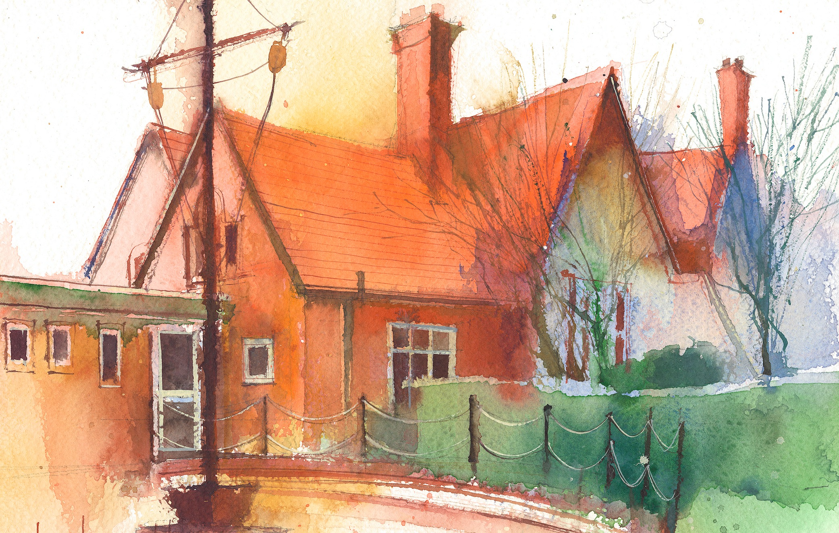

This timetable is available in the event that a Foundation 2 pupil is required to self-isolate at home, but the cohort remains open to other pupils.
Please visit the Foundation 2 Remote Learning Page on the school website to access any downloadable resources and activity sheets.

 | Session 1: 09:00-10:30 | Session 2: 10:50 – 12:00 | Session 3: 10:50 – 12:00 | Session 4: 10:50 – 12:00
Monday | Literacy  Adult Led Focus  Read the page where they walk up the hill and find the tree. Discuss the different images as they walk up. What is happening to the sky in the pictures?  What is a sunset?  Focus Task – Model writing simple sentence to describe what they can see.  I can see the sunset. | Phonics  By the end of this lesson your child should be able to:  To read the digraph ‘ai’ Introduce concept of vowel sounds.  We recommend the following resources and activities to achieve this objective:  Blending practice.  Children will complete activities in their individual rocket phonics workbooks. | Maths  By the end of this lesson your child should be able to:  To understand the concept of a part whole model  We recommend the following resources and activities to achieve this objective:  Have large part whole model made from hoops and strips of paper.  Start with a lego man, head in one part and body in the other. Notice when I separate, there is nothing left in the whole hoop, all are in the parts.  Have lots of different objects. 2 bananas and 2 oranges in my two parts, move them to my whole, how many do we have all together?  Repeat with different amounts, no more than 5 total.  Use large number cards to put in the whole hoop.  Show part whole model on the board, get children from lollipop sticks to come and put different things in the parts, another child to move them all to the whole and count them. | Topic  By the end of this lesson your child should be able to:  To talk about stories from around the world.  We recommend the following resources and activities to achieve this objective:  I know a story about a frog. Tiddalik - it is an Australian Folk Tale. Read the story and discuss the key themes.  Where is Australia?  In the story, there are lots of animals native to Australia.  Find out more about Kangaroos, kookaburra, Koalas, Quokka, Wombat and Cassowary.  Do we have any of these animals in England?
Tuesday | Literacy  Adult Led Focus  Look at the double page with the tree full of birds.  Discuss all the beautiful birds in the picture. Some have spots/stripes, big/small, red/blue/yellow/pink.  Focus Task – Can they think of a way of describing one of the birds?. Oral composition – whatever sentences they like.  I will model writing one of the sentences using a capital letter at the start, finger spaces between the words and a full stop at the end. | Phonics  By the end of this lesson your child should be able to:  Write the digraph ‘ai’  We recommend the following resources and activities to achieve this objective:  Segmenting practice.  Children will complete activities in their individual rocket phonics workbooks. | Maths  By the end of this lesson your child should be able to:  To practice turning addition problems into part whole models  We recommend the following resources and activities to achieve this objective:  Read red riding hood.  Have large part whole model made from paper plates and strips of paper.  5 cakes to be shared out between red riding hood and the wolf. How can we share them?  Model all different ways for the cakes to be shared out using the part whole model.  When done a few times, draw part whole models on the board, using numerals to represent the cakes on the floor. | Topic  By the end of this lesson your child should be able to:  To understand the Lifecycle of a frog  We recommend the following resources and activities to achieve this objective:  Tiddalik was a frog. Do they know the lifecycle of a frog? Look at images of frogspawn – does this look anything like a frog?  Show images of the stages the frog goes through. Discuss each stage.  Focus on the vocabulary of First, next, then, finally.  Pond, frogspawn, tadpole, froglet, frog  Watch timelapse videos to show the process.  Act this out.
Wednesday | Literacy  Adult Led Focus  In the story the birds help the boy and Grandad fly home. Would they like to fly?  Would they rather have wings like a bird or fly inside an aeroplane? PP discussion.  Focus Task –  Oral composition of a simple sentence.  I will model writing one of the sentences using a capital letter at the start, finger spaces between the words and a full stop at the end. | Phonics  By the end of this lesson your child should be able to:  Read the digraph ‘ee’ Introduce concept of vowel sounds.  We recommend the following resources and activities to achieve this objective:  Blending practice  Children will complete activities in their individual rocket phonics workbooks. | Maths  By the end of this lesson your child should be able to:  To further solidify understanding of part whole models  We recommend the following resources and activities to achieve this objective:  Put a large part whole model and 5 objects on the floor. How many ways can we split up our whole into two parts.  Call on children who can remember number bonds to 5 from last week’s learning, replicate it on the part whole model and write the equation on the board.  Write each equation on the board once the part whole model has been successfully completed.  Remind again how part whole model relates to equation. | Topic  By the end of this lesson your child should be able to:  To understand the importance of a healthy lifestyle.  We recommend the following resources and activities to achieve this objective:  In the story Tiddalik drinks all the water and doesn’t leave any for the other animals. Is this kind? Why not?  Everyone needs to have water to stay healthy, plants, animals and humans. Discuss benefits of drinking lots of water.  In the story Tiddalik falls asleep. Why is it important to have lots of sleep? Discuss other parts of a Healthy Lifestyle  Write a list of other things that are important for a Healthy Lifestyle
Thursday | Literacy  Adult Led Focus  Read the whole story again  Focus Task – Complete a story map, using actions for each part of the story to help us re-tell it. | Phonics  By the end of this lesson your child should be able to:  Write the digraphs ‘ee’  We recommend the following resources and activities to achieve this objective:  Segmenting practice  Children will complete activities in their individual rocket phonics | PE  By the end of this lesson your child should be able to:  The focus of the learning is to explore different movements using different parts of the body and move their bodies to music.  We recommend the following resources and activities achieve this objective.  This Half Term the focus in PE is ‘Dance’. Lessons will be led by specialists form Claremont School | Maths  By the end of this lesson your child should be able to:  To put groups that make 5 into a part whole model  We recommend the following resources and activities to achieve this objective:  In pairs, part whole model sheets, labelled whole and parts.  Remind children of orientation the paper should be.  Give each pair 5 cubes.  Remind of each number bond, once said it the pairs must replicate it using their cubes and part whole model.  Do for each number bond to 5, including reverse order numbers, ie –  2 + 3 and 3 + 2  Remind children that even through arrangement is different, it still adds up to 5.
Friday | RE  By the end of this lesson your child should be able to:  To know that Jesus died on the cross on Good Friday.  We recommend the following resources and activities to achieve this objective:  Watch the story of The Last Supper by Saddleback Kids.  Discuss the content of the story. Why did Jesus wash their feet? How did the others feel when Jesus did that for them?  Using bread, break it into pieces and we will sit in a circle and re-enact the last supper together.  Reflect on the time Jesus spend praying in the garden of Gethsemane. Can they work together as a whole class to create an Easter Garden in the outdoor area.  Can they think of some prayers to write on flowers to decorate the garden? | Forest Schools  By the end of this lesson your child should be able to:  Talk about the world around them.  We recommend the following resources and activities to achieve this objective:  Children to work collaboratively to build dens, make minibeast hotels and ‘cook’ forest food. | Phonics  By the end of this lesson your child should be able to:  Consolidate their learning of Common Exception words ‘be, was’  We recommend the following resources and activities to achieve this objective:  Children will complete activities in their individual rocket phonics workbooks. | Heart Smart  By the end of this lesson your child should be able to:  ‘Don’t hold onto what’s wrong’ – Friendship  “It is important to listen to one another”  We recommend the following resources and activities to achieve this objective:  In pairs tell the children they are going to play a listening game. Ask the children to sit with their backs to one another. Give each child the same set of simple objects. Child one chooses an object and without turning around tells the other child which object they have chosen. Child two then picks up the same object. Ask the children to turn around and  check if they are you holding the same object. Ask them if they have listened carefully. Repeat with child two choosing  the object.  You could ask older children to carry out a more difficult version of the activity by creating a simple pattern using  threading beads. As child one creates a pattern, they should instruct child two to make the same pattern. When the  children turn to face each other ask them to check if their patterns are the same.  Boris says, ‘Listening carefully to what our friends say is very important.’

