Foundation 2 Weekly Timetable Week Commencing 20.04.26
To contact your child’s class teacher, please email schooloffice@dawpool.wirral.sch.uk or phone 0151 648 3412
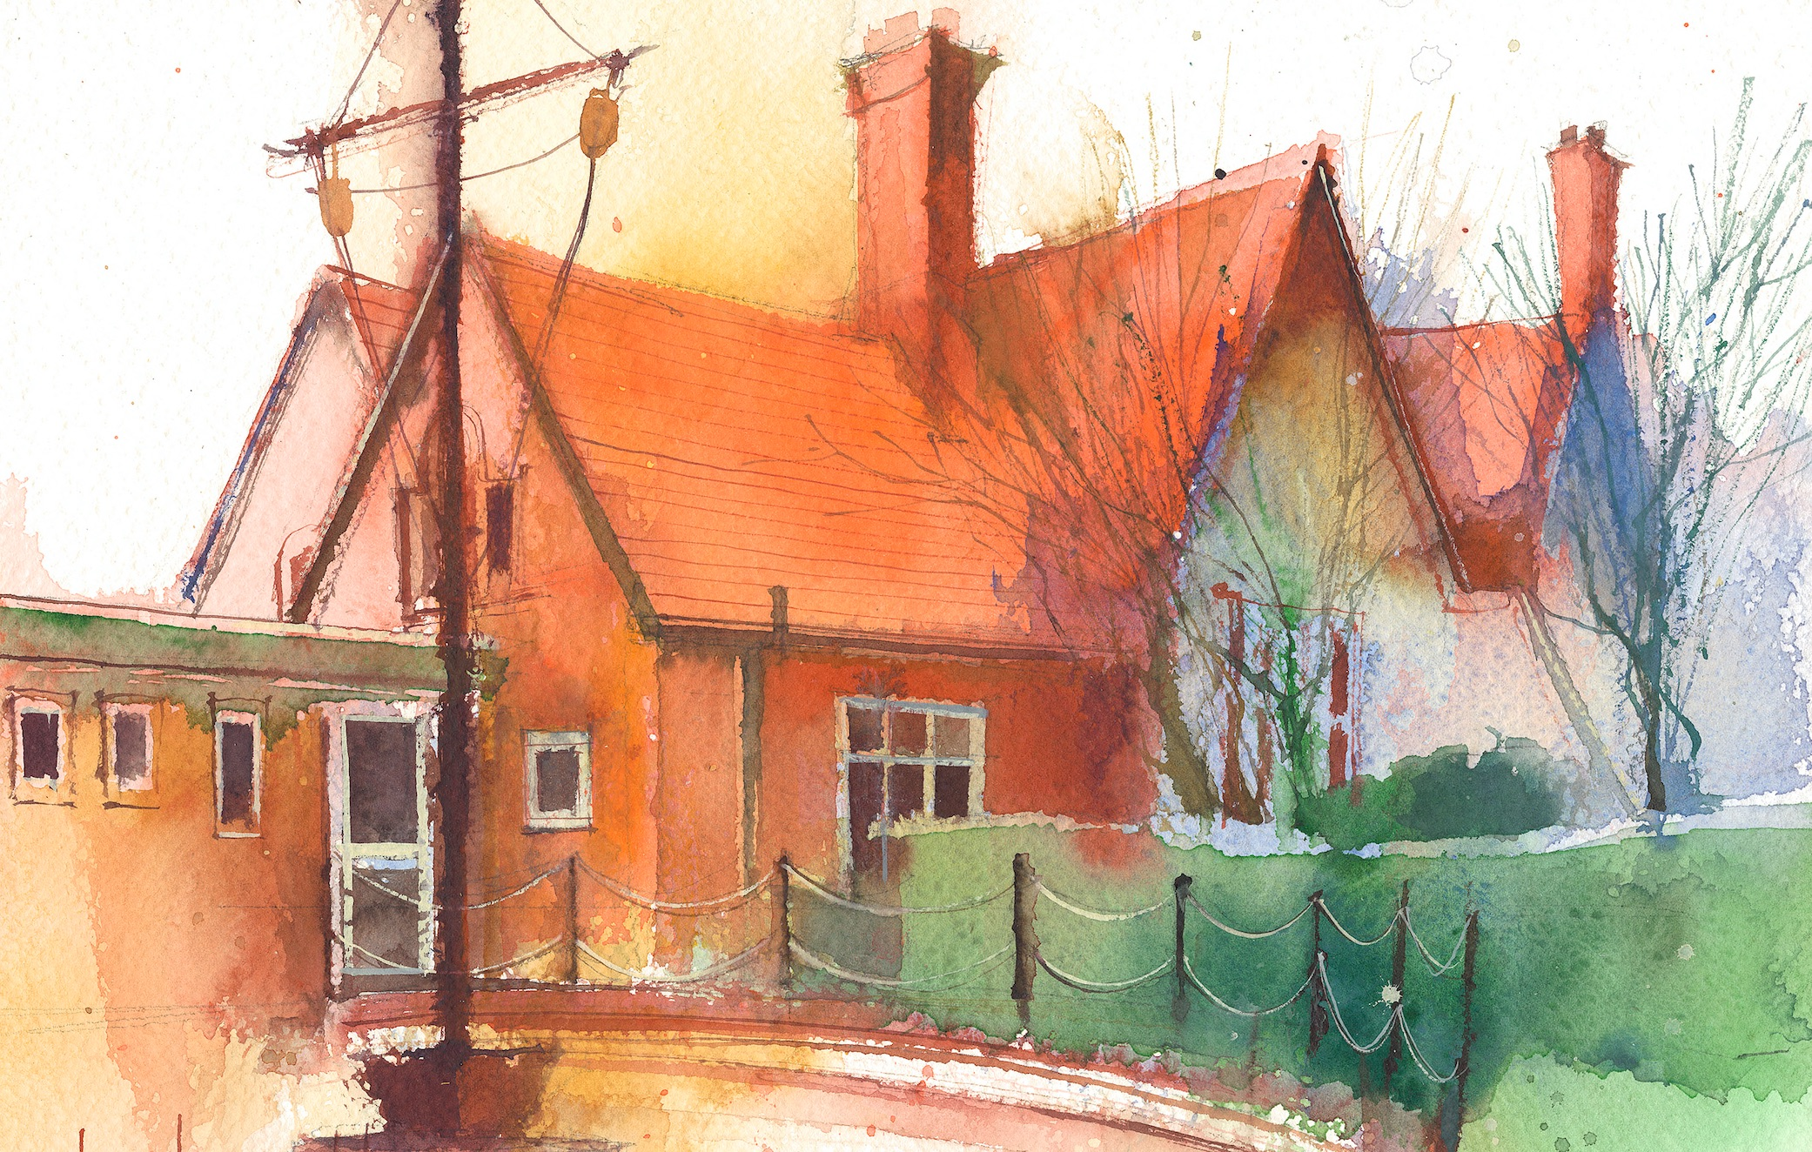

This timetable is available in the event that a Foundation 2 pupil is required to self-isolate at home, but the cohort remains open to other pupils.
Please visit the Foundation 2 Remote Learning Page on the school website to access any downloadable resources and activity sheets.

 | Session 1: 09:00-10:30 | Session 2: 10:50 – 12:00 | Session 3: 10:50 – 12:00 | Session 4: 10:50 – 12:00
Monday | Literacy  Adult Led Focus  Read the section where he discovers it is actually bear who has come to help him. How do you think bear feels when Mouse tells him he doesn’t want help?  Why do you think Mouse wants to do it alone?  Focus Task  Look at the images with speech bubbles. Bear is asking “Can I help you?” Discuss together an answer the mouse could give. Model writing one of the sentences | Phonics  By the end of this lesson your child should be able to:  To learn to read and recognise the digraph ‘ar’  We recommend the following resources and activities to achieve this objective:  Blending practice.  Children will complete activities in their individual rocket phonics workbooks. | Maths  By the end of this lesson your child should be able to:  Children will use a number line to solve problems involving counting forwards and backwards within 10, and to compare or combine numbers.  We recommend the following resources and activities to achieve this objective: Have a physical number line on the floor and a number line on the whiteboard. Present a story: “The frog starts on 2 and jumps 3 steps forward. Where does he land?” Children move the frog along the number line while counting aloud.  Reverse the problem: “The frog is on 5 and jumps back 2 Where is he now?”  I will have a number line on the board and model adding arrows to show jumps, and write starting/ending numbers | Topic  Travelling to Space  Read the story ‘Whatever Next’ by Jill Murphy.  Discuss how Baby Bear travelled to the Moon. Do you think this is really how people travel to the moon? PP to share discussions.  Watch NASA Space Launch clip on You Tube.  Discuss what Baby Bear took with him. What would they take with them to space and why? PP discussions.  Write a list of the things they would take to space.
Tuesday | Literacy  Adult Led Focus  Read the next 4 pages. How are they supposed to cross the water?  What is bear doing to the map?  Focus Task  Discuss together what the bear is making. PP discussions to share ideas.  I will write a list of all the things it might be. | Phonics  By the end of this lesson your child should be able to:  The learn to write the digraph ‘ar’  We recommend the following resources and activities to achieve this objective:  Segmenting practice.  Children will complete activities in their individual rocket phonics workbooks. | Maths  By the end of this lesson your child should be able to:  Children will use a number line to solve problems involving counting forwards and backwards within 10, and to compare or combine numbers.  We recommend the following resources and activities to achieve this objective:  Draw a number line 0–10. Ask a problem: “I have 3 apples. How many more do I need to have 7?”  Children count forwards on the number line from 3 to 7. Discuss: “How many jumps did you make?”  Reverse the problem: start with 8, take away 3, where do you land?  I will have a number line on the board and model adding arrows to show jumps, and write starting/ending numbers | Topic  Show pictures and talk about travelling from Earth to the Moon  Watch some rocket launches.  Act it out: sitting in rocket, the countdown, “blast off”, slow motion floating.  Can they design their own rockets?  Using cardboard tubes and collage materials can they create a rocket?  Using recyclable materials can we create a giant rocket in class?
Wednesday | Literacy  Adult Led Focus  Read the section to reveal the boat they have made.  They folded the paper to create the boat.  Will the paper boat help them sail across the water? Why?  Focus Task  Write some simple instructions for how to make the boat.  Bend it  Fold it  Lift it | Phonics  By the end of this lesson your child should be able to:  The learn to read the digraph ‘or’  We recommend the following resources and activities to achieve this objective:  Blending practice  Children will complete activities in their individual rocket phonics workbooks. | Maths  By the end of this lesson your child should be able to:  Children will use a number line to solve problems involving counting forwards and backwards within 10, and to compare or combine numbers..  We recommend the following resources and activities to achieve this objective: I will roll the dice. To show what number we will start on. How many more jumps will it take to get to 10?  Reverse it and start on 10. Now roll the dice and jump back that many spaces.  What number do I end up on?  Use the number line on the whiteboard to show the arrows forward and backwards. | PE  By the end of this lesson your child should be able to:  Understand why we need to keep the score during a game.  We recommend the following resources and activities to achieve this objective:  Keep asking the questions Why do we need to keep the score? What should we do when we are tagged? Why should we wait to get our tag back?  In pairs, pupils take turns being the shark (attacker) and fish (defender). The shark follows the fish around the space following and copying their pathway. On your command, the fish must try and avoid being caught (tagged) by the shark. Pupil then swap roles.  On your command 'go' count down from 10 to 0. If the shark catches the fish they score a point. Swap roles. Can pupils count their score? The pupil at the end of the game with the most points is the winner.
Thursday | Literacy  Adult Led Focus  Read the section where they travel through the storm in the boat. How does Mouse feel? How does Bear feel? PP to discuss this.  I will show them an image of the bear and mouse with thought bubbles. Explain the concept of a thought bubble  Focus Task  What is mouse thinking as they sail in the boat? What is bear thinking. I will add sentences to the though bubbles. | Phonics  By the end of this lesson your child should be able to:  Learn to write the digraph ‘or’  We recommend the following resources and activities to achieve this objective:  Segmenting practice  Children will complete activities in their individual rocket phonics | Maths  By the end of this lesson your child should be able to: Children will use a number line to solve problems involving counting forwards and backwards within 10, and to compare or combine numbers.  We recommend the following resources and activities to achieve this objective: Draw a number line 0–10.  Pose a problem: “Sam is on 3, Alex is on 6. Who is further along the number line?”  Children use a counter or their finger to count the difference between positions.  “How many steps forwards does Sam need to catch up?”  “How many steps backwards does Alex need to take to join Sam?” | RE  By the end of this lesson your child should be able to:  To explore a range of objects and discuss these with the group.  We recommend the following resources and activities to achieve this objective:  Open the Chatterbox together and discover what is inside. The children take turns looking at and handling the objects. The conversation and questions will generate ideas for the learning activities, make notes as you chat and your planning has begun.  The children’s ideas, comments, questions, work, pictures, writing and photos are all to be recorded in one giant book (floor book). Everyone contributes either directly onto the pages or by sticking paper, objects, photos or post-its into the floor book. This book is the record of the RE that has taken place and will form the basis of your assessment.
Friday | Literacy  Adult Led Focus  Read the final pages Discuss the image together. What time of day do they think it is? How do they know?  Discuss the picture together.  Introduce them to the concept of an adjective. It is a word that helps us describe things.  Focus Task – In PP create a list of adjectives to describe the picture. I will write these words on the board. | Phonics  By the end of this lesson your child should be able to:  To learn to read and write the Common Exception words some, one, said  We recommend the following resources and activities to achieve this objective:  Children will complete activities in their individual rocket phonics workbooks. | Maths  By the end of this lesson your child should be able to: Children will use a number line to solve problems involving counting forwards and backwards within 10, and to compare or combine numbers.  We recommend the following resources and activities to achieve this objective:  Have a physical number line on the floor and one on the whiteboard. “I have 4 carrots. I get 3 more. How many do I have now?”  Where do I start? Children start at 4 and move forward 3 on the number line, counting aloud. How many steps did I take?  Reverse: “I have 7 carrots. I eat 2. How many are left?”  Encourage children to explain their thinking. | Heart Smart  By the end of this lesson your child should be able to:  Be kind and encouraging to others  We recommend the following resources and activities to achieve this objective:  Remind the children about the way the Scrapman talks to Boris and how Boris feels when he listens to him.  Ask the children what they would like to say to cheer Boris up.  Ask them what kind words they would use to let Boris know he is special and loved.  On blank postcards, ask the children to draw a picture and write an encouraging message for Boris.  Boris says, ‘It’s great to tell others how special they are.’

