Year 1 Weekly Timetable Week Commencing 28.9.26
To contact your child’s class teacher, please email schooloffice@dawpool.wirral.sch.uk or phone 0151 648 3412
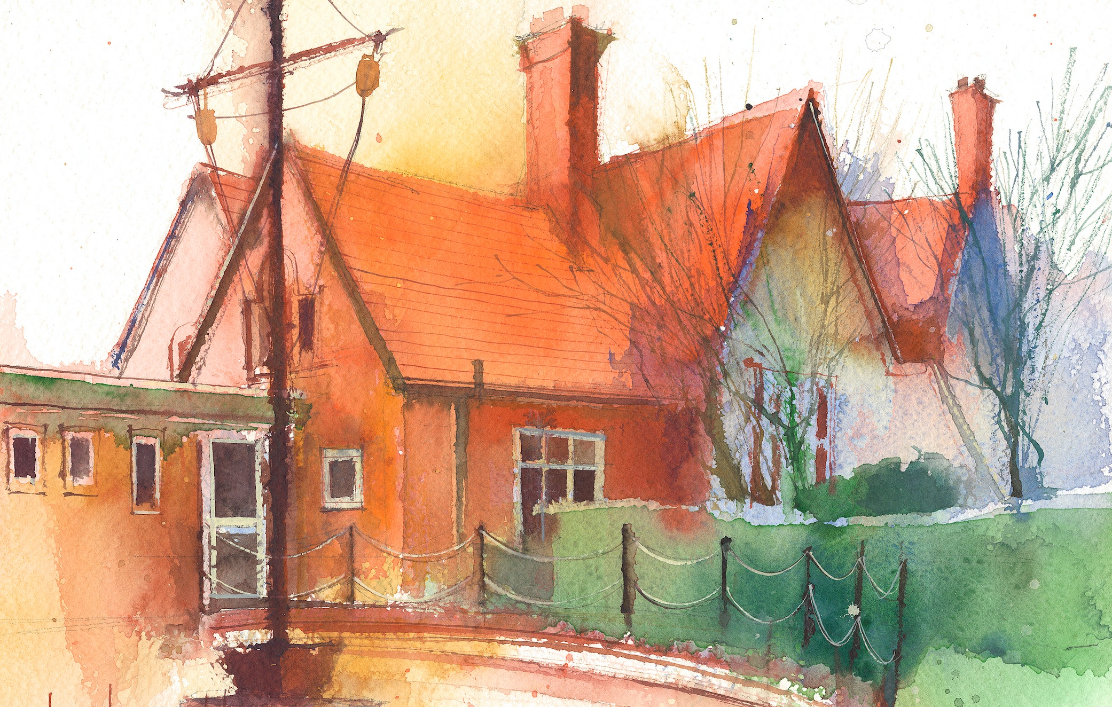

 | Lessons 09:00 – 10:30 |  | Lessons 10:45 – 12:15 |  | Lessons 13:15 – 15:30  (Incorporating 15-minute break) | Additional Tasks
Monday | Phonics: i  English  To write a prediction.  Busy Learning  Whole School Worship |  | Maths  To compare groups  Busy Learning |  | Geography  To understand the differences in weather between Cape Town and the Wirral throughout the year  Busy Learning  Music | Useful Links / Other Recommended Activities  Oak National Academy  https://classroom.thenational.academy/  BBC Bitesize  https://www.bbc.co.uk/bitesize  Purple Mash  https://www.purplemash.com/sch/dawpool#/  Hit the button  https://www.topmarks.co.uk/maths-games/hit-the button
Tuesday | Phonics: i-e  English  To write a dictated sentence  Busy Learning |  | Maths  To use symbols to compare numbers  Busy Learning |  | Art  To create light and dark shades of colour  Busy Learning  Picture News
Wednesday | Phonics: i-e  English  To write a simple sentence  Busy Learning |  | Maths  To compare the value of numbers  Busy Learning |  | Science  Experiment days - Autumn & Winter  Busy Learning  iSingPop
Thursday | Phonics: i-e  English  To write a dictated sentence  Busy Learning |  | Maths  PV to 10 assessment  Busy Learning |  | Forest School/RE  To problem solve  HeartSmart  To understand emotions.  Singing Worship
Friday | Phonics: Tricky Word: come, do, so  English  To write a dictated sentence  Celebration worship |  | Maths  PV to 10 assessment  Busy Learning |  | PE  To create agility circuits. .  Computing  Introduction to Purple Mash

