Summer 27.04.2026-.01.05.2026
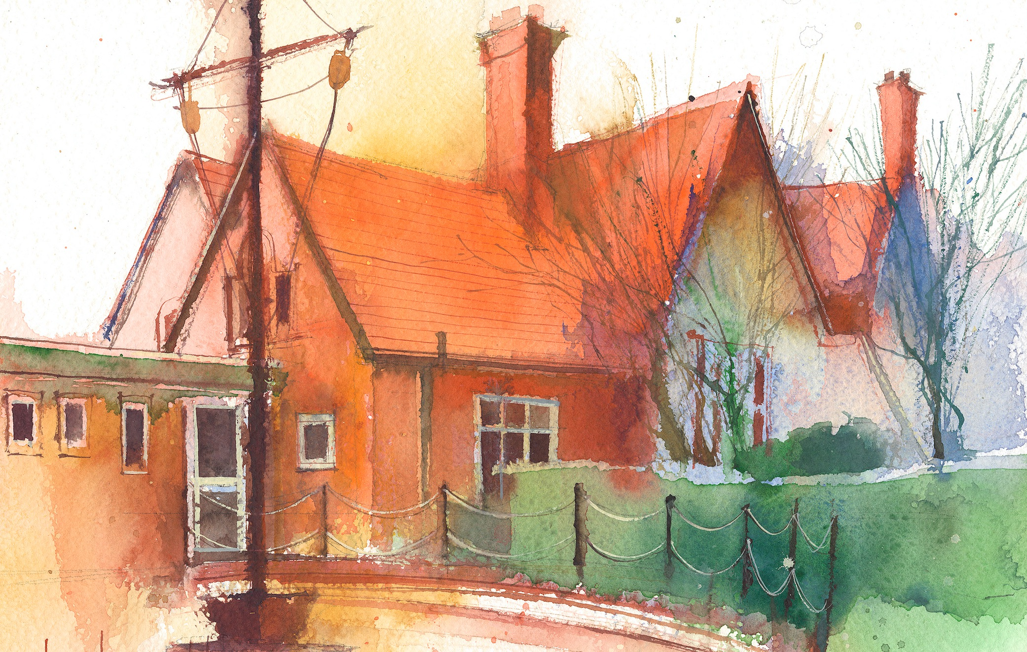
To contact your child’s class teacher, please email schooloffice@dawpool.wirral.sch.uk or phone 0151 648 3412
 | Lessons 09:00 - 10:30 |  | Lessons 10:45 - 12:15 |  | Lessons 13:15 - 15:30  (Incorporating 15-minute break) | Additional Tasks
Monday  27/04/26 | Mrs McCanns plans Maths |  |  |  |  | Drama Club
Tuesday  28/04/26 | Maths to  By the end of this lesson your child should be able to: know how to show equivalent fractions and decimals. Lesson 4 |  | CDAT English  By the end of this lesson your child should be able to: have read and seen the pictures in Wisp. Then use talk partners to discuss how would you feel to be a refugee and make group posters from a child’s viewpoint to display on working wall. |  | Science  By the end of this lesson your child should be able to:. Compare and group together everyday materials based on their properties including hardness, solubility, transparency, conductivity and response to magnets  Picture news, British Values | Future Medics Club
Wednesday  29/04/26 | Maths  Fluent in five/ Rapid Reasoning  By the end of this lesson your child should be able to: understand thousands as fractions.Lesson 5 |  | CDAT English  By the end of this lesson your child should be able to: write a series of questions after the freeze frame and hot seating of some of the characters in Wisp, a story of Hope. |  | PE  Tag Rugby  Handwriting | Chess Club
Thursday  30/04/26 | Fluent in five/ Rapid Reasoning  By the end of this lesson your child should be able to: understand thousandths as decimals. Lesson 6 |  | CDAT English  By the end of this lesson your child should be able to: look at the cover of and blurb and read the first part of Wisp a story of hope. In talk partners make a brainstorm of what you think a wisp is |  | Topic  By the end of this lesson your child should be able to: new topic Rainforest | Choir/Drama Netball Club
Friday  01/05/26 | Maths  Fluent in five/ Rapid Reasoning  By the end of this lesson your child should be able to: understand thousandths on a place value chart, lesson 7 |  | CDAT English  By the end of this lesson your child should be able to: answer the questions from Wednesday and show they can write clear detailed questions and a clear answer using their skills from reading, listening, freeze framing and hot seating. |  | IT  By the end of this lesson your child should be able to:spreadsheets.  Spanish  Handwriting | Celebration of weeks work

