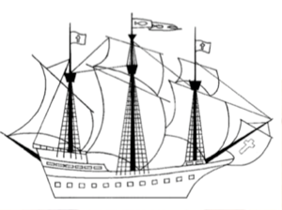`

Dawpool C.E. (Aided)

Primary School

*DAWPOOL*

*‘The Fruit of the Spirit is Love, Joy, Peace, Patience, Kindness, Generosity, Faithfulness, Gentleness and Self-Control’ (Galatians 5: 22-23).*

Dawpool C.E (Aided) Primary School

School Lane

Thurstaston

Wirral

CH61 0HH

0151 648 3412

[schooloffice@dawpool.wirral.sch.uk](mailto:schooloffice@dawpool.wirral.sch.uk)

[www.dawpool-ce.eschools.co.uk](http://www.dawpool-ce.eschools.co.uk)

@DawpoolCofE



Vision Statement

‘The Dawpool community are united in their ambition to create a school which embodies the **person, love and work** of **Jesus Christ**: a school which enables **Christian values to flourish** and where all children may experience the **abundant life that Jesus offers**.’

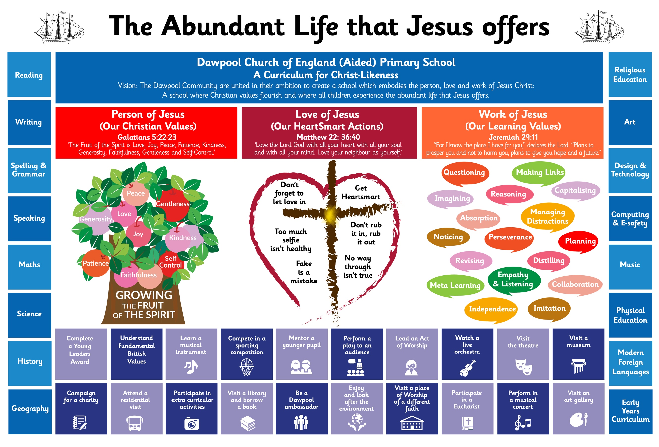

**A Dawpool Artist**

How does Art contribute to the ‘Abundant Life’? 3

Dawpool’s Vision for Art 3

National Curriculum for Art 4

Key stage 1 4

Key stage 2 4

A Foundation Stage Artist 5

A Year 1 Artist at Dawpool 6

Colour Creations 6

African Art 6

Clay Pots 6

Year 1 Art Vocabulary 6

A Year 2 Artist at Dawpool 7

Antarctica 7

The Great Fire of London 7

Our Wonderful World 7

Year 2 Art Vocabulary 8

A Year 3 Artist at Dawpool 8

William Morris 8

Georges Seurat 9

Year 3 Art Vocabulary 9

A Year 4 Artist at Dawpool 10

Iron man-Tone, texture, movement and expression………………………………………………………....**10** Romans study of colour and pattern……………………………………………….....................Error! Bookmark not defined.

Warhol and the Pop Art movement **Error! Bookmark not defined.**

Year 4 Art Vocabulary 11

A Year 5 Artist at Dawpool 11

Peter Thorpe Space Art 11

Greek Pots –Sculpting Vases 12

Rain Forests- Henri Rousseau 12

Watercolour Sunflowers 12

Bird Drawing and Feather Printing 12

Year 5 Art Vocabulary 12

A Year 6 Artist at Dawpool 13

Skills and Gustav Klimt 13

Georgia O’Keeffe 13

Claude Monet and impressionism 13

The Art of Asia 13

Year 6 Art Vocabulary 14

Archived (2021-22): Education Recovery in Art 15

## How does Art contribute to the ‘Abundant Life’?

Art, craft and design stimulates creativity and imagination. It provides visual, tactile and sensory experiences and a unique way of understanding and responding to the world. Pupils use colour, form, texture, pattern and different materials and processes  
to communicate what they see, feel and think. Through art and design activities, they learn to make informed value judgements and aesthetic and practical decisions, becoming actively involved in shaping environments. They explore ideas and meanings in the work of artists, craftspeople and designers. They learn about the diverse roles and functions of art, craft and design in contemporary life, and in different times and cultures. Understanding, appreciation and enjoyment of the visual arts have the power to enrich our personal and public lives.

## Dawpool’s Vision for Art

On completion of the art curriculum at Dawpool, pupils will have developed:

* *The ability to use art vocabulary (for example line, shape, pattern, colour, texture, form) to talk about their own work and that of others.*
* *Experience of using a range of art materials and tools, e.g. textiles, acrylic, clay, pastel, collage, pencil.*
* *Experience of using a computer to create and manipulate artwork.*
* *The ability to draw and paint from observation and imagination.*
* *A knowledge and understanding of other artists and designers.*
* *The ability to select and use materials, tools and techniques to create a range of 2D and 3D artwork.*
* *The ability to reflect on and evaluate their own work and that of others.*
* *Enjoyment of art.*

## National Curriculum for Art

### Key stage 1

Pupils should be taught:

* to use a range of materials creatively to design and make products
* to use drawing, painting and sculpture to develop and share their ideas, experiences and imagination
* to develop a wide range of art and design techniques in using colour, pattern, texture, line, shape, form and space
* about the work of a range of artists, craft makers and designers, describing the differences and similarities between different practices and disciplines, and making links to their own work.

### Key stage 2

Pupils should be taught to develop their techniques, including their control and their use of materials, with creativity, experimentation and an increasing awareness of different kinds of art, craft and design.

Pupils should be taught:

* to create sketch books to record their observations and use them to review and revisit ideas
* to improve their mastery of art and design techniques, including drawing, painting and sculpture with a range of materials [for example, pencil, charcoal, paint, clay]
* about great artists, architects and designers in history

The National Curriculum for Art at Key Stages 1 and 2 can be downloaded from the ‘Curriculum’ tab of the Dawpool school website.

## A Foundation Stage Artist

|  |  |
| --- | --- |
| **A Foundation Stage Artist** | |
| **Class** | **Development Matters Statements**  **Expressive Arts and Design – Creating with Materials** |
| **Foundation 1** | * Explore different materials freely, to develop their ideas about how to use them and what to make. * Develop their own ideas and then decide which materials to use to express them. * Use drawing to represent ideas like movement or loud noises. * Show different emotions in their drawings and paintings, like happiness, sadness, fear etc. * Explore colour and colour-mixing. |
| **Foundation 2** | * Return to and build on their previous learning, refining ideas and developing their ability to represent them. * Create collaboratively sharing ideas, resources and skills. |
| **Early Learning Goals** | * Safely use and explore a variety of materials, tools and techniques, experimenting with colour, design, texture, form and function. * Share their creations, explaining the process they have used. |

|  |  |  |
| --- | --- | --- |
| **Term** | **Topic** | **Activities which may be included. Please note the nature of the EYFS means planning changes daily.** |
| **Autumn Term** | **Where in the world**  **Once upon a time** | * Introduce children to the resources in the classroom and model the correct way to use each resource. * Ensure children are using materials and resources correctly at all times. * Show children how to tidy away and safely store equipment after use. * Use pencils, crayons, felt tip pens and paint to create their own representations. * Bend, fold and cut paper creatively. * Create own designs using craft materials. * Explore how colours change when mixed together. |
| **Spring Term** |
| **Summer Term** |

## A Year 1 Artist at Dawpool

|  |
| --- |
| Colour Creations |
| * I know a variety of colours. * I know primary colours. * I know which primary colours make secondary colours. * I know the difference between light and dark shades of colour. * I know about the artist Kandinsky. |
| African Art |
| * I know about Africa, its colours, shapes and patterns. * I know about Maasai culture and jewellery. * I know how to create a layered background. * I know how to design and decorate a mask. |
| Clay Pots |
| * I know how to use tools to create a clay pot. * I know how to join two pots together. * I know how to decorate my clay put by pressing, rolling, rubbing and stamping. |

|  |
| --- |
| * I can show how people feel in paintings and drawings. |
| * I can create moods in art work. |
| * I can use pencils to create lines of different thickness in drawings. |
| * I can name the primary and secondary colours. |
| * I can create a repeating pattern in print. |
| * I can cut, roll and coil materials. * I can create a printed piece of art by pressing, rolling, rubbing and stamping. * I can make a clay pot. * I can join two clay finger pots together. |
| * I can use IT to create a picture. |
| * I can describe what I can see and give an opinion about the work of an artist. |
| * I can ask questions about a piece of art. |

### Year 1 Art Vocabulary

|  |  |  |  |
| --- | --- | --- | --- |
| **line** | **shape** | **technique** | **space** |
| **artist** | **media** | **materials** | **design** |
| **primary colours** | **secondary colours** | **cold colours** | **warm colours** |
| **clay pot** | **pattern** | **moulding** | **colour wheel** |

## A Year 2 Artist at Dawpool

|  |
| --- |
| Antarctica |
| * I can create tints with paint by adding white-children will be able to mix paints to create graduated tints. * I can create tones with paint by adding black- children will be able to mix paints to create graduated tones independently. * I can focus on one part of an explorers artefact object using a view finder and draw it in detail and using a pencil to add shades and tones. * I will be able to create a picture of an Antarctic landscape using watercolours and mixing my own secondary colours. * I will be able to create a drawing of a penguin using pencils and crayons and add detail. * I will be able to develop a wide range of art techniques in using colour, pattern, texture, and space in the context of making a drip painting from shades( Link to Bonfire night) * I can create a drip painting using shades I have mixed. * I will be able to talk about the work of Jackson Pollock and use his technique to create a picture. |
| The Great Fire of London |
| * I can use pastels to create flames, learning about the foreground and the background as I create my piece of work. * I will know about the artist Rita Greer and what techniques she used to create her Great Fire of London inspired work and use collage to create a picture of the Great Fire of London. * I can create a 3D piece of art work using The great fire of London and Ludgate as inspiration. * I can use mixed media to create my own interpretation of a scene from The Great Fire of London. |
| Our Wonderful World |
| * I will learn about how Native Americans and Aboriginal artists painted on rocks using natural materials and create my own rock art. * I will be able to create a 3D structure using natural materials that I have collected in Forest school using inspiration from Andy Goldsworthy and his work. * I will be able to use natural materials to create a collage picture, based on Rangoli patterns and the use of leaves to create colour and pattern. * I will be able to weave using natural materials using inspiration from different cultures use of weaving ie Turkey. * I will create a mandala using natural materials, after finding out about the Indian cultural and spiritual reasons for making them. |

* I can choose and use three different grades of pencil when drawing.
* I can use charcoal, pencil and pastel to create art.
* I can use a viewfinder to focus on a specific part of an artefact before drawing it.
* I can mix paint to create all the secondary colours.
* I can create brown with paint.
* I can create tints with paint by adding white.
* I can create tones with paint by adding black.
* I can use different effects within an IT paint package.
* I can suggest how artists have used colour, pattern and shape.
* I can create a piece of art in response to the work of another artist.

### Year 2 Art Vocabulary

|  |  |  |  |
| --- | --- | --- | --- |
| **light** | **dark** | **foreground** | **middle ground** |
| **background** | **blend** | **layering** | **colour** |
| **texture** | **shades** | **tones** | **collage** |
| **media** | **3D** | **2D** | **shape** |
| **form** | **shading** | **mix** |  |

## A Year 3 Artist at Dawpool

|  |
| --- |
| William Morris |
| * I know who William Morris was and understand about his life and work. * I know what the Arts and Crafts movement was, why it was important and understand the impact which it had. * I know what still life drawing is and the skills needed to produce a still life picture. * I know what printmaking is, how it would have been done in the 19th century and can design my own printing block.   I know how to create my own printed pattern using my knowledge and understanding of William Morris and the Arts and Crafts movement. |
| Georges Seurat |
| * I know who Georges Seurat was and how his style differed to the styles of others. * I know what is meant by Pointillism and can recognise artwork prdocued by Seurat. * I know the importance of the science of colour and can understand Seurat’s theories of colour mixing. * I know about the importance of shading and how dots can be used to create areas of light and dark like in Seurat’s work.   I know about another famous artist who joined in on the Pointillism movement. |
| Vincent Van Gogh |
| * I will use lines to create depth and texture. * I will use colours and lines to create shade and tint. * I will learn how to revisit and develop ideas. * I will use lines to create movement. * I will develop develop my sketching techniques. * I will use lines and colour to create portraits in the style of Van Gogh. |

* I can show facial expressions in my art.
* I can use sketches to produce a final piece of art.
* I can use different grades of pencil to shade and to show different tones and textures.
* I can create a background using a wash.
* I can use a range of brushes to create different effects in painting.
* I can identify the techniques used by different artists.
* I can use digital images and combine with other media in my art.
* I can compare the work of different artists.
* I recognise when art is from different cultures.
* I recognise when art is from different historical periods.

### Year 3 Art Vocabulary

|  |  |  |  |
| --- | --- | --- | --- |
| **Georges Seurat** | **Pointillism** | **Complimentary colours** | **Colour wheel** |
| **Sketch** | **William Morris** | **Art and crafts movement** | **Still life drawings** |
| **Pencil grip** | **Background wash** | **Printing block** | **Patterns** |
| **Rotation** | **Symmetry** | **Reflection** | **Stencil** |
| **Sequence** |  |  |  |

## A Year 4 Artist at Dawpool

**Key topics:**

|  |
| --- |
| Iron Man-Tone, texture, movement and expression |
| * I can use marks and lines to show texture in my art. * I can experiment to create a range of tones, experimenting to add dimension. * I can show facial expressions and body language in sketches and paintings. * I can use line, tone, shape and colour to represent figure and forms in movement. * I can create my own sketch of a figure in movement. * I can create a sketch of the Iron man using tone, line, shape and dimension. |

|  |
| --- |
| Romans-investigating pattern |
| * I can explain some of the features from historical periods. * I can create a stamp using Roman art work as my inspiration. * I can create a pattern using a stamp I created. * I can print onto different materials using 4 different colours. * I can explore and continue patterns. * I can create patterns using rotation and symmetry and reflection. * I can create a pattern using a stencil(pressprint). |
| Andy Warhol and the Pop art movement |
| * I can find out who Andy Warhol was and explore the pop art movement. * I can use Warhol’s blotted line technique to create artwork. * I can explore and recreate Warhol’s Campbell’s soup art work. * I can explore Warhol’s portraits of celebrities and create my own. * I can create a self portrait in the style of Andy Warhol. * I can use objectives of popular culture to create Pop art. * I can explore an alternative Pop artist-Roy Lichtenstein. |

* I can show facial expressions and body language in sketches and paintings.
* I can use marks and lines to show texture in my art.
* I can use line, tone, shape and colour to represent figure and forms in movement.
* I can show reflections in my art.
* I can print onto different materials using at least four colours.
* I can sculpt clay and other mouldable materials.
* I can integrate my digital images into my art.
* I can experiment with the styles used by other artists.
* I can explain some of the features of art from historical periods.

### Year 4 Art Vocabulary

|  |  |  |  |
| --- | --- | --- | --- |
| **delicate** | **bold** | **contrasting** | **dramatic** |
| **subtle** | **rough** | **blending** | **smooth** |
| **uneven** | **stippling** | **repeating** | **vibrant** |
| **colourful** | **bright** | **dark** | **realistic** |
| **unrealistic** | **sketch** | **line** | **brush** |
| **Contour hatching** | **natural** | **unnatural** | **Shade** |
| **colour** | **reflecting** | **scumbling** | **Cross hatching** |

## A Year 5 Artist at Dawpool

|  |
| --- |
| Peter Thorpe Space Art |
| * I know Peter Thorpe’s artistic style and can use it to replicate my own. * I know what abstract art is. * I can draw objects. * I can draw on my learning about Earth and Space in Science for my art work. * I can evaluate my work against criteria. |
| Greek Pots –Sculpting Vases |
| * I know about artists and crafts people. * I know about different containers. * I know how to model with plasticine and clay. * I know how to use a range of tools and techniques. * I know how to design my own work using vases from Ancient Greece as inspiration. |
| Rain ForestsWatercolour rainforests |
| * I know how to take a line for a walk and use it to create a rainforest watercolour. * I know how to add detail and use dark tones, mixing watercolours. * I know how to apply watercolour with precision and can blend colours together. |
| Bird Drawing and Printing |
| * I know how to study, observe and draw a bird. * I know to look at line, tone and shape to create an image of a bird. * I know how to make a printing block from press print. |
| Express yourself |
| * I can explore how clothing can be used to express ourselves. * I can observe and draw different facial expressions. * I can create wire models to express body language. * I can explore how lines and fonts can express ideas. * I can observe how artists use colour to express themselves in art. * I can study the artwork of Chuck Close and explore his techniques. |

* I can identify and draw objects and use marks and lines to produce texture.
* I can successfully use shading to create mood and feeling.
* I can organise line, tone, shape and colour to represent figures and forms in movement.
* I can express emotion in my art.
* I can create an accurate print design following criteria.
* I can use images which I have created, scanned and found; altering them where necessary to create art.
* I can research the work of an artist and use their work to replicate a style.

### Year 5 Art Vocabulary

|  |  |  |  |
| --- | --- | --- | --- |
| **artist** | **landscape** | **Detail** | **techniques** |
| **skills** | **tone** | **pattern** | **blending** |
| **comparing** | **composition** | **reference** | **genre** |
| **scale** | **portrait** | **outline** | **clay** |

## A Year 6 Artist at Dawpool

|  |
| --- |
| Skills and Gustav Klimt |
| Skills   * To know how to define, identify and use different types of line * To know how to create tone using pencil shading * To know colour theory and why it is important to artists   Gustav Klimt   * I know about the life and work of symbolist painter Gustav Klimt (biographical) * I know how to sketch in the style of Klimt * I know and use symbolism in the style of Klimt * I know about Klimt’s ‘golden period’ and key works such as: “The Kiss’ and “AdeleBloch Bauer’ and can produce pieces in this style. |
| Georgia O’Keeffe |
| * I know who Georgia O’Keeffe was and her contribution to art. * I know features of Georgia O’Keeffe’s style. * I know how to sketch and paint in the style of Georgia O’Keeffe. |
| Claude Monet and impressionism |
| * I know what impressionism is and how it evolved. * I know facts about the life and work of Claude Monet. * I know and can create pieces in the style of Monet’s cityscapes and landscapes. * I know about Monet’s series of pictures e.g. Haystacks. * I know about the artwork Monet produced at his garden at Giverny and can create work in the same style. |

|  |
| --- |
| The Art of Asia |
| * I know what and when Mehndi, rangoli and mandala patterns are used and know how to create my own. (India) * I know about chinese calligraphy and blossom art and know how to draw bamboo. (China) * I know about Blossom and Manga Art and can create my own pieces in this style. (Japan) |

* I can explain why I have used different tools to create art.
* I can explain why I have chosen specific techniques to create my art.
* I can explain the style of my work and how it has been influenced by a famous artist.
* I can over print to create different patterns.
* I can use feedback to make amendments and improvement to my art.
* I can use a range of e-resources to create art.

### Year 6 Art Vocabulary

|  |  |  |  |
| --- | --- | --- | --- |
| drawing | line | **Klimt** | **Monet** |
| pastel | form | gilding | impressionism |
| acrylic | texture | mosaic | seascapes |
| fine line | refine | fresco | response |
| water colour | colour wheel | montage | Giverny |
| oil paint | primary | frieze | recreate |
| shading | secondary | pattern | reflection |
| hatching | tertiary | symbolism | **Other Cultures** |
| curved hatching | decoration | portrait | calligraphy |
| cross hatching | collage | landscape | ink |
| tone | textile | realism | brushstrokes |
| shape | silhouette | detail | blossom |
| techniques | shadow | abstract | willow pattern |
| **Artists** | | experimentation | mango |
| Paul Nash & Richard Nevinson | | propaganda | mehndi |
| Georgia O’Keefe | | censorship | rangoli |
| Claude Monet | |  | mandala |
| Gustav Klimt | |  |  |

## Archived (2021-22): Education Recovery in Art

In response to the COVID-19 pandemic, we have identified 3 overarching improvement priorities for education recovery:

* *Reading across the curriculum*
* *Teachers’ subject, pedagogical and pedagogical content knowledge*
* *Quality First Teaching*

A focus on these 3 priorities will ensure that all pupils can access the full curriculum which is central to the ‘**Abundant Life that Jesus offers.**’

In addition to these 3 priorities, we have taken a **subject-specific approach** when prioritising what to teach.

In determining what to prioritise in the **art curriculum**, we have focused on our **vision for art** which outlines our aspirations for pupils in this subject. We have also considered the [guidance](https://www.gov.uk/government/publications/teaching-a-broad-and-balanced-curriculum-for-education-recovery) produced by the DfE. The main aim of education recovery at Dawpool is to teach pupils what they need in order to make sense of later work in the curriculum. We have therefore identified the following priorities for the **art curriculum**.

Pupils will:

* *Develop fine and gross motor skills by cutting, gripping, moulding, etc.*
* *Use a range of different materials and tools in their artwork, e.g. textiles, acrylic, clay, pastel, collage, pencil.*
* *Have regular opportunity to draw and paint from observation and imagination.*
* *Revise art vocabulary so they can talk about, and reflect on, their own work and that of others.*
* *Explore other artists and designers to understand the multiple forms in which art exists.*