**Weekly Timetable Year Group WC 24th March 2025**

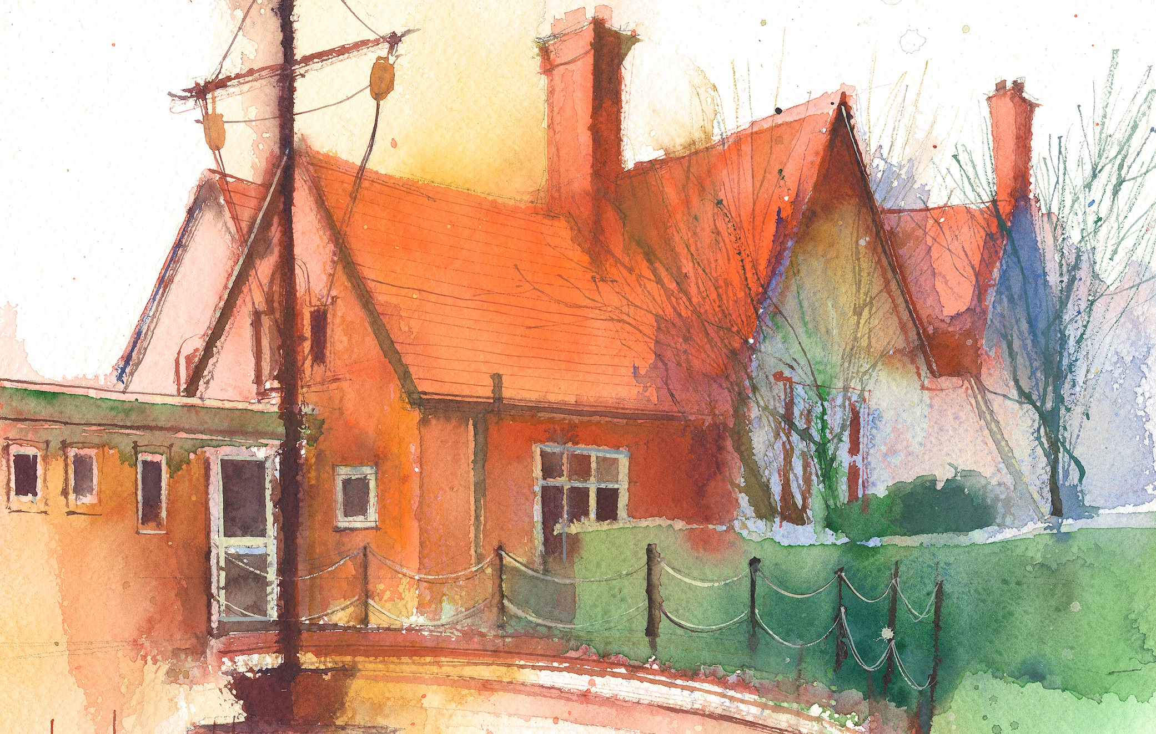

|  |  |  |  |  |  |  |
| --- | --- | --- | --- | --- | --- | --- |
|  | **Lessons 09:00 – 10:30** |  | **Lessons­­­­ 10:45 – 12:15** |  | **Lessons 13:15 – 15:30 (Incorporating 15-minute break)** | |
| **Monday** | **Maths**  **Mrs Bowker**  Maths  By the end of this lesson children will know how to draw angles round a point.  They will use Third Space Learning Shape Lesson 6 “ Drawing angles around a point.” | **Literacy**  **Poetry with Mrs Bowker** | **P.E**  **Mrs Bowker**  **Hockey**  Recap and refine dribbling and passing creating attacking opportunities  Lesson 5 Complete P.E. Term 2 | **R.E**  **Easter story**  By the end of this lesson children will be able to discuss and record the meaning of victory for the Christian faith.  Questful R.E. learning outcomes |
| **Tuesday** | Science 1  Materials testing materials for magnetism  Testing materials for transparency  Testing materials for electrical conductors or insulators.  test materials for absorption  Testing materials for sound conductivity  Children will rotate for these group activities | Science 2  Materials testing materials for magnetism  Testing materials for transparency  Testing materials for electrical conductors or insulators.  Testing materials for sound conductivity  test materials for absorption  Children will rotate for these group activities | **Guitarists out**  **Spellings Rule 57**  **government**  **guarantee**  **harass**  **hindrance**  **identity**  **immediate**  **immediately**  **individual**  **interfere**  **interrupt**  **language**  **leisure**  **Rising stars spellings 2”ent” “ant”**  **Spring unit 8 and oak academy video**  [**Click here**](https://www.thenational.academy/teachers/search?term=spellings+ent+ant&yearGroups=year-5) | **Literacy/Topic**  **L.O. Children will discuss issues surrounding the deforestation debate and plan to write a debate about the arguments for and against.** |
|  |
| **Wednesday** | **Mrs Bowker**  . | **Mrs Hall** | **Mrs Bowker** | |
| **Thursday** | **Maths**  **Mrs Bowker**  Maths  By the end of this lesson children will know how to draw angles round a point.  They will use Third Space Learning Shape Lesson 8 “ Calculate lengths and angles in shapes.” | **Literacy/Topic**  **L.O. Children will discuss issues surrounding the deforestation debate and plan to write a debate about the arguments for and against.** | **Forest schools**  **(Half of the class)**  **Finish work on life cycles and present to year 2** | |
| **Friday** | **Maths**  **Mrs Hall**  **Cracking Comprehension**  **Mr G Year 4 to take ICT.**  **Lesson 4.2 Coding using Purple Mash 2 Code. Introduction to coding language and practise creating a simple program** | **Maths**  **Mrs Bowker**  Maths  By the end of this lesson children will know how to draw angles round a point.  They will use Third Space Learning Shape Lesson 9 “ Recognise regular and irregular polygons.” | **PPA**  **Mrs Woods to cover**  **Heartsmart**  **Spanish** | |

**Weekly**

Worship (Mon & Fri) 10:10-10:30

HeartSmart (20-minutes per week)

Picture News (20-minutes per week)

No Outsiders (20-minutes per week)

My Happy Mind (20-minutes per week)

Reading for Pleasure (at least 10-minutes per day)

**Weekly**

Maths (daily)

Rapid Reasoning / Fluent in Five (daily)

Power of Reading x 3

Punctuation & Grammar x1

Spelling x1

Reading Comprehension x1

RE

Science

PE

**Weekly / Fortnightly / Blocked**

History

Geography

DT

Art

Music

Computing (MFL) KS2

(Y3/4 September – Feb)

(Y5/6) February – July)