**Weekly Timetable Year Group WC 30th June 2025**

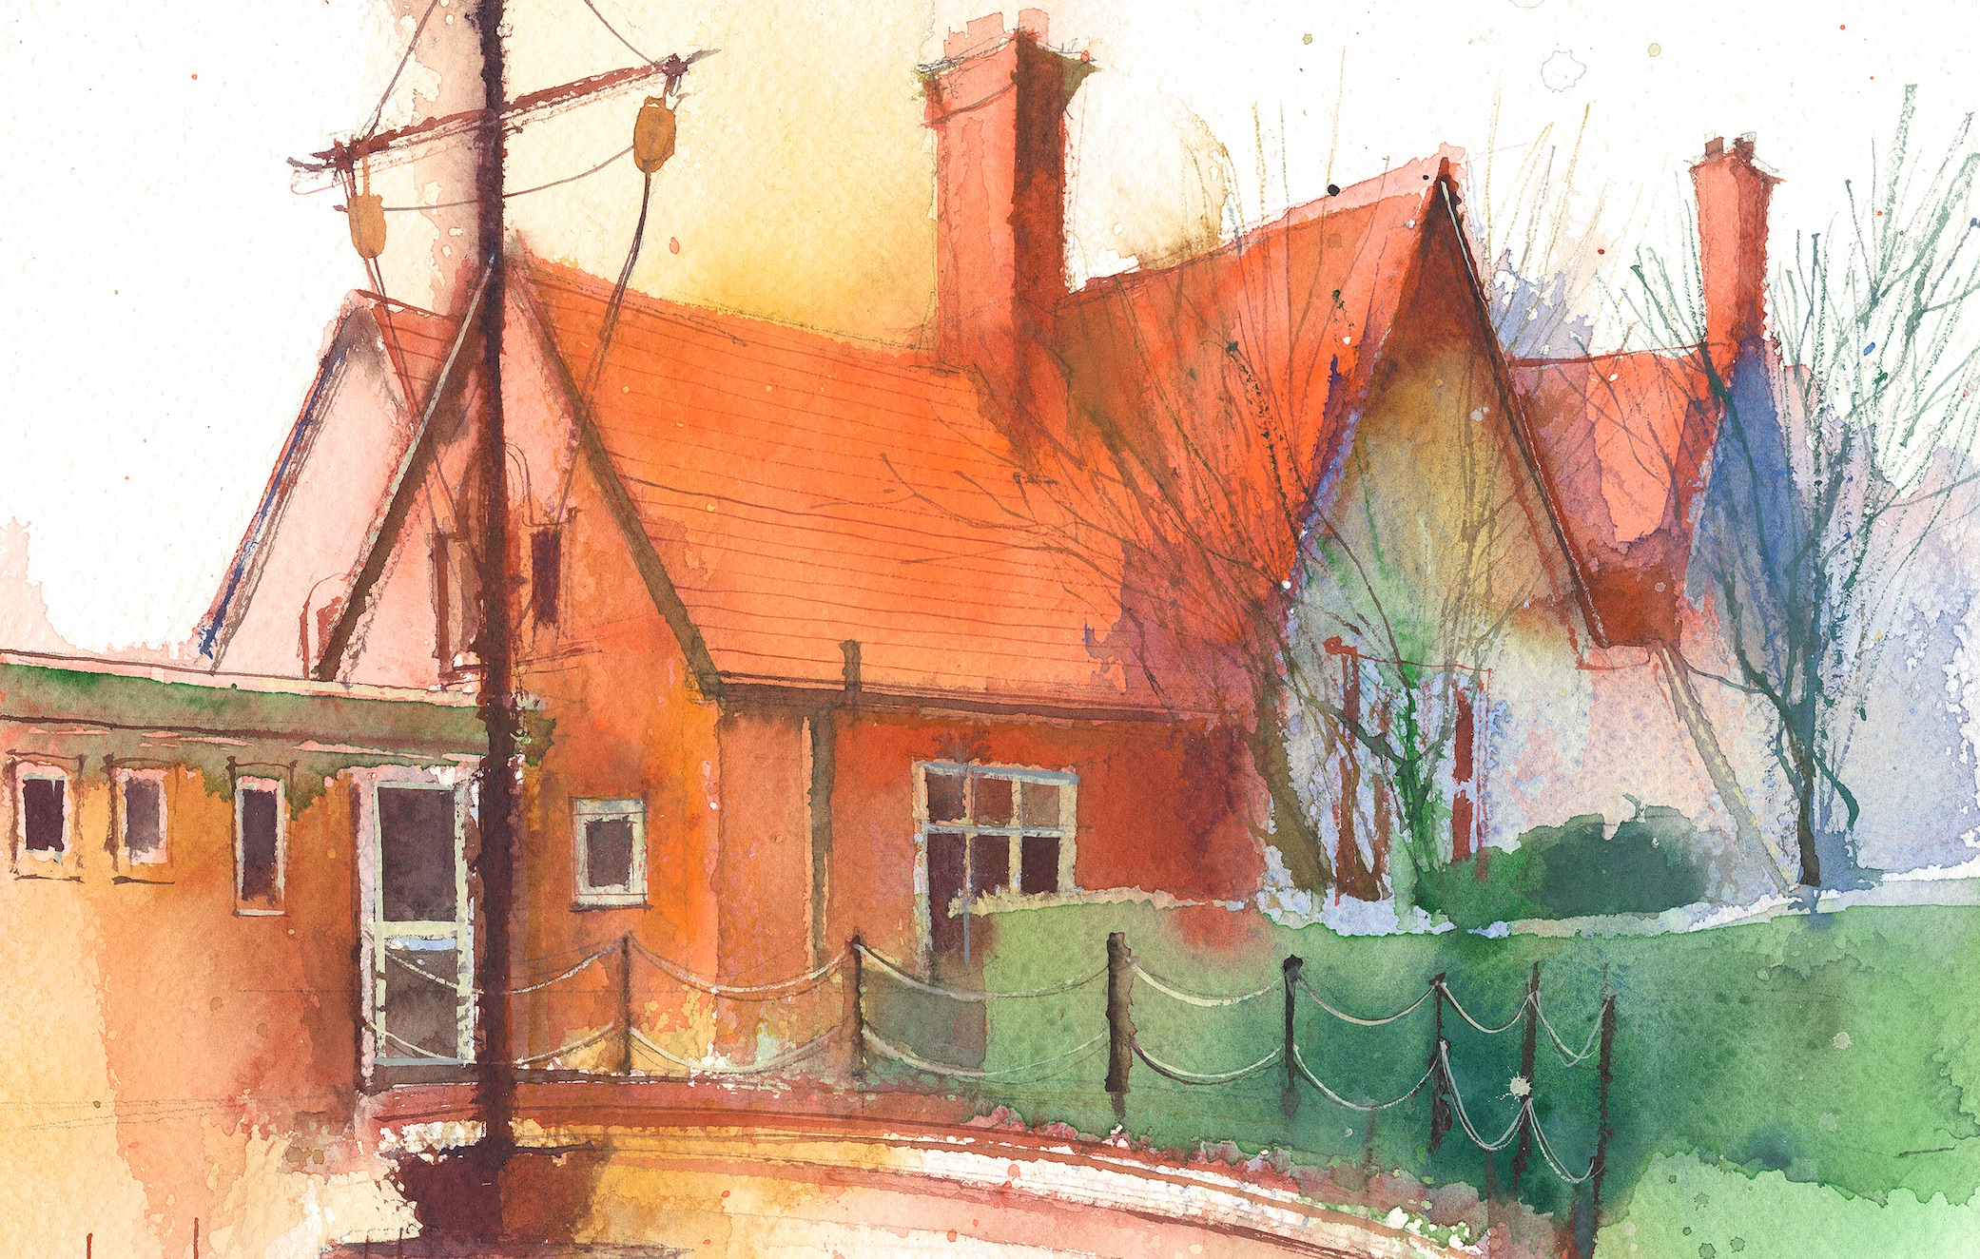

|  |  |  |  |  |  |  |
| --- | --- | --- | --- | --- | --- | --- |
|  | **Lessons 09:00 – 10:30** |  | **Lessons­­­­ 10:45 – 12:15** | **T** | **Lessons 13:15 – 15:30 (Incorporating 15-minute break)** | |
| **Monday** | Maths  Learning objective- To convert units of length | Literacy (POR)  .  Learning objective: To finish writing a convincing diary entry from Clovis’s perspective. | P.E  Pupils will build upon their prior learning of applying pressure and marking, to create and apply basic defensive tactics. | Questful R.E.  Unit 5.5 Old Testament women |
| **Tuesday** | Maths  Learning objective: To know how to convert between metric and imperial units | Literacy  Learning objective; To understand the key events in Chapter 13, describe characters' feelings, learn new words, and express ideas through writing. | Topic  South America Work | |
| **Wednesday** | Maths  Learning objective: To know how to convert between units of time | Literacy  Use evidence from Romeo and Juliet to write an engaging and structured news article. | Art  Express yourself piece of work | |
| **Thursday** | Maths  Learning objective: To know how to read and interpret timetables | Literacy (POR)  Learning Objective- To use vocabulary to describe emotions and actions and then write from a character’s point of view | Science  Forces and Friction | |
| **Friday** | Maths  Learning objective- To review how to convert all units from what we have covered this topic | Literacy  Grammar unit 29 | Mrs Wood | |

**Weekly**

Worship (Mon & Fri) 10:10-10:30

HeartSmart (20-minutes per week)

Picture News (20-minutes per week)

No Outsiders (20-minutes per week)

My Happy Mind (20-minutes per week)

Reading for Pleasure (at least 10-minutes per day)

**Weekly**

Maths (daily)

Rapid Reasoning / Fluent in Five (daily)

Power of Reading x 3

Punctuation & Grammar x1

Spelling x1

Reading Comprehension x1

RE

Science

PE

**Weekly / Fortnightly / Blocked**

History

Geography

DT

Art

Music

Computing (MFL) KS2

(Y3/4 September – Feb)

(Y5/6) February – July)