Year 1 Weekly Timetable Week Commencing 20.10.25
To contact your child’s class teacher, please email schooloffice@dawpool.wirral.sch.uk or phone 0151 648 3412
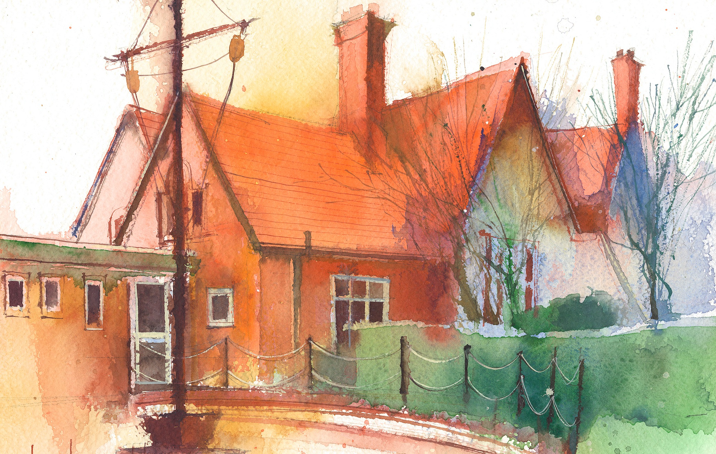

 | Lessons 09:00 – 10:30 |  |  | Lessons 10:45 – 12:15 |  | Lessons 13:15 – 15:30 (Incorporating 15-minute break) | Additional Tasks
Thursday | Phonics: oo as u (segmenting practise)  Spag | Singing Assembly |  | Maths: To use a number line.  ERIC/ GR |  | Forest School: Teamwork  Heartsmart: Children reflect on the choices they make and how these impact their hearts and the hearts of those around them. | Have a wonderful half term!  During your half term week, please can you encourage your children to collect some more Autumnal items such as amazing coloured leaves, acorns, conkers, seeds and nuts.  We will continue to send home your child’s reading books so you can enjoy them over the week.  Looking forward to seeing you all when you get back.
Friday | Phonics: Tricky words: oh, their  Cracking Comprehension | Celebration Assembly |  | Maths: To use a number line.  ERIC/ GR |  | PE: The focus of the learning is to understand the importance of being coordinated.  Pupils will perform a circuit to develop their application and understanding of coordination.  Computing: I can log in to purplemash.  Golden Time: Time to play with special toys!

