**Year 1 Weekly Timetable Week Commencing 30.06.25**

**To contact your child’s class teacher, please email** [**schooloffice@dawpool.wirral.sch.uk**](mailto:schooloffice@dawpool.wirral.sch.uk) **or phone 0151 648 3412**

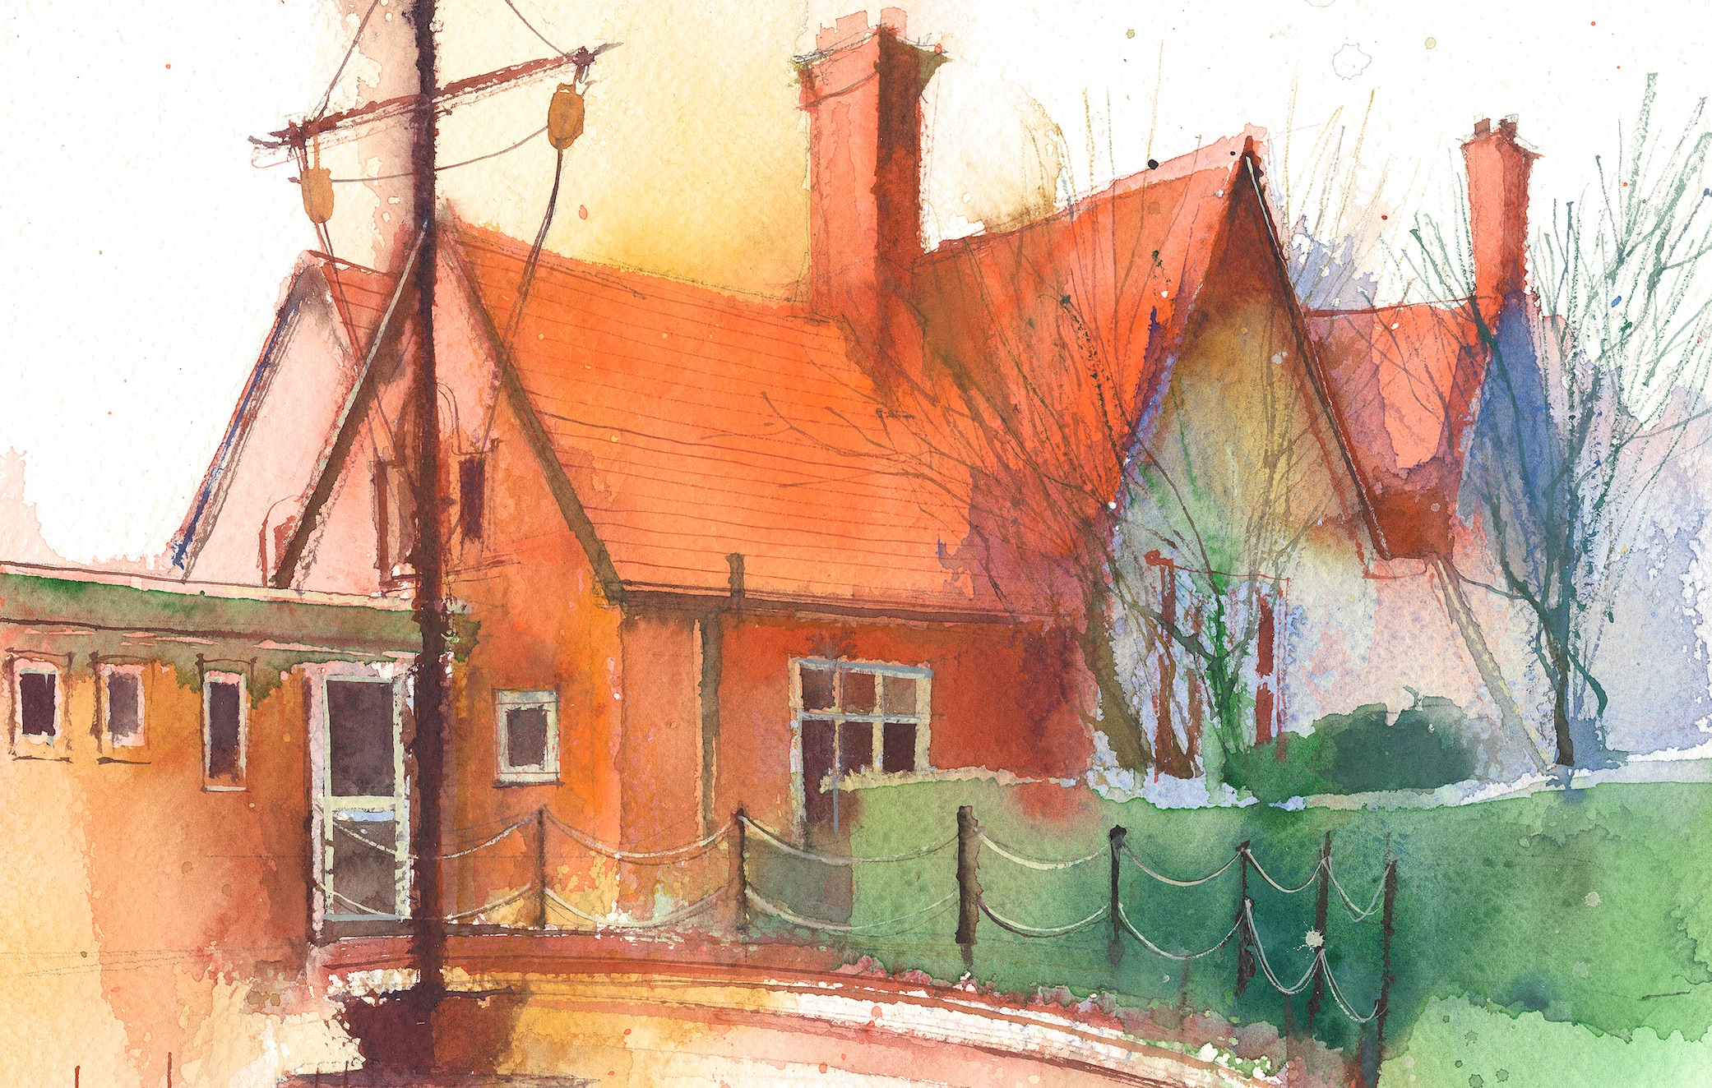

|  |  |  |  |  |  |  |
| --- | --- | --- | --- | --- | --- | --- |
|  | **Lessons 09:00 – 10:30** |  | **Lessons­­­­ 10:45 – 12:15** |  | **Lessons 13:15 – 15:30 (Incorporating 15-minute break)** | **Additional Tasks** |
| **Monday** | **Phonics:** sh as ci (blending practice)  **English:** I can write my own chapter of the wishing chair. | **Maths:** To know how to choose the correct operations in word problems.  **ERIC / GR** | **Fluent in 5**  **Topic/art:** To be able to produce art based on the work of Kandinsky.  **Computing:**  • To understand what an event is.  • To begin to understand how code executes when a program is run.  **Picture News** | Useful Links / Other Recommended Activities  **Oak National Academy**  <https://classroom.thenational.academy/>  **BBC Bitesize**  <https://www.bbc.co.uk/bitesize>  **Purple Mash**  <https://www.purplemash.com/sch/dawpool#/>  **Recommended Reading List**  [See here](https://www.dawpool.wirral.sch.uk/website/recommended_reading_lists/577821) |
| **Tuesday** | **Phonics:** sh as ci (segmenting practice)  **English:** I can write adjectives about what I can see. | **Maths:** To know how to choose the correct operations in word problems.  **ERIC / GR** | **Fluent in 5**  **Science:**To be able to describe and compare the structure of a variety of common animals.  **My Happy Mind:** Relate |
| **Wednesday** | **Phonics:** sh as ssi (blending practice)  **Maths:** To know how to choose the correct operations in word problems. | **Forest School:** Lighting fires and seeing how fire moves.  **ERIC / GR** | **Fluent in 5**  **PE:**  • The focus of the learning is for pupils to understand why we need to listen to the instructions when playing a game.  • Pupils will understand why we need to follow the instructions (rules) of a game and begin to understand what the consequences are if we do not follow the instructions.  **No Outsiders** |
| **Thursday** | **Phonics:** sh as ssi (segmenting practice)  **Spag** | **Maths:** To understand the value of different coins.  **ERIC / GR** | **Fluent in 5**  **Art:** with Mrs Young in Year 2.  **Heartsmart:** No way through isn’t true. |
| **Friday** |  | **See Mrs Clark’s Planning** |  |