Snow Day
Below are the activities we originally had planned for today. Don’t worry if you don’t get chance to do them all, we will be catching up on them next week at some point.

Phonics
Today in Phonics we were going to be practicing reading and writing the Tricky Words we and me. Start by re-capping on the following words. Maybe ask your grown up to write them on large pieces of paper and see if you can jump on them and shout them out as you land.
we, me, be, was, my, you
Next have a go at reading these sentences.
Can we spot a bat?
I swept and she sang to me.
We rang the bell.
Ask your grown up to say this sentence out loud several times. Can you remember it and write it yourself? Don’t forget finger spaces between words and a full stop at the end.
My mum sings to me.

Topic
Our new Topic is focussing on Peter Rabbit and all the different animals Beatrix Potter wrote about. Perhaps today you could watch the Peter Rabbit films and make a list of all the animals. If you don’t have access to the films, maybe you could do some research on the internet to find out all the animals Beatrix Potter chose as the focus of each of her books. Can you bring the list into school for me on Monday?

Maths
This week we have been talking about “one more”. When you add one more to something the amount you have gets bigger. One more than 2 is 3. When we write this down the number sentence looks like this. 2+1=3
Maybe you can practice this with snowballs. If you make 5 snowballs and add one more, how many do you have? What does this look like written down?
If you have 9 mini marshmallows in your hot chocolate and you add one more how many do you have? What does this look like written down?

Literacy
In Literacy today, we were going to be comparing and contrasting characters from stories and films. Look at the two images of Peter Rabbit below. One is the illustration by Beatrix Potter herself, and the other is taken from the film Peter Rabbit. Discuss with your grown up. What is the same about the two characters? What is different about them? Can you make a list?

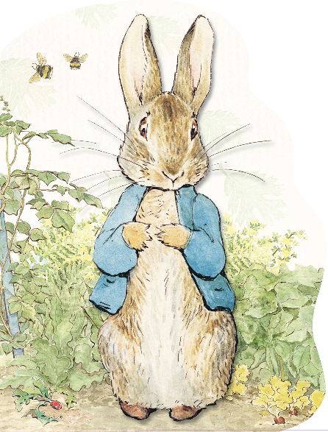

What is the same? | What is different?

