Spring term Week 2 Year 5 Weekly Plan: 12.01.2026.16.12.2026
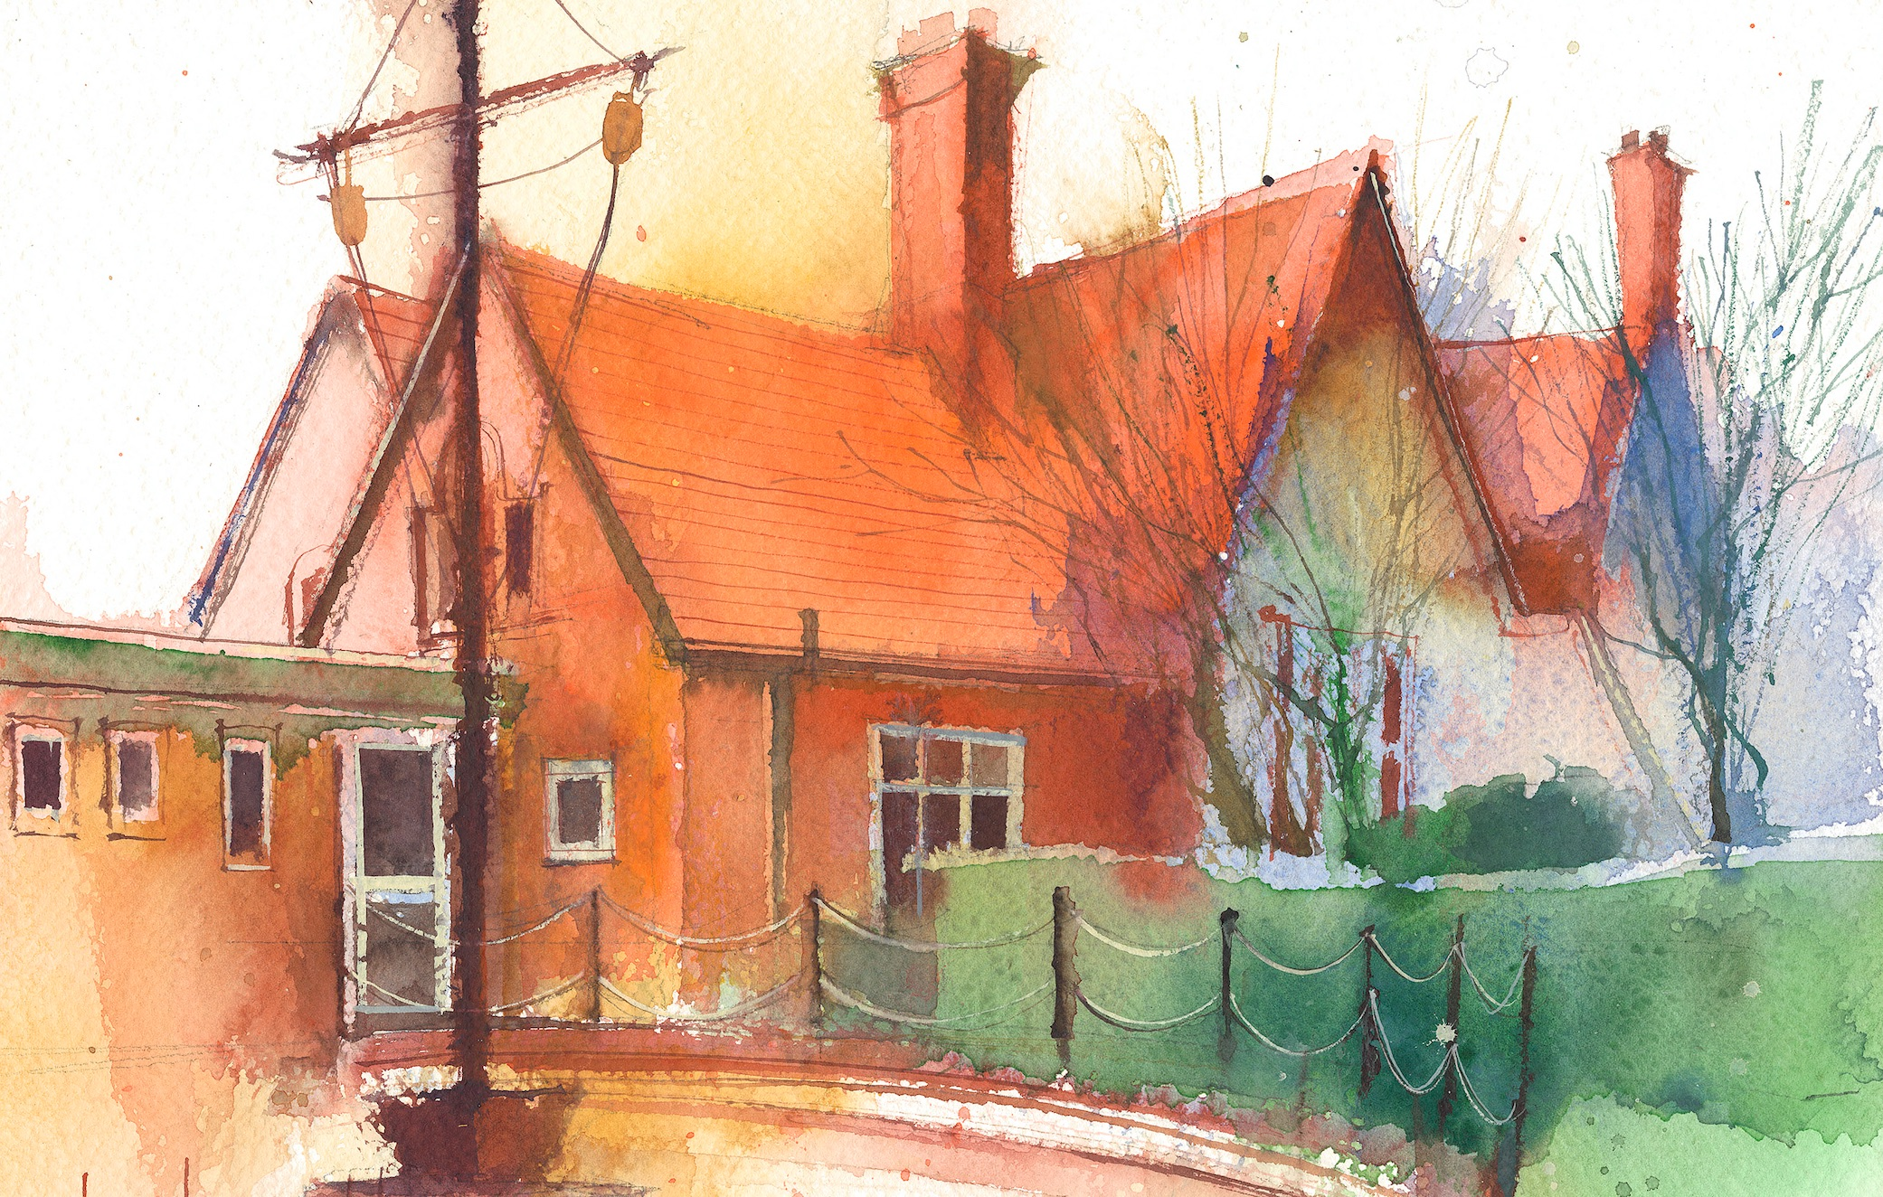
To contact your child’s class teacher, please email schooloffice@dawpool.wirral.sch.uk or phone 0151 648 3412
 | Lessons 09:00 - 10:30 |  | Lessons 10:45 - 12:15 |  | Lessons 13:15 - 15:30  (Incorporating 15-minute break) | Additional Tasks
Monday  12/01/26 | Mrs McCann Plans
Tuesday  13/01/26 | Maths  Fluent in five/ Rapid Reasoning  By the end of this lesson your child should be able to: know how to find common multiples lesson 3 |  | CDAT English  By the end of this lesson your child should be able to: Read the first part of Arnie the doughnut and fill in the doughnut of the day worksheet. Box up the first part of the story |  | Science  By the end of this lesson your child should be able to: learn about the lifecycle of mammals and insects and to be able to sketch detailed annotated diagrams.  Picture news, British Values | .
Wednesday  14/01/26 | Maths  Fluent in five/ Rapid Reasoning  By the end of this lesson your child should be able to: know how to find factors lesson 4 |  | CDAT English  By the end of this lesson your child should be able to use speech bubbles in a short narrative passage and to read first part of comprehension sheet, to box up second part of the story |  | Topic  By the end of this lesson your child should be able to:  Learn about the specific countries of South America. Each table will be given a country to study. They will use laptops to start building up fact files about their country as a team which they will feed back to the other groups. | Chess
Thursday  15/01/26 | Maths  By the end of this lesson your child should be able to: know how to find common factors. Lesson 5  Music  KS 2 singing practise 10.10 |  | CDAT English  By the end of this lesson your child should be able to be able to read and box up third part of the story and use subordinating conjunctions |  | Art/ Topic  By the end of this lesson your child should be able to: about South American art and its use of patterns and colour. | Singing
Friday  16/01/26 | Maths  Fluent in five/ Rapid Reasoning  By the end of this lesson your child should be able to: know how to do 2, 3, 4-digit column addition |  | English  By the end of this lesson your child should be able to: read and box up the final part of the story. To listen to Chris O Dowd read the story and answer some comprehension questions.  Weekly spelling gest |  | IT  RE,  By the end of this lesson your child should be able to: understand about the 5.3-unit Jesus. Explain how parables in this unit can answer questions about values and commitments | Celebration of weeks work

