**Year 1 Weekly Timetable Week Commencing 16.06.25**

**To contact your child’s class teacher, please email** [**schooloffice@dawpool.wirral.sch.uk**](mailto:schooloffice@dawpool.wirral.sch.uk) **or phone 0151 648 3412**

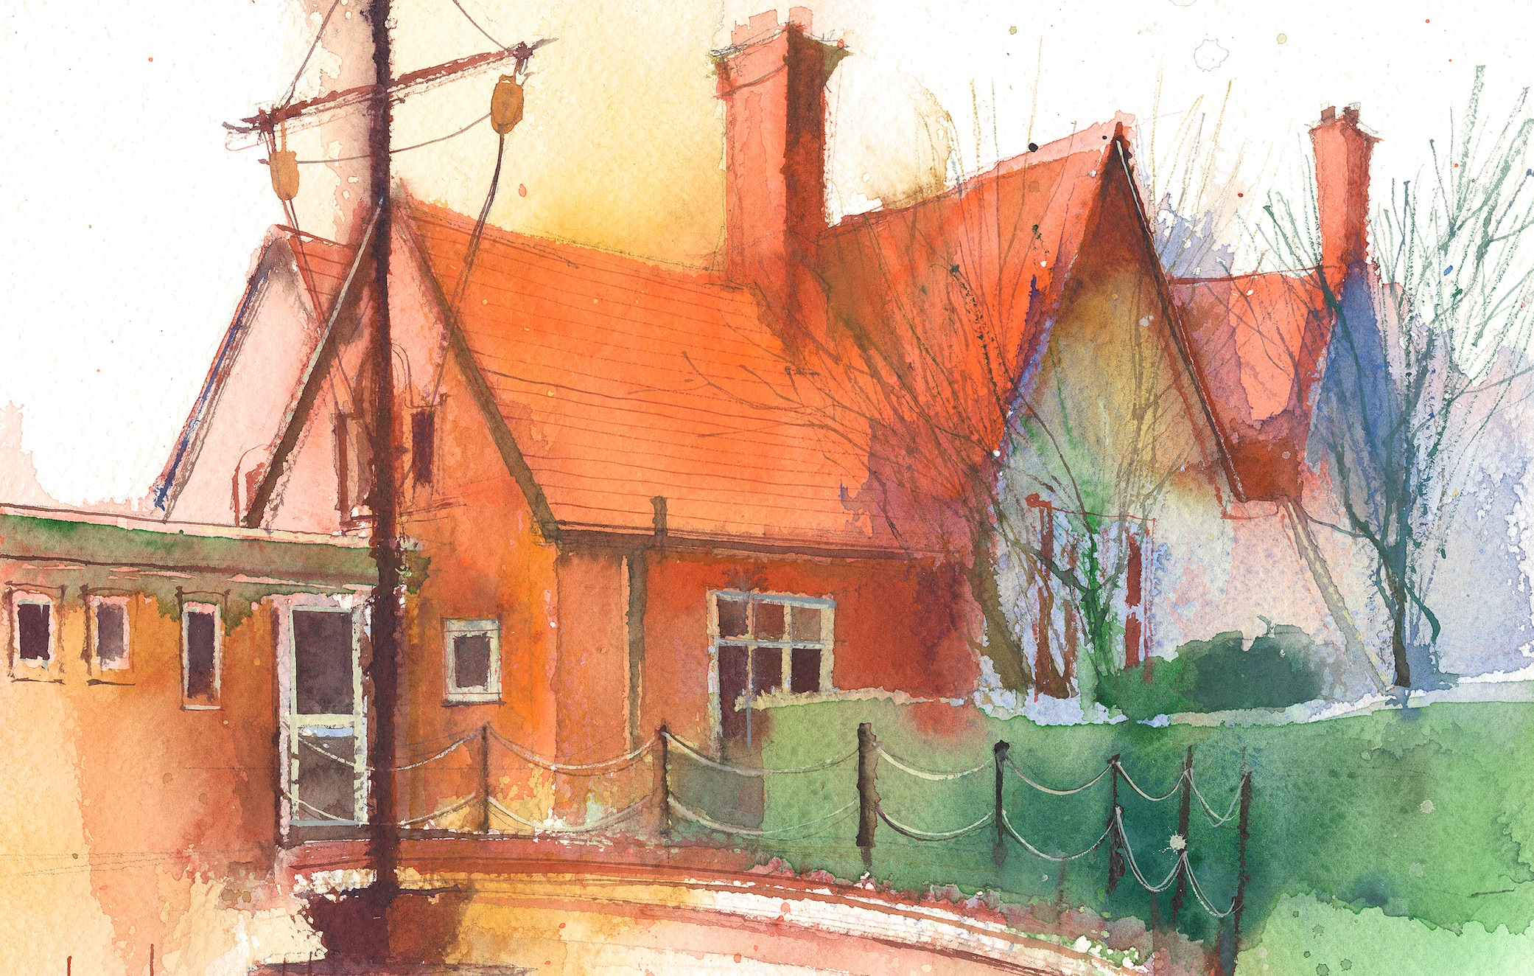

|  |  |  |  |  |  |  |
| --- | --- | --- | --- | --- | --- | --- |
|  | **Lessons 09:00 – 10:30** |  | **Lessons­­­­ 10:45 – 12:15** |  | **Lessons 13:15 – 15:30 (Incorporating 15-minute break)** | **Additional Tasks** |
| **Monday** | **Phonics:** s as sc (blending practice)  **English:** I can explore rhythm and rhyme. | **Maths:** To understand hours, minutes and seconds.  **ERIC / GR** | **Fluent in 5**  **Topic/art:** I can add black and white to colour to change the shade.  **My Happy Mind:** Relate | Useful Links / Other Recommended Activities  **Oak National Academy**  <https://classroom.thenational.academy/>  **BBC Bitesize**  <https://www.bbc.co.uk/bitesize>  **Purple Mash**  <https://www.purplemash.com/sch/dawpool#/>  **Recommended Reading List**  [See here](https://www.dawpool.wirral.sch.uk/website/recommended_reading_lists/577821) |
| **Tuesday** | **Phonics:** s as sc (segmenting practice)  **English:** I can adapt ‘Spring Green’ poem to create my own and perform it. | **Maths:** To know how to tell the time to the hour.  **ERIC / GR** | **Fluent in 5**  **Science:**To be able to describe and compare the structure of a variety of common animals.  **No Outsiders** |
| **Wednesday** | **Phonics:** s as st (blending practice)  **Maths:** To know how to tell the time to the half hour. | **Forest School:** Lighting fires and seeing how fire moves.  **ERIC / GR** | **Fluent in 5**  **PE:**  • The focus of the learning is for pupils to understand why we need to take turns when playing games. • Pupils will learn to cooperate and play fairly when playing in small groups with others.  **I sing pop** |
| **Thursday** | **Phonics:** s as st (segmenting practice)  **Spag** | **Maths:** To understand the value of different coins.  **ERIC / GR** | **Fluent in 5**  **Computing:**  • To understand what an event is.  • To use an event to control an object.  **Heartsmart:** No way through isn’t true.  **Picture News:** |
| **Friday** |  | **See Mrs Clark’s Planning** |  |