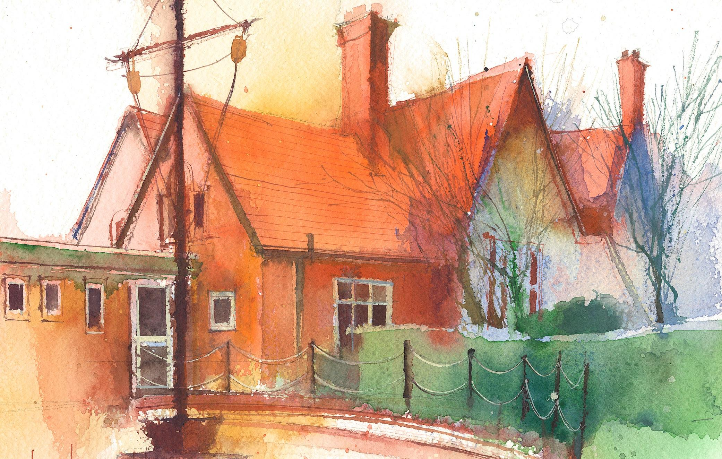
Year 1 Weekly Timetable Week Commencing: 28.11.22
To contact your child’s class teacher, please email schooloffice@dawpool.wirral.sch.uk or phone 0151 648 3412

This timetable is available in the event that a Year 1 pupil is required to self-isolate at home, but the cohort remains open to other pupils.
Please visit the Year 1 Class Page on the school website to access any downloadable resources and activity sheets.

 | Session 1:  09:00 - 09:30  . | Session 2:  09:30 - 10:30 |  | Session 3:  10:45 - 12:10 |  | Session 4:  13:15 - 15:30  (Incorporating 15-minute break)
Monday  28.11 | Rocket Phonics  By the end of this lesson your child should be able to:  - know that when we hear the sound short /oo/, it is sometimes spelled with the letter u  - practise segmenting words that include u as short /oo/  - apply segmenting words that include u as short /oo/ within sentences | English  By the end of this lesson your child should be able to:  -begin to draw inferences from illustrations in The Jolly Postman.  We recommend the following resources and activities to achieve this objective:  Share the illustration of the palace with the children. Who do they think lives here? What is happening? Who might be writing to the people who live here? Share the envelope and address with the children, who do they think are on the stamp? What makes them think that? Where will this be on their map?  Collective Worship |  | Maths  By the end of this lesson your child should be able to:  - be able to make addition stories using correct vocabulary  We recommend the following resources and activities to achieve this objective:  Look at the picture and think about what addition stories they can make. Ask pupils if they can make a story based picture. What would it sound like? What numbers would they use? Encourage them to use the correct vocabulary of aggregation. For example: There are 4 puffins. Another 3 puffins join them. How many puffins are there now? Then ask them what would it look like if they had to write it as a number sentence. Which numbers would they use and what symbols would be included? |  | Rocket Phonics  By the end of this lesson your child should be able to:  - know that when we see the letters u-e in some words, we say /y+oo/  - practise blending words that include u-e as /y+oo/  - apply blending to words that include u-e as /y+oo/ within sentences  Fruit snack and story time
Tuesday  29.11 | Rocket Phonics  By the end of this lesson your child should be able to:  - know that when we hear the sound /y+oo/, it is sometimes spelled with the letters u-e  - practise segmenting words that include u-e as /y+oo/  - apply segmenting words that include u-e as /y+oo/ within sentences | English  By the end of this lesson your child should be able to:  -retell a well known story.  We recommend the following resources and activities to achieve this objective:  -Re-read the story of Cinderella that was delivered by the Jolly Postman. Using pictures, children can create a story map by putting them in the correct order. Once the story map is complet, children will retell the story using their map as a prompt.  -Read the story of goldilocks. Retell as a group and add actions. Children will begin to draw their own story maps. |  | Maths  By the end of this lesson your child should be able to:  - be able to solve addition problems presented in pictorial form.  We recommend the following resources and activities to achieve this objective:  Show pupils the explore task picture. Provide them with cubes or counters in two different colours to represent the hula hoops. Ask them to show you how many hula hoops there are in total. Tell pupils your friend says there are 6 hula hoops in total. Did he count correctly? How can we tell? Ask pupils how many green hula hoops they can see. Write this as part of a number bond diagram for the class. Then ask them how many yellow hula hoops they can see and fill in the other part. Once the diagram has been completed, ask pupils if they can write a number sentence for the parts of the diagram that tell the story of the picture. |  | Dance  (Please keep PE Kit for Wednesdays to save confusion. Our usual PE day will be Wednesday after Christmas.)  Fruit snack and story time  Christmas Play Practise
Wednesday  30.11 | Rocket Phonics  By the end of this lesson your child should be able to:  - know that when we see the letters u-e in some words, we say long /oo/  - practise blending words that include u-e as long /oo/  - apply blending to words that include u-e as long /oo/ within sentences | English  By the end of this lesson your child should be able to:  -Begin to write their own mini book of ‘Goldilcoks and the three bears’  We recommend the following resources and activities to achieve this objective:  Complete own story maps of Goldilocks and the Three Bears and use actions to retell the story.  Write our own mini books of Goldilcoks using the key events of the story. Focus on Capital letters, full stops, finger spaces, using our phonics knowledge. |  | Maths Consolidation  By the end of this lesson your child should be able to:  - be able to apply knowledge of number bonds to solve problems  Give children an equation in their books.  Ask pupils to show multiple ways to solve the equation. They can draw pictures to match the addition sentences they create. How many different ways can they solve it? |  | British Values Assembly  Fruit snack and story time  PE Games / Christmas Practise
Thursday  01.12 | Rocket Phonics  By the end of this lesson your child should be able to:  - know that we when hear the sound long /oo/, it is sometimes spelled with the letters u-e  - practise segmenting words that include u-e as long /oo/  - apply segmenting to words that include u-e as long /oo/ within sentences | English  By the end of this lesson your child should be able to:  -Write their own version of a well known tale.  We recommend the following resources and activities to achieve this objective:  Children will continue to make their own goldilocks story. Remind of full stops, capital letters, finger spaces, using phonics. |  | Maths  By the end of this lesson your child should be able to: understand that subtraction can be done by crossing out or taking away.  We recommend the following resources and activities to achieve this objective:  Show children picture of 8 monkeys swinging on a tree. Three monkeys jump off and now you need to know how many are left on the tree. Ask pupils if they know how many are left and how they worked it out. If a pupil mentions taking away, ask how you would do that on paper (crossing/rubbing it out). Explain that the method we will focus on today is subtracting by crossing out.  Model the problem using a ten frame and also as a written equation. Can also be shown as a number bond. Complete a guided practise together, using different objects and practising subtraction by crossing out. |  | Christmas card designs  Christmas practise  Fruit snack and story time
Friday  02.12 | Rocket Phonics  By the end of this lesson your child should be able to:  - know what when we see the letters ue in some words, we say /y+oo/  - practise blending words that include ue as /y+oo/  - apply blending to words that include ue as /y+oo/ within sentences | Maths  By the end of this lesson your child should be able to:  -understand that subtraction can be done by crossing out or taking away.  We recommend the following resources and activities to achieve this objective:  Recap of subtraction by crossing out.  Children to complete independent worksheet to practise and demonstrate their understanding of subtraction by crossing out. |  | English - SPAG  By the end of this lesson your child should be able to:  - use correct letter formation  - use capital letters for names  We recommend the following resources and activities to achieve this objective:  Activity: Children to write the insert to their Christmas cards |  | RE - Incarnation  By the end of this lesson your child should be able to:  - explain what advent is  - begin to explain the significance of the different advent candles  We recommend the following resources and activities to achieve this objective:  Recap Rev Jane’s visit from previous lesson.  * What can we remember about what happens in church at Christmas?  Introduce the word ‘advent’ (the arrival of something or someone). Explain that the four weeks leading up to Christmas are known as Advent.  * What are we waiting for to arrive? (the birth of Jesus) Christians spend advent waiting and preparing for the celebration of Jesus’ birth.  Look at Advent PowerPoint and introduce some different advent traditions families might have (advent candles, advent calendars, etc)  Show advent wreath PowerPoint and explain that in churches these are displayed - a circle wreath to show that God lasts forever and the four candles to represent the four weeks leading to Christmas with the fifth candle to symbolise the birth of Jesus on Christmas Day. Discuss the significance of the four different candles and their colours  Activity 1: Create coloured advent candles / wreath colouring  Activity 2. Paper plate wreath decorating  Show a coloured candle  * What does this candle represent?  * Can we remember on which week of advent it is lit?  Fruit snack and story time
Additional Tasks/Homework tasks
We also advise your child to complete the following tasks this week:
-Please practise correct formation of all numbers.
-Christmas song practise of our Nativity ‘Mary’s Knitting.’
-Reading and writing words with the new phonics sounds from this week.

