**Mrs Hall Weekly Timetable Week Commencing 25.09.23**

**To contact your child’s class teacher, please email** [**schooloffice@dawpool.wirral.sch.uk**](mailto:schooloffice@dawpool.wirral.sch.uk) **or phone 0151 648 3412**

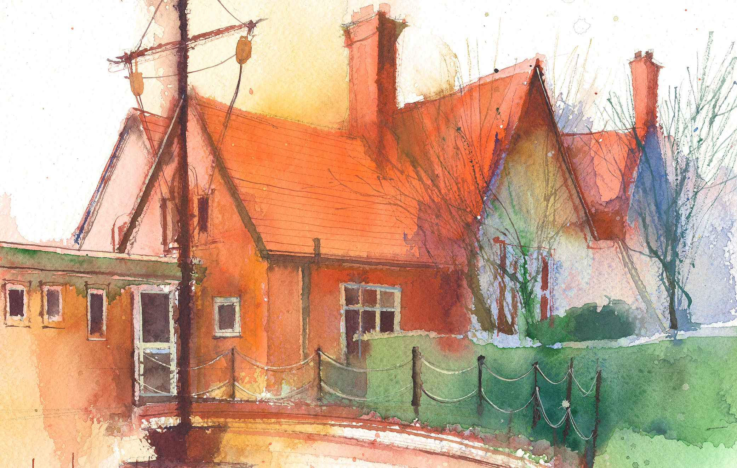

|  |  |  |  |  |  |  |
| --- | --- | --- | --- | --- | --- | --- |
|  | **Lessons 09:00 – 10:30** |  | **Lessons­­­­ 10:45 – 12:15** |  | **Lessons 13:15 – 15:30 (Incorporating 15-minute break)** | **Additional Tasks** |
| **Monday** |  |  |  | Useful Links / Other Recommended Activities  **Oak National Academy**  <https://classroom.thenational.academy/>  **BBC Bitesize**  <https://www.bbc.co.uk/bitesize>  **Purple Mash**  <https://www.purplemash.com/sch/dawpool#/>  **Recommended Reading List**  [See here](https://www.dawpool.wirral.sch.uk/website/recommended_reading_lists/577821) |
| **Tuesday** |  |  |  |
| **Wednesday** |  |  |  |
| **Thursday** | **.** |  |  |
| **Friday** | **Year 2 Phonics**  By the end of this lesson your child should be able to:  **Lesson Focus – Handwriting.**  **To know how to form the letters c, a, d, s, g, o in cursive font.**  **To practise cursive handwriting with words that include these letters.**  **To apply cursive handwriting to sentences that include these letters.**  **Year 2 Heart Smart**  By the end of this lesson your child should be able to:  **Can the children describe ways we can use our power in positive and negative ways?** | **Year 2 Reading Comprehension – Minibeasts in the Garden or Park/ Minibeasts in the Pond**  By the end of this lesson your child should be able to:  **To look and listen to a text about Minibeasts and make inferences from the text. Answer questions about the text.**  **To respond to and answer questions about insects that live in ponds.** | **Year 2 RE**  By the end of this lesson your child should be able to:  **Write a prayer saying thank you for the Harvest. Children write their prayer on a leaf to be hung on a Harvest Prayer Tree.** |