Year 4 Weekly Timetable Week Commencing: 12.01.26
To contact your child’s class teacher, please email schooloffice@dawpool.wirral.sch.uk or phone 0151 648 3412
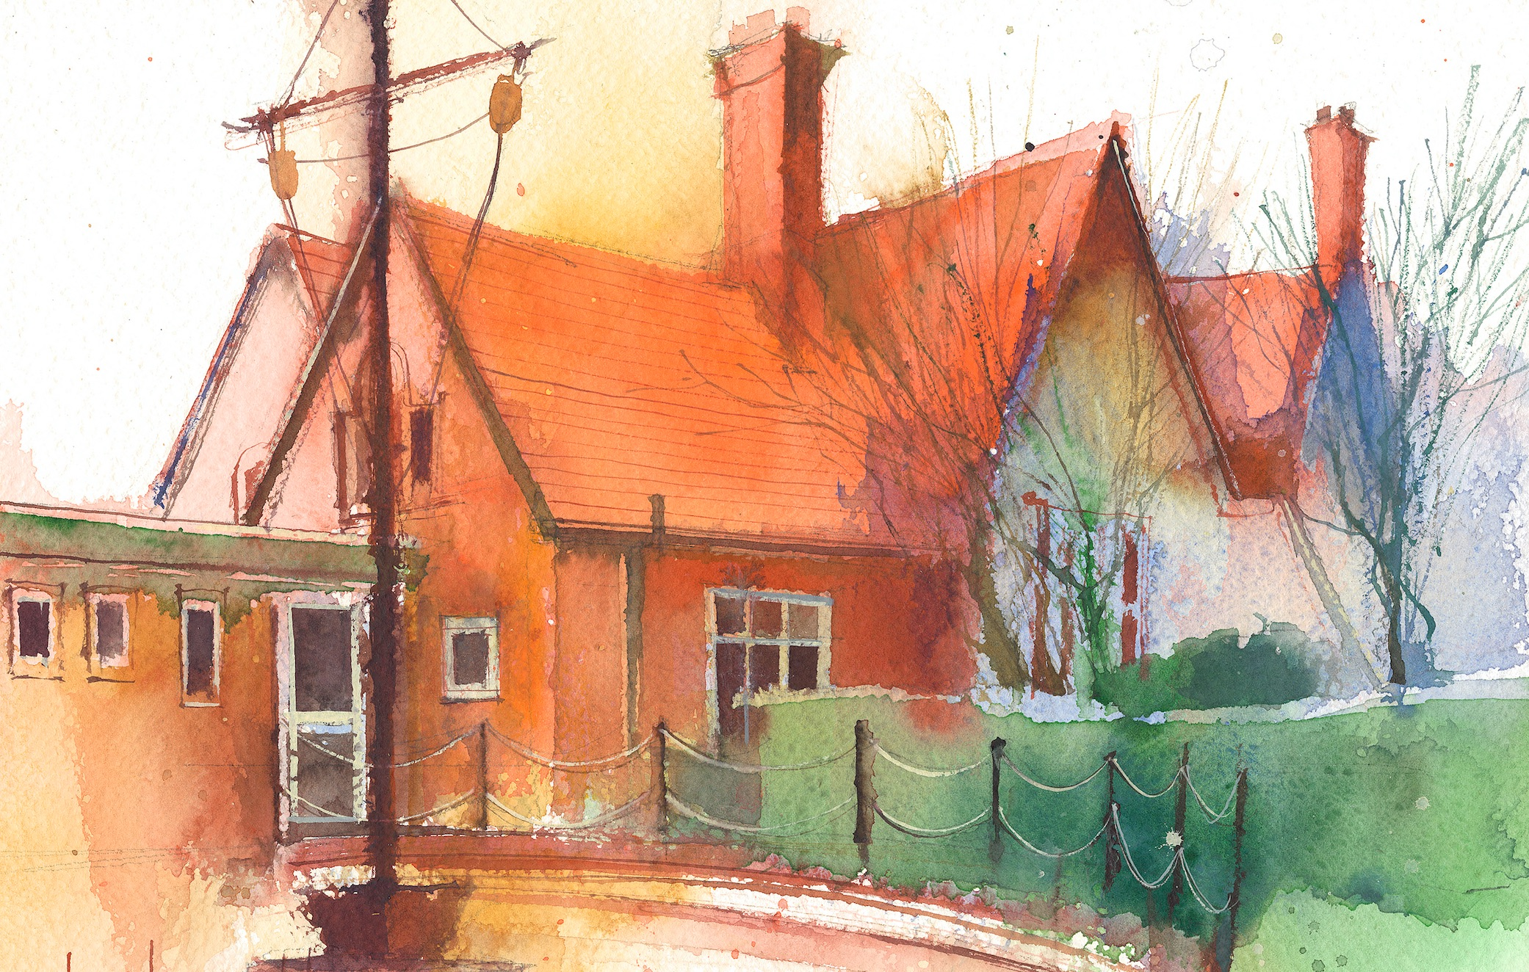

 | Lessons 09:00 – 10:30 |  | Lessons 10:45 – 12:15 |  | Lessons 13:15 – 15:30 (Incorporating 15-minute break) | Additional Tasks
Monday | Maths  Multiplication A-  9 times tables and division facts  Collective Worship 10:10 |  | English- It fell from the sky  To describe a setting  Weekly spellings |  | Computing  Times table Rock Stars | Useful Links / Other Recommended Activities  Oak National Academy  https://classroom.thenational.academy/  BBC Bitesize  https://www.bbc.co.uk/bitesize  Purple Mash  https://www.purplemash.com/sch/dawpool#/  Times table practise:  https://www.timestables.co.uk/multiplication-tables-check/  Hit the button  https://www.topmarks.co.uk/maths-games/hit-the-button
Tuesday | Maths  3, 6 and 9 times tables |  | English  Use evidence in the text to answer written comprehension questions  Class based worship: picture news |  | RE  Exploring Jesus’ power and authority through his words and actions.  Heart Smart  Too much selfie isn’t healthy
Wednesday | Maths  To multiply and divide by 7 |  | Ukulele 11:00- 11:30  English  Write fronted subordinate clauses using conjunction ‘although’ |  | Science- Electricity  I can identify common appliances that run on electricity
Thursday | Sing worship 9:10  Maths  7 times tables and division facts |  | English  To use a range of subordinating conjunctions |  | Geography-  I can explore and explain the layers of the Earth  Comprehension
Friday | Maths  11 times tables and division facts  Celebration worship 10:10 |  | English  To use a range of adverbs |  | Spelling Test 1:15-1:30  PE: 1:30-2:30  Gymnastics  Times Table Practise  Times tables Rock Stars

