**Year 1 Weekly Timetable Week Commencing 14.07.25**

**To contact your child’s class teacher, please email** [**schooloffice@dawpool.wirral.sch.uk**](mailto:schooloffice@dawpool.wirral.sch.uk) **or phone 0151 648 3412**

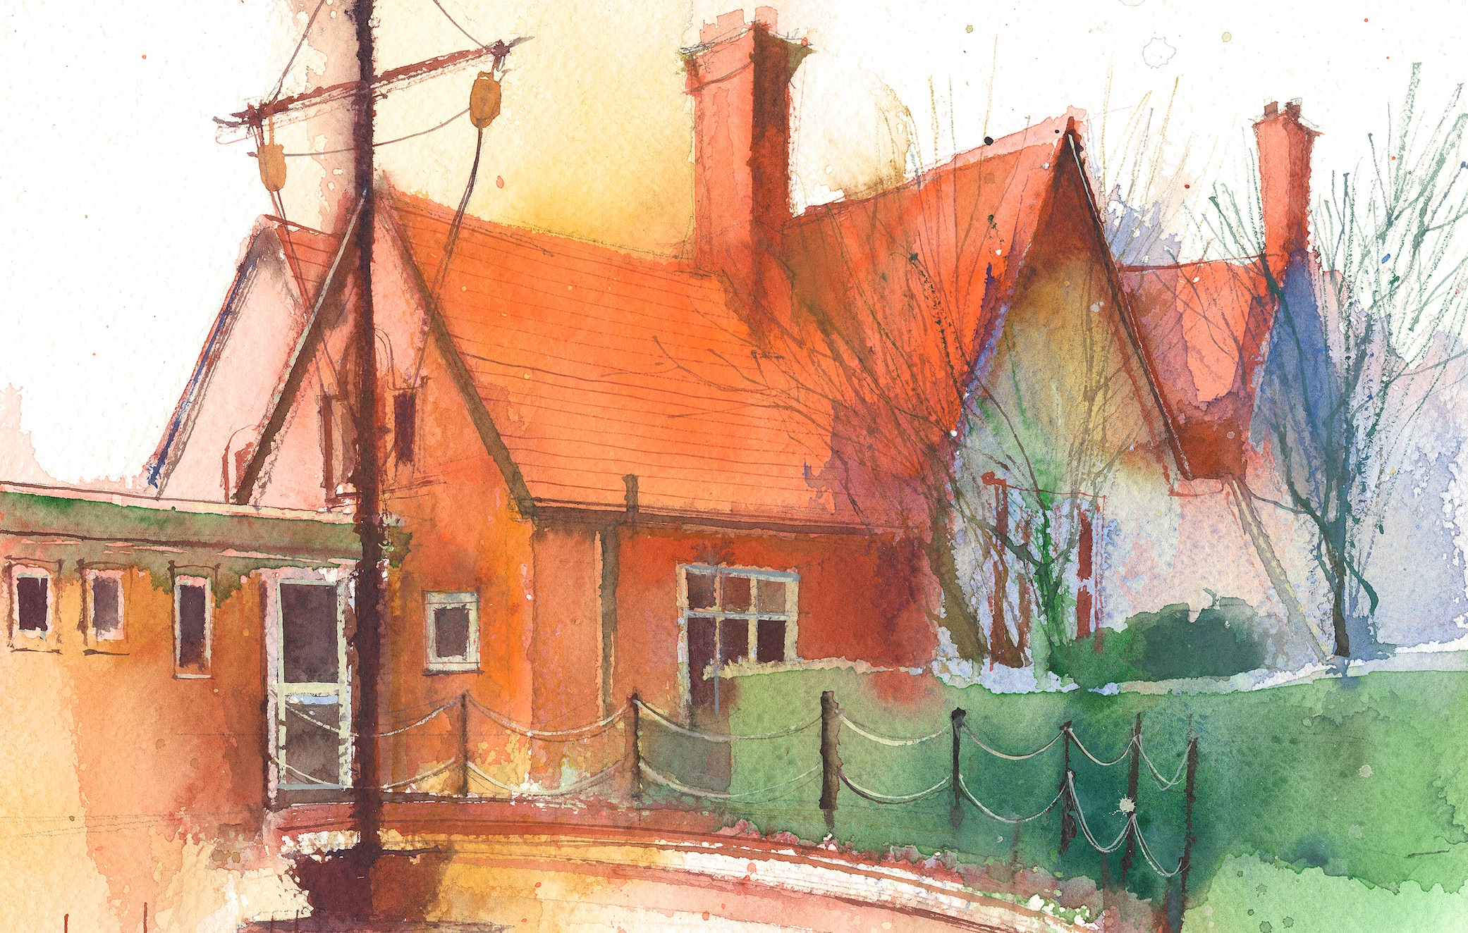

|  |  |  |  |  |  |  |
| --- | --- | --- | --- | --- | --- | --- |
|  | **Lessons 09:00 – 10:30** |  | **Lessons­­­­ 10:45 – 12:15** |  | **Lessons 13:15 – 15:30 (Incorporating 15-minute break)** | **Additional Tasks** |
| **Monday** | **Phonics:** consolidate a  **English:** I can act out the story of the lighthouse keeper’s lunch. | **D&T:** I can draw a picture and write about my favourite snack.  **ERIC / GR** | **Fluent in 5**  **D&T:** I can design a lighthouse keeper’s lunch.  **Computing:** To find and understand examples of where technology is used in the local community.  **Picture news** | Useful Links / Other Recommended Activities  **Oak National Academy**  <https://classroom.thenational.academy/>  **BBC Bitesize**  <https://www.bbc.co.uk/bitesize>  **Purple Mash**  <https://www.purplemash.com/sch/dawpool#/>  **Recommended Reading List**  [See here](https://www.dawpool.wirral.sch.uk/website/recommended_reading_lists/577821) |
| **Tuesday** | **Phonics:** consolidate ti  **D&T:** I can create a lunch for the lighthouse keeper. | **D&T:** I can create a lunch for the lighthouse keeper.  **ERIC / GR** | **Fluent in 5**  **D&T:** I can eat my lighthouse keeper’s lunch.  **Computing:** To record examples of technology outside school.  **My Happy Mind:** Relate |
| **Wednesday** | **Phonics:** consolidate ci  **D&T:** I can evaluate the lunch for the lighthouse keeper. | **D&T:** I can evaluate the lunch for the lighthouse keeper.  **ERIC / GR** | **Fluent in 5**  **PE:**  • The focus of the learning is for pupils to play competitive games against other pupils.  • Pupils will understand how to keep track of their scores and beat their personal best.  • Pupils will learn how to play fairly and listen to instructions.  **No Outsiders** |
| **Thursday** | **Phonics:** consolidate ssi  **Art:** Exploring patterns with shells. | **Maths:** I can play ‘shop’ and use money correctly.  **ERIC / GR** | **Fluent in 5**  **Art:** with Mrs Young in Year 2.  **Heartsmart:** No way through isn’t true. |
| **Friday** |  | **See Mrs Clark’s Planning** |  |