**Week 3 Year 5 Weekly Plan: 29.09.2025 03.10.2025**

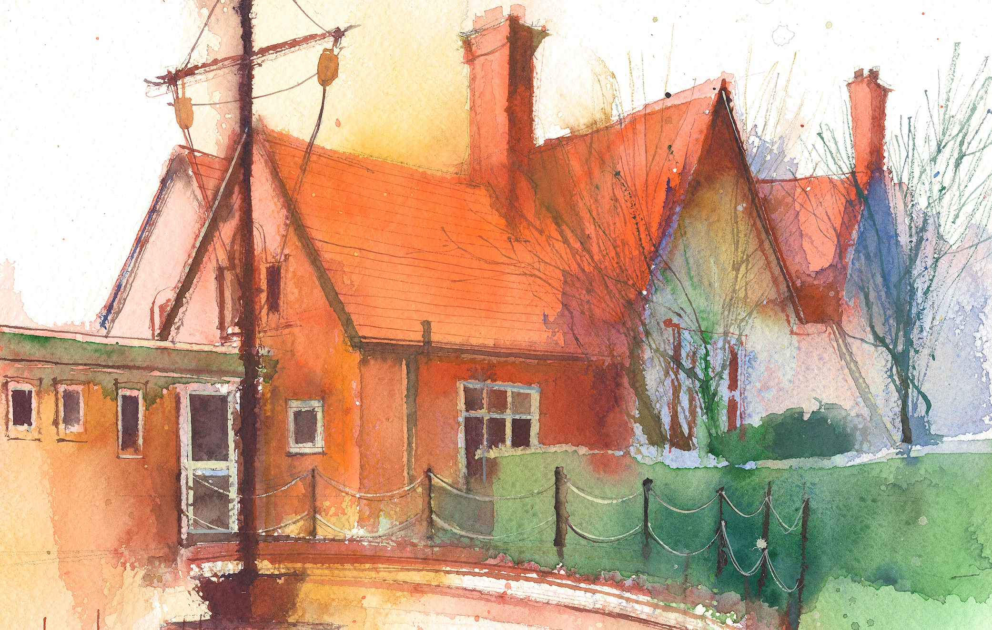

**To contact your child’s class teacher, please email** [**schooloffice@dawpool.wirral.sch.uk**](mailto:schooloffice@dawpool.wirral.sch.uk) **or phone 0151 648 3412**

|  |  |  |  |  |  |  |
| --- | --- | --- | --- | --- | --- | --- |
|  | **Lessons 09:00 - 10:30** |  | **Lessons­­­­ 10:45 - 12:15** |  | **Lessons 13:15 - 15:30**  **(Incorporating 15-minute break)** | **Additional Tasks** |
| **Monday**  **29/09/25** | **Maths**  **Fluent in Five**  **Rapid Reasoning**  **Arithmetic**  By the end of this lesson your child should be able to:   * To demonstrate fluency in key mathematical concepts as part of the fluent in five and rapid reasoning tasks. * To develop increasing accuracy in weekly arithmetic tasks. | **Reading Assessment**  **HeartSmart (Continued)**  By the end of this lesson your child should be able to:   * Research Richard the Lionheart then describe what ‘heart’ reputation they would want to have. | **Music**  By the end of this lesson your child should be able to:  begin to recognise the basic style indicators of Classic Rock music.  **Power of Reading.**    By the end of this lesson your child should be able to: finish their practise of the Baucis and Philemon Playscripts before tomorrow’s performance | Cross country, Birkenhead Park |
| **Tuesday**  **30/9/25** | **Maths**  Fluent in five/ Rapid Reasoning  By the end of this lesson your child should be able to: **Maths Assessment** |  | **Power of Reading**  By the end of this lesson your child should be able to: produce, collaborate and act out the play Baucis and Philemon in their group of 6 |  | **PE**  We will be doing Athletics with Mr. Roberts till half term  **Topic**  The children will finish their Ancient Greek timeline  **Picture news, British Values** | . |
| **Wednesday**  **01/10/25** | **Maths to**  Fluent in five/ Rapid Reasoning  By the end of this lesson your child should be able to: understand the relationship between numbers in different columns. Lesson 6 |  | **Power of reading**  By the end of this lesson your child should be able to: using their work from acting out a play, the children will use a scaffold to write their own play script based on the story of the Odysseus and Cyclops.  **Spelling Assessment** |  | **Topic/Art**  By the end of this lesson your child should be able to: be introduced  to Greek art, including the pottery and the designs and patterns made on pots and vases. Also to look at the architecture. that we can see in Liverpool that has many Greek columns similar to the Parthenon.  **Handwriting** | Staff Meeting/Chess |
| **Thursday**  **02/10/25** | Fluent in five/ Rapid Reasoning  **Music**  **9.00 -9.30 KS1 Singing**  **Maths**  By the end of this lesson your child should be able to: know how to find 10,100,1,000, 10,000,100,000 more or less than any number. Lesson 7 |  | **Power of Reading**    By the end of this lesson your child should be able: to: finish and read out loud their playscript to a partner. |  | **Science**  By the end of this lesson your child should be able to: know Earth, Sun and Moon facts and the phases of the moon.  **Handwriting** | School Photos |
| **Friday**  **03/10/25** | **Maths**  Fluent in five/ Rapid Reasoning  By the end of this lesson your child should be able to: know how to partition numbers up to 1,000,000, lesson 8 |  | **English**  By the end of this lesson your child should be able to:  do their spelling test on suffix words and then finish their Cyclops playscript. |  | **SPAG**  By the end of this lesson your child should be able to: understand verbs and verb tenses, Unit 3 Nelson Grammar  **RE**  By the end of this lesson your child should be able to: understand about the bible unit 5.1 the bible, Questful RE.. | **Celebration of weeks work** |