Foundation 2 Weekly Timetable Week Commencing 14.12.21
To contact your child’s class teacher, please email schooloffice@dawpool.wirral.sch.uk or phone 0151 648 3412
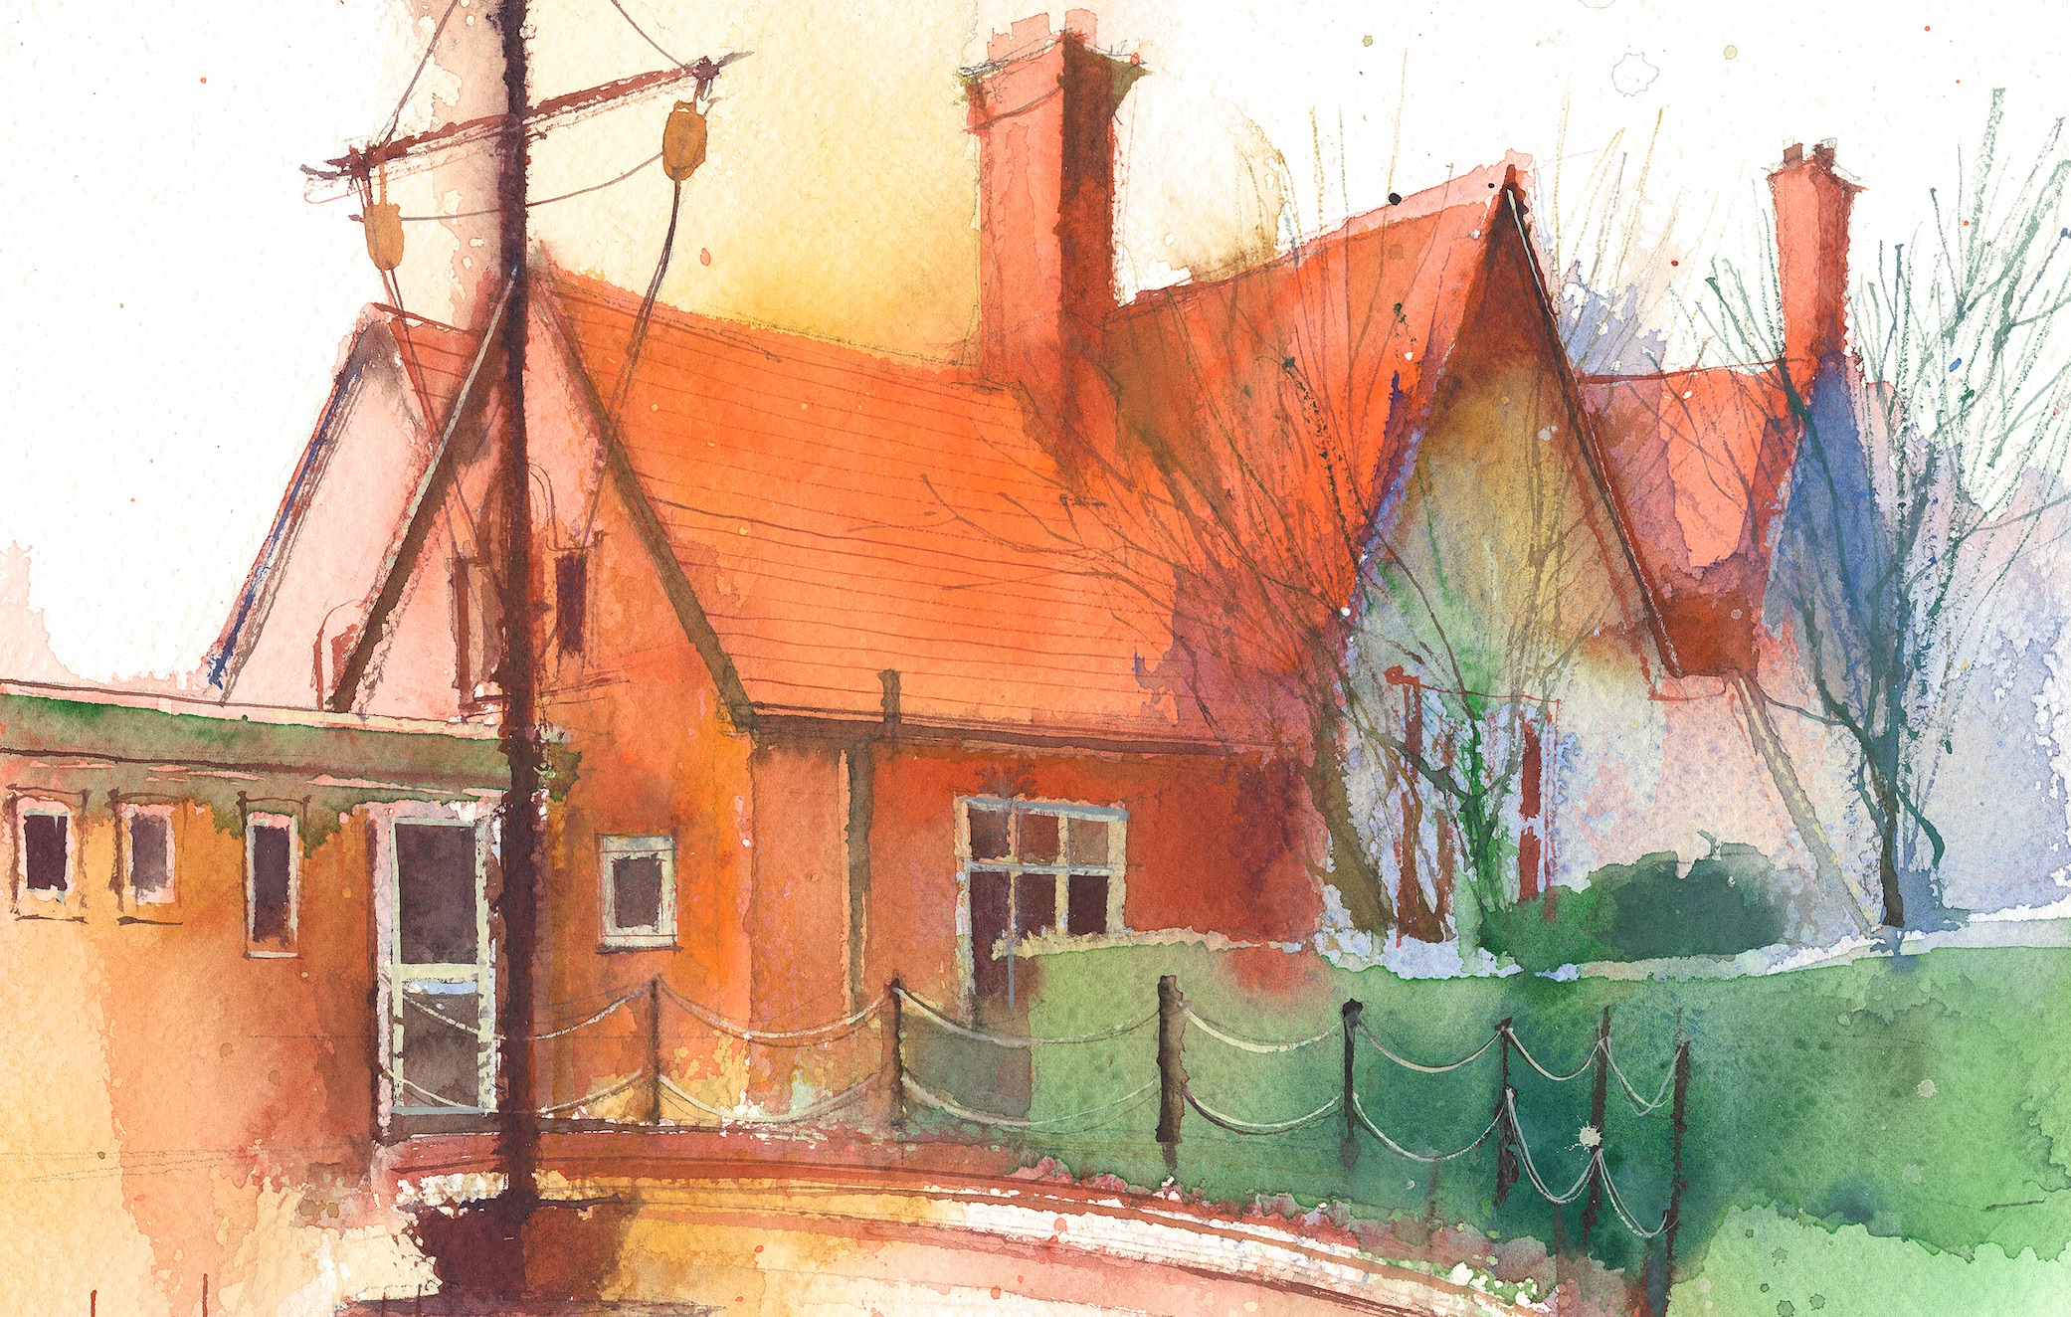

This timetable is available in the event that a Foundation 2 pupil is required to self-isolate at home, but the cohort remains open to other pupils.
Please visit the Foundation 2 Remote Learning Page on the school website to access any downloadable resources and activity sheets.

 | Session 1: 09:00-10:30 |  | Session 2: 10:50 – 12:00 |  | Session 3: 13:15 – 15:25 (Incorporating 15-minute break) | Additional Tasks
Monday  13/12/21 | Phonics  By the end of this lesson your child should be able to:  Re-cap on Phase 2 phonemes, graphemes and tricky words  We recommend the following resources and activities to achieve this objective:  Re-cap on Phase 2 Sounds and Tricky Words  Sing the Alphabet Song  Letter Formation Practice |  | RE  By the end of this lesson your child should be able to:  We recommend the following resources and activities to achieve this objective: |  | Heart Smart  By the end of this lesson your child should be able to:  We recommend the following resources and activities to achieve this objective: | We also advise your child to complete the following tasks this week:  Phonics 1  Practice writing the sounds on the whiteboards.  Phonics 2  Guided Read Groups  Topic 1  Make reindeer tree decorations.  Topic 2  Christmas baking.
Tuesday  14/12/21 | Phonics  By the end of this lesson your child should be able to:  Re-cap on Phase 2 phonemes, graphemes and tricky words  We recommend the following resources and activities to achieve this objective:  Re-cap on Phase 2 Sounds and Tricky Words  Sing the Alphabet Song  Practice Writing Phase 2 Tricky Words |  | Maths  By the end of this lesson your child should be able to:  *To form the numbers 0-5  We recommend the following resources and activities to achieve this objective:  Re-cap on number to 5.  I will say a number, can they write it on their boards?  I will hold up some objects. Can they count and write that number on their boards?  Can they write numbers 0-5 in the correct order? |  | PE  By the end of this lesson your child should be able to:  * To move their bodies appropriately to music.  We recommend the following resources and activities to achieve this objective:  Zumba with Claremont Specialist Sports College.  Listen to a variety of different pieces of music.  Can they march to the beat?  Can they follow a sequence of moves?  Can they connect these moves together?  Can they talk about how their bodies feel after exercise?  What changes can they notice and discuss?
Wednesday  15/12/21 | Phonics  By the end of this lesson your child should be able to:  Re-cap on Phase 2 phonemes, graphemes and tricky words  We recommend the following resources and activities to achieve this objective:  Re-cap on Phase 2 Sounds and Tricky Words  Sing the Alphabet Song  Look at Phoneme Frames  Can we practice writing words in a phoneme frame? Make sure to put one unit of sound in each frame.  e.g.  c-a-t  s-o-ck |  | Christmas Production |  | Christmas Production
Thursday  16/12/21 | Phonics  By the end of this lesson your child should be able to:  Re-cap on Phase 2 phonemes, graphemes and tricky words  We recommend the following resources and activities to achieve this objective:  Re-cap on Phase 2 Sounds and Tricky Words  Sing the Alphabet Song  Word and Picture match.  Read the words. Can they find the correct picture to match it? |  | Personal, Social and Emotional Development  By the end of this lesson your child should be able to:  To learn poems, rhymes and songs  We recommend the following resources and activities to achieve this objective:  What is in the treasure chest today?  I will open it up to show the book ‘The Night Before Christmas’.  I will explain that this is a poem, not a story. Can they spot the rhyming words as I get to them?  Stop and discuss the poem at regular intervals.  Can they think of new rhyming words to add to the poem? |  | Personal, Social and Emotional Development  By the end of this lesson your child should be able to:  To work and play co-operatively with others.  We recommend the following resources and activities to achieve this objective:  Christmas Baking
Friday  17/12/21 | Christmas Party Day |  | Christmas Party Day |  | Christmas Party Day

