Year 4 Weekly Timetable Week Commencing 11.01.21
To contact your child’s class teacher, please email year4@dawpool.wirral.sch.uk
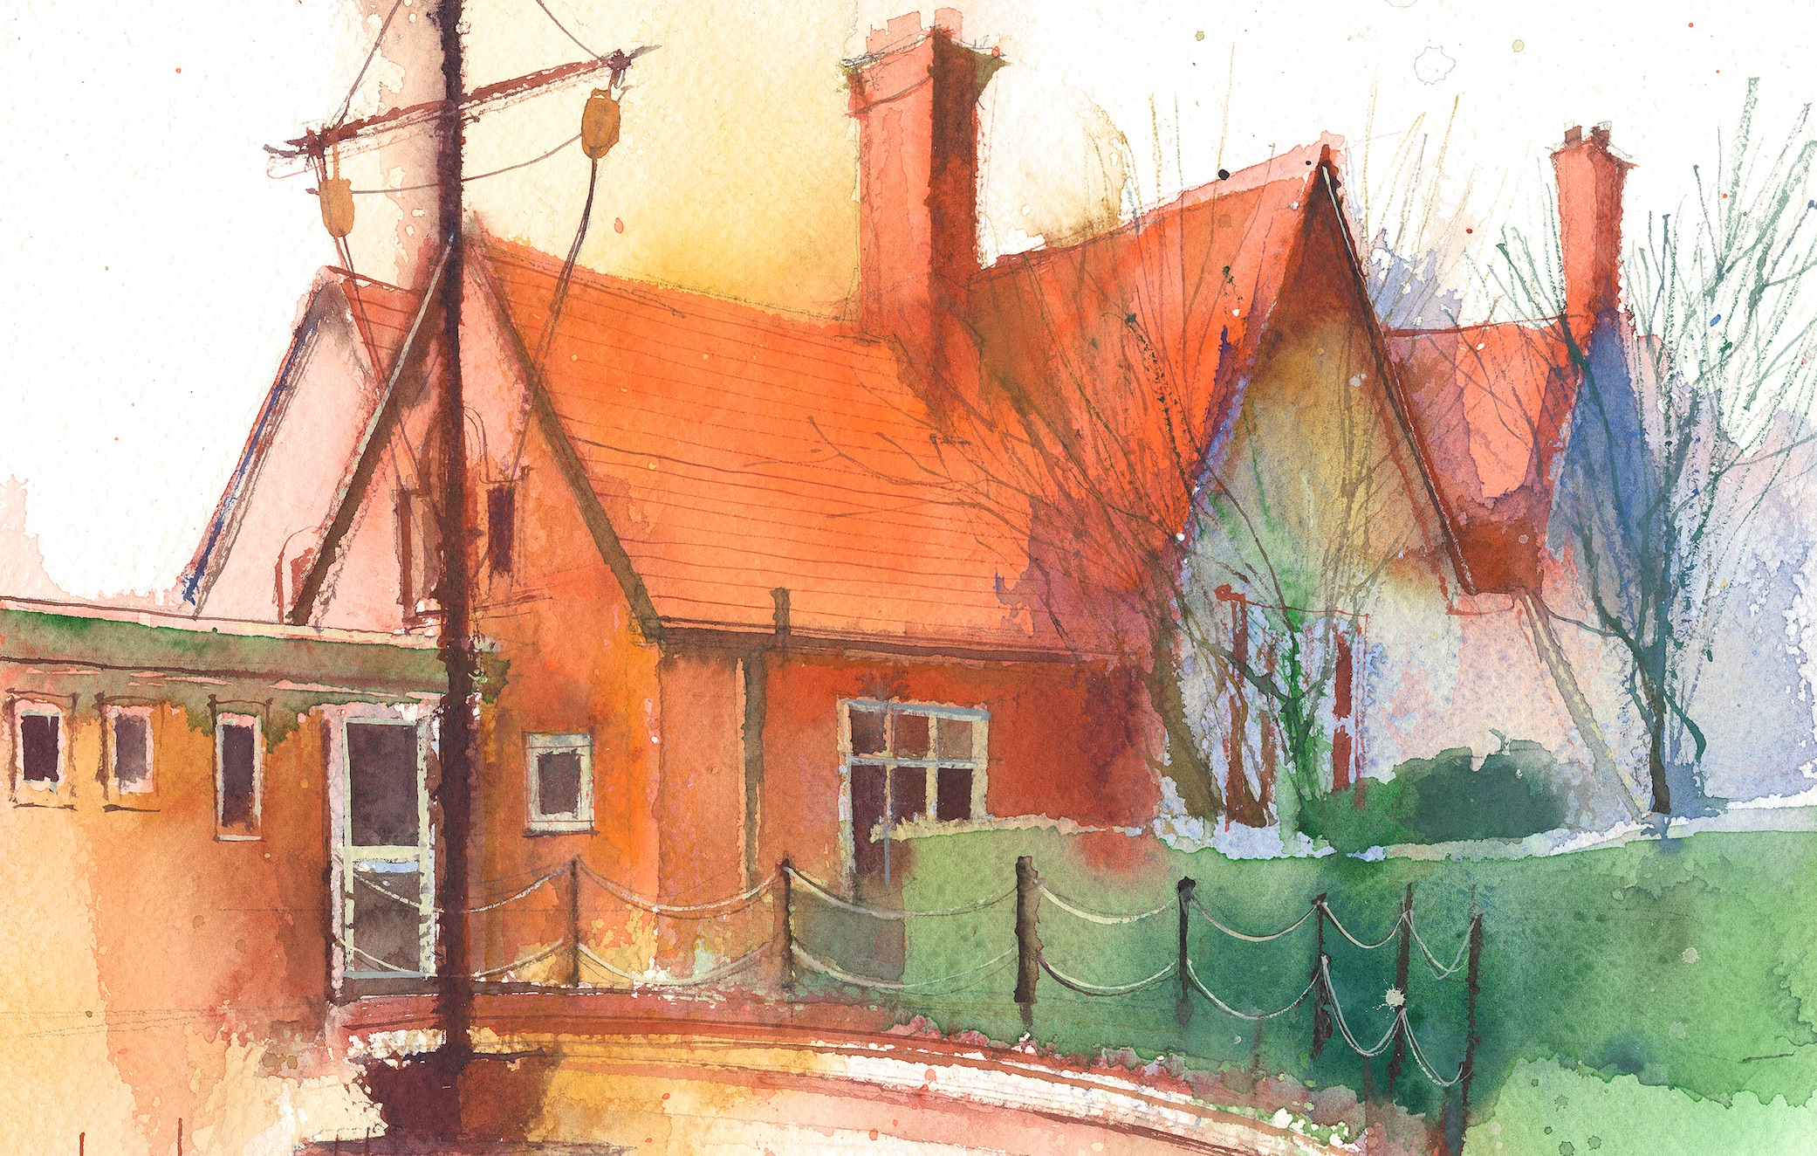

This timetable is available in the event that all Year 4 pupils are required to self-isolate at home. Please visit the Year 4 Remote Learning Page to
access any downloadable resources and activity sheets. The assessed task should be submitted to the teacher at the end of each day via Purple Mash.

 | Session 1: 09:00-10:30 |  | Session 2:10:45 – 12:15 |  | Session 3: 13:15 – 15:30 (Incorporating 15-minute break) | Assessed Task
Monday  11.01.21 | SUBJECT (Maths)  By the end of this lesson your child should be able to:  Use a range of written methods to multiply a 2-digit and a 1-digit number  We recommend the following resources and activities to achieve this objective:  Third Space Lesson slide 5  Worksheet 5  Section 1 Confidence builder  Section 2 Confident  Section 3 Very confident  (Can do all sections three sections if you wish)  Also try :  Rapid reasoning Week 32 Day 1  Fluent in 5 Week 32 day 1 |  | SUBJECT (Literacy)  By the end of this lesson your child should be able to:  Describe what a simile and a metaphor is  We recommend the following resources and activities to achieve this objective:  BBC Bitesize  Twinkl activities (see eschools) |  | SUBJECT(s)  Art  By the end of this lesson your child should be able to:  Understand how the Romans used Mosaic art to express their culture and religion.  We recommend the following resources and activities to achieve this objective:  Look at Powerpoint  Create your own Mosaic using Purple Mash  Twinkl Powerpoint  Purple Mash activity | Login to Purple Mash to submit today’s assessed task:  Open Mosaic activity from “TO DOS” and when completed submit to Mr G
Tuesday  12.01.21 | SUBJECT  By the end of this lesson your child should be able to:  To use a range of written methods to multiply a 2-digit and a 1-digit number  We recommend the following resources and activities to achieve this objective:  Third Space Lesson slide 6 Worksheet 6  Section 1 Confidence builder  Section 2 Confident  Section 3 Very confident  (Can do all sections three sections if you wish)  Also try:  Rapid reasoning Week 32 Day 2  Fluent in 5 Week 32 day 2 |  | SUBJECT  By the end of this lesson your child should be able to:  Answer the question “What is onomatopoeia?”  We recommend the following resources and activities to achieve this objective:  Twinkl Powerpoint  BBC Bitesize  Twinkl worksheet |  | SUBJECT(s)  By the end of this lesson your child should be able to:  Answer the question “How did the Roman Empire become so powerful?”  We recommend the following resources and activities to achieve this objective:  Oak Academy  Purple Mash | Go to the “TODOS” section of Purple Mash  and complete the assignment and submit to Mr G
Wednesday  13.01.21 | SUBJECT  By the end of this lesson your child should be able to:  To know how to multiply a 3-digit number by a 1-digit number  We recommend the following resources and activities to achieve this objective:  Third Space learning slide lesson 7  Lesson 7 Worksheet  Section 1 Confidence builder  Section 2 Confident  Section 3 Very confident  (Can do all sections three sections if you wish)  Also try:  Rapid reasoning Week 32 Day 3  Fluent in 5 Week 32 day 3 |  | SUBJECT  By the end of this lesson your child should be able to:  Understand and respond to questions about the story of Romulus and Remus  We recommend the following resources and activities to achieve this objective:  Twinkl Powerpoint |  | SUBJECT(s)  By the end of this lesson your child should be able to:  Illustrate how particles behave inside solids liquids and gases  We recommend the following resources and activities to achieve this objective:  Watch the video  Oak online learning  Paper or Purple Mash | Purple Mash Solids, liquids, gases activity  See TODOS for details
Thursday  14.01.21 | SUBJECT Maths  By the end of this lesson your child should be able to:  To know how to divide a 2-digit number by a 1-digit number  We recommend the following resources and activities to achieve this objective:  Third Space Lesson 8  Worksheet 8  Section 1 Confidence builder  Section 2 Confident  Section 3 Very confident  (Can do all sections three sections if you wish)  Also try:  Rapid reasoning Week 32 Day 4  Fluent in 5 Week 32 day 4 |  | SUBJECT Spellings  By the end of this lesson your child should be able to:  Learn how to spell key words from the year 4 spelling list  We recommend the following resources and activities to achieve this objective:  Oak Academy |  | SUBJECT(s) P.E.  By the end of this lesson your child should be able to:  Carry out some physical activity. | Complete the spellings from your TODO activities. These are based on today’s spelling lesson
Friday  15.01.21 | SUBJECT  By the end of this lesson your child should be able to:  To know how to divide a 2-digit number by a 1-digit number with remainders  We recommend the following resources and activities to achieve this objective:  Third Space Lesson 9  Worksheet 9  Section 1 Confidence builder  Section 2 Confident  Section 3 Very confident  (Can do all sections three sections if you wish)  Also try:  Rapid reasoning Week 32 Day 5  Fluent in 5 Week 32 day 5 |  | SUBJECT Reading  By the end of this lesson your child should be able to:  Read chapter 3 of “A Bridge on fire” and respond to the chapter  We recommend the following resources and activities to achieve this objective:  See TODOS in Purple Mash |  | SUBJECT(s)  By the end of this lesson your child should be able to:  Enter comments on the class blog and review learning for the week  We recommend the following resources and activities to achieve this objective: | Responses from the chapter to be submitted to Mr G via TODOS  And entries to our class blog to review the week
Additional Tasks

We also advise your child to complete the following tasks this week:
Practise times table on Purple Mash

