Year 6 Weekly Timetable Week Commencing 13.04.26
To contact your child’s class teacher, please email schooloffice@dawpool.wirral.sch.uk or phone 0151 648 3412
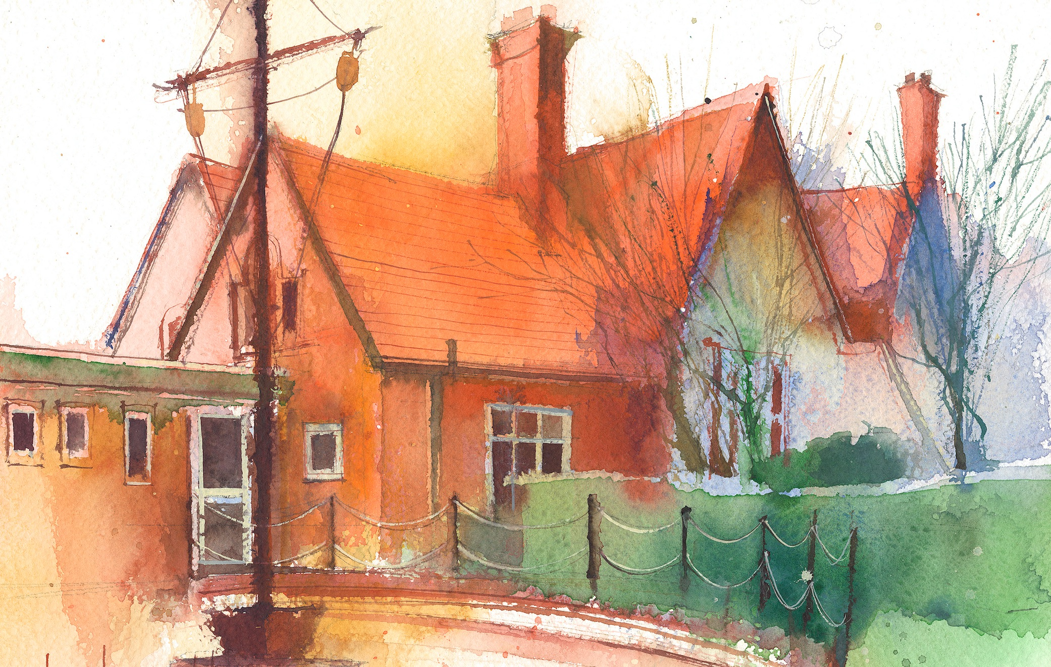

Mrs Croft Monday – Friday

 | Lessons 09:00 – 10:30 |  | Lessons 10:45 – 12:15 |  | Lessons 13:15 – 15:30  (Incorporating 15-minute break) | Additional Tasks
Monday | Fluent in Five/Rapid Reasoning and Arithmetic  Objective:  - To improve mental and written arithmetic strategies and algorithms within a timed period.  Maths  Objective:  - I can explore shapes with the same perimeter. |  | English:  Objectives:  - I can use a range of subordinate clauses.  - I can check the non-negotiables of spelling, punctuation and Capital letters. |  | Geography:  Objective:  - I can locate the continent of North America and use to locate and label countries and capital cities.  Heartsmart:  Objective:  - I can explore fake is a mistake and what it means to be my true self. | - Create a fact file on a country in North America of your choice.  - Write a postcard from New York home.  - Draw your own New York skyline
Tuesday | Fluent in Five/Rapid Reasoning and Arithmetic  Objective:  1To improve mental and written arithmetic strategies and algorithms within a timed period.  Maths  Objective:  - I can explore both area and perimeter. |  | English: Narrative  Objectives:  - I can use figurative language  - I can write a setting description.  - I can check the non-negotiables of spelling, punctuation and Capital letters. |  | Science: Living things and their habitats  Objectives  - I can classify plants and animals and record in a table  - I can sort plants and animals based on their observable characteristics.
Wednesday | Fluent in Five/Rapid Reasoning and Arithmetic  Objective:  - To improve mental and written arithmetic strategies and algorithms within a timed period.  Maths  Objective:  - I can find the area of a triangle by counting squares. |  | English: Narrative  Objectives:  - I can write a persuasive letter.  - I can use a dash.  - I can check the non-negotiables of spelling, punctuation and Capital letters. |  | PPA – Mrs Croft  Mrs McCann RE/Computing
Thursday | Fluent in Five/Rapid Reasoning and Arithmetic  Objective:  - To improve mental and written arithmetic strategies and algorithms within a timed period.  Maths  Objective:  I can find the area of a right-angled triangle. |  | English: Narrative  Objectives:  - I can use speech to convey character and advance action.  - I can check the non-negotiables of spelling, punctuation and Capital letters. |  | PE: Specialist teacher from Claremount  Music:  Objectives:  - I can listen and appraise a range of songs exploring the theme of individuality.
Friday | Fluent in Five/Rapid Reasoning and Arithmetic  Objective:  1.To improve mental and written arithmetic strategies and algorithms within a timed period.  Maths  Objective:  - I can find the area of any triangle. |  | English – Non-fiction  Objectives:  - I can use passive voice.  - I can write a diary entry.  - I can use embedded relative clauses. |  | Art  Objective:  - I can explore the artwork of Claude Monet.  Spanish:  Objective:  - I can understand new nouns and use them to play a game.

