Foundation 2 Weekly Timetable Week Commencing 05.12.22
To contact your child’s class teacher, please email schooloffice@dawpool.wirral.sch.uk or phone 0151 648 3412
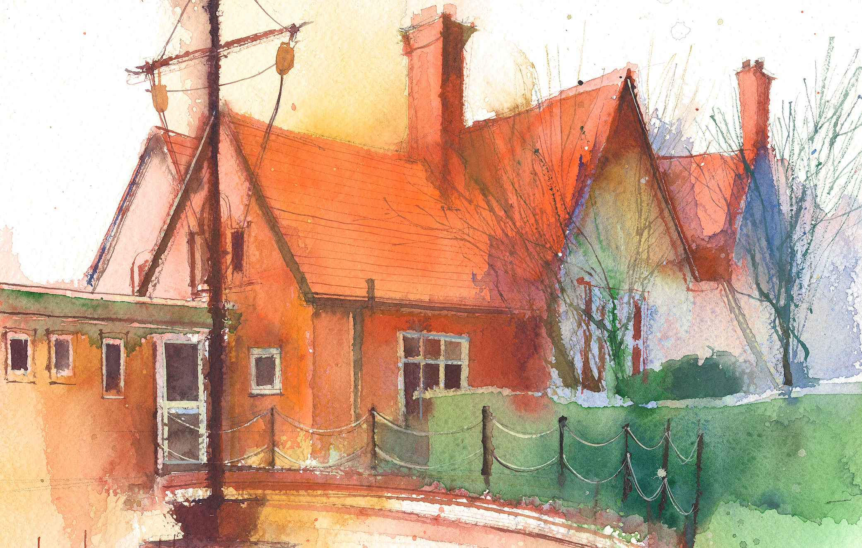

This timetable is available in the event that a Foundation 2 pupil is required to self-isolate at home, but the cohort remains open to other pupils.
Please visit the Foundation 2 Remote Learning Page on the school website to access any downloadable resources and activity sheets.

 | Session 1: 09:00-10:30 |  | Session 2: 10:50 – 12:00 |  | Session 3: 13:15 – 15:25
Monday  05/12/22 | Phonics  By the end of this lesson your child should be able to:  Recognise and say the sound ‘ll’ as a single sound  We recommend the following resources and activities to achieve this objective:  Blending practice.  Children will complete activities in their individual rocket phonics workbooks.  (Week 11) |  | Maths  By the end of this lesson your child should be able to:  To understand the composition of the number 6  We recommend the following resources and activities to achieve this objective:  Watch Numberblocks – Six.  Pause the episode at different points and discuss the things they see.  Focus on what Number 6 looks like, what images you can see in each scene and how they make number 6. |  | Topic  During the afternoons we will undertake activities linked to all areas of the Early Years Curriculum;  Prime Areas; Communication and Language;  Personal, Social and Emotional Development;  Physical Development.  Specific Areas; Literacy, Maths, Understanding the World and Expressive Arts and Design.  Afternoon sessions will also include RE, HeartSmart and Forest Schools.  Activities will be linked to our class topic which is ‘Where in the World’. We aim to use children’s films as a hook for learning to help us find out more about the world around us. Throughout the year we will select films that enable us to cover all requirements of the Early Years Curriculum.  We will talk about where the film is set and find out where this country is on a map. We will then the theme of the film as a way of guiding our planning.  PLEASE NOTE  The very nature of the EYFS curriculum enables us to go with the interests of the children. The activities we plan are for a guide only.  Staff can use and adapt activities or add additional activities and not cover others. It is all dependent on how and where the children’s interests take us.  Activities are designed to cover several weeks, if needed.  A copy of the current topic plan is available to view on the class website page.
Tuesday  06/12/22 | Phonics  By the end of this lesson your child should be able to:  Recognise and write the sound ‘ll’  We recommend the following resources and activities to achieve this objective:  Segmenting practice.  Children will complete activities in their individual rocket phonics workbooks. |  | Maths  By the end of this lesson your child should be able to:  Addition. To see that a number increases when you add 1 more.  We recommend the following resources and activities to achieve this objective:  In numberblocks number 5 and number 1 joined together to make 6. 5+1=6  Are there any other ways of making 6?  Give all children sets of 6 cubes. Can they break up the cubes to find new ways of making 6?
Wednesday  07/12/22 | Phonics  By the end of this lesson your child should be able to:  Recognise and say the sound ‘ss’ as a single sound  We recommend the following resources and activities to achieve this objective:  Blending practice  Children will complete activities in their individual rocket phonics workbooks. |  | Maths  By the end of this lesson your child should be able to:  To develop a basic understanding of time.  We recommend the following resources and activities to achieve this objective:  In Numberblocks, Number 6 is made up of different parts of a dice.  Look at a picture of Number 6, do they know which number each part of him represents? How do they know?  Sit the children in a large circle and in the middle I will roll the jumbo dice. What number is represented? Can they do that many jumps/claps/hops? Repeat several times
Thursday  08/12/22 | Phonics  By the end of this lesson your child should be able to:  Recognise and write the sound ‘ss’  We recommend the following resources and activities to achieve this objective:  Segmenting practice  Children will complete activities in their individual rocket phonics workbooks. |  | Maths  By the end of this lesson your child should be able to:  To develop a basic understanding of time.  We recommend the following resources and activities to achieve this objective:  Re-cap on yesterdays lesson  In numberblocks number 5 and number 1 joined together to make 6. 5+1=6  Are there any other ways of making 6?  Give all children sets of 6 cubes. Can they break up the cubes to find new ways of making 6?
Friday  09/12/22 | PE  By the end of this lesson your child should be able to:  Revise and refine fundamental movement skills already acquired.  We recommend the following resources and activities to achieve this objective:  During this half term the children will use the hall space to undertake games and activities that require them to roll, crawl, walk, jump, run, hop, skip and climb.  Children will also learn to stop and change directions safely. |  | Phonics  By the end of this lesson your child should be able to:  To consolidate learning of the sounds satipnmdgockeurhbfffl and CEW ‘I, the, to, go, no, into’.  To practice writing the CEW ‘no’  We recommend the following resources and activities to achieve this objective:  Children will complete activities in their individual rocket phonics workbooks.

