Year 2 Weekly Timetable Week Commencing 18.01.21
To contact your child’s class teacher, please email year2@dawpool.wirral.sch.uk
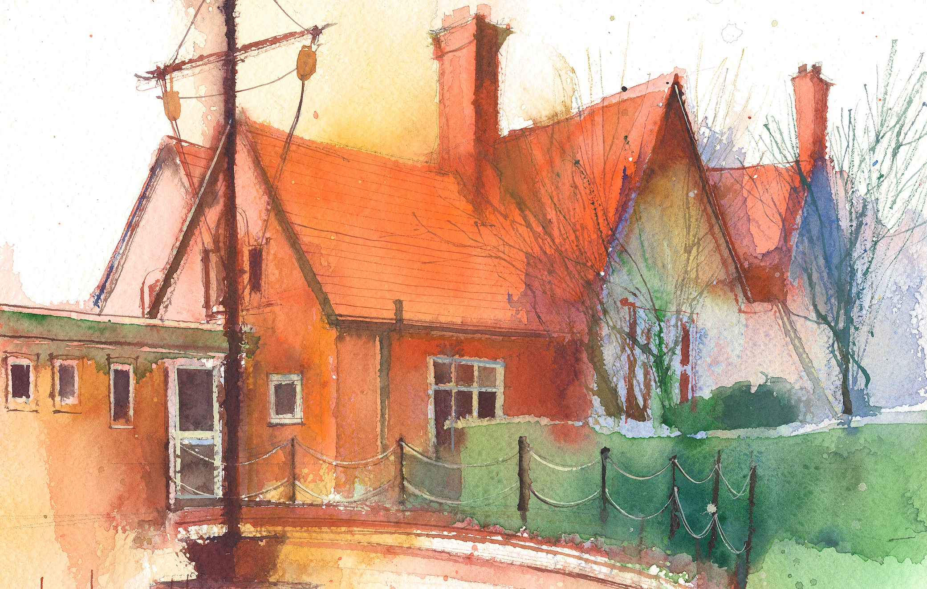

This timetable is available in the event that all Year 2 pupils are required to learn at home. Please visit the Year 2 Remote Learning Page to
access any downloadable resources and activity sheets. The assessed task should be submitted to the teacher at the end of each day via Purple Mash.

 | Session 1: 09:00-10:30 |  | Session 2:10:45 – 12:15 |  | Session 3: 13:15 – 15:30 (Incorporating 15-minute break) | Assessed task
Monday  18.01.21 | Grammar  By the end of this lesson your child should be able to: Understand the use of an apostrophe to represent missing letters in a word. Eg it’s. Know that these words are called contractions.  We recommend the following resources and activities to achieve this objective: https://www.youtube.com/watch?v=5xE-vw2ctqo  Click on the link above and watch the Jack Hartness video on contractions.  https://www.youtube.com/watch?v=OyI8xH2CXsw Click to watch the video on apostrophes.  I have attached a sheet on contractions to complete. You can write them yourself if you do not wish to print the sheet. Challenge- I have also attached a booklet about contractions using an apostrophe.  I have attached a powerpoint if you should require further explanation of using an apostrophe to shorten a word. |  | Maths  By the end of this lesson your child should be able to: understand what an array is and use it to work out a multiplication equation.  We recommend the following resources and activities to achieve this objective: I have attached a lesson plan and a video to watch from Oak academy which explains this concept. Please start with the lesson plan. https://classroom.thenational.academy/lessons/to-explore-arrays-part-1-6mvkcd?activity=video&step=1 |  | History  By the end of this lesson your child should be able to: Understand that we have knowledge of the Great Fire of London because of Samuel Pepys diary and how he described what happened.  We recommend the following resources and activities to achieve this objective: Watch the Magic Grandad Great fire of London video from the link below.  https://www.youtube.com/watch?v=VarSSAwiimU  Can you find out about Samuel Pepys. Why was he an important person in history? | Login to Purple Mash to submit today’s assessed task:  On our History blog write and tell me any facts you have found out about Samuel Pepys.
Tuesday  19.01.21 | English-writing  By the end of this lesson your child should be able to: Generate ideas for descriptive writing.  We recommend the following resources and activities to achieve this objective: Read the story of Vlad and the Great Fire of London (attached). Then watch the two attached videos.  https://www.youtube.com/watch?v=SPY-hr-8-M0 https://www.youtube.com/watch?v=Er3GKw8Z3R4  Can you imagine that you are Vlad and think about how he felt being in the middle of a fire? I have attached a sheet that will help you to focus on what you would see, hear, smell and touch. Think of as many words as you can for each category and write them in a list. You don’t have to write them in sentences at this point as we will be doing this tomorrow. This activity is to give you ideas for your writing.  Connected to the sheet for writing are some ideas for words to write in each column. You should only look at these when you have done your own lists. Then you can magpie some of the ideas if you need to. |  | Maths  By the end of this lesson your child should be able to: To be able to use knowledge of the 2, 5 and 10 times tables to further investigate commutative law.  We recommend the following resources and activities to achieve this objective: https://classroom.thenational.academy/lessons/to-explore-arrays-part-2-71hp2t?activity=video&step=1 |  | Science  By the end of this lesson your child should be able to: Understand the basic needs of humans and other animals.  We recommend the following resources and activities to achieve this objective:  Please follow the ppt and complete the task within it. I have attached the sheet below for the research part of the lesson. There is a voice over to go with this slide. If you don’t want to print the sheet you can just write your own fact file about your pet on paper. | Go onto the Science blog and write a sentence or sentences about what the basic needs of humans are.
Wednesday  20.01.21 | English-writing  By the end of this lesson your child should be able to:  Write a descriptive passage using the plan we made yesterday. Use capital letters and full stops and challenge ourselves to use adjectives.  We recommend the following resources and activities to achieve this objective: I have made a video of me teaching this writing task. Click below to follow it and complete the task I set. I hope you enjoy it!  .https://www.loom.com/share/2761cf758225432983427e4577cca3bd |  | Maths  By the end of this lesson your child should be able to: To be able to solve word problems using multiplication facts from the 2, 5 and 10 times tables.  We recommend the following resources and activities to achieve this objective: Follow the attached lesson plan. You will need a pencil and some paper. |  | Art  By the end of this lesson your child should be able to:  Use collage to recreate flames.  We recommend the following resources and activities to achieve this objective: I have attached a ppt to follow. It says use tissue paper but if you don’t have this available you can use anything you have around the house to make a fire collage. You might use pieces of boxes that are orange, red etc or you could colour in pieces of paper in fire colours and tear them up to make your collage. Alternatively you could use found objects from outside to make a picture of a fire, such as leaves or twigs. Send me photos of your creations by email if you like! | Please send a photo of your writing for English, via our class email if you can so we can celebrate your hard work.
Thursday  21.01.21 | Spelling  By the end of this lesson your child should be able to: recognise that the ‘n’ sound is sometimes spelled with ‘kn’ or ‘g’  We recommend the following resources and activities to achieve this objective:  Uploaded activity sheet - with step by step instructions. |  | Maths  By the end of this lesson your child should be able to: distinguish between odd and even numbers.  We recommend the following resources and activities to achieve this objective: Follow the attached powerpoint. I have recorded a voice over from me onto the powerpoint.I have also attached sheets that include a practical activity. You will need some small objects to count with. You can use lego, counters etc. Choose the sheet that best suits your child’s understanding. I have also attached a challenge sheet should you wish to challenge yourself. |  | P.E.  By the end of this lesson your child should be able to: use songs and dance to learn timetables and number facts.  We recommend the following resources and activities to achieve this objective: Click on the link below and join in with the supermovers vidoes.  https://www.bbc.co.uk/teach/supermovers/ks1-maths-multiplication-and-division-with-clara-the-hen/zbt9scw  https://www.bbc.co.uk/teach/supermovers/ks1-maths-the-times-tables-mash-up-with-monty-magpie-billy-the-badger/znxcpg8  https://www.bbc.co.uk/teach/supermovers/ks1-maths-number-patterns-with-maggie-magpie/zvv7rj6 | Visit the spelling blog on Purple Mash. Add any new ‘k’ or ‘g’ words that you found in your own reading materials.
Friday  22.01.21 | Reading comprehension  By the end of this lesson your child should be able to: discuss the text provided, retrieve answers from the text and give opinions that link to the given text.  We recommend the following resources and activities to achieve this objective: Read aloud the text ‘Sophie’s Snail’ to your child. Then read it again together – pausing to explain any unfamiliar words.  - Ask your child the ‘Listening Questions’.  - Move on to the written questions sheet – your child may need support to read some or all of the questions.  - Answers have been provided.  - Now read a book of your own choice for at least 15 minutes. |  | Maths  By the end of this lesson your child should be able to: use their knowledge of place value when solving a problem with odd and even numbers.  We recommend the following resources and activities to achieve this objective: https://teachers.thenational.academy/lessons/exploring-odd-and-even-numbers-part-1-65k62e?from_query=odd+and+even+numbers  Click on the link above and follow the lesson on place value and odd and even numbers.  I have attached a game for the children to play about odd and even numbers. (should you wish to further extend their learning.) |  | ICT  By the end of this lesson your child should be able to: explain how Christians can do God’s will on earth.  We recommend the following resources and activities to achieve this objective:  Teaching notes and slideshow have been provided.  If your child would like to share their drawings or poster from this session – please email a copy to the class email address. | Go to the RE blog on Purple Mash and answer the question:  How can Christians do God’s will on earth?

