Foundation 1 Weekly Timetable Week Commencing 26.04.21
To contact your child’s class teacher, please email schooloffice@dawpool.wirral.sch.uk or phone 0151 648 3412
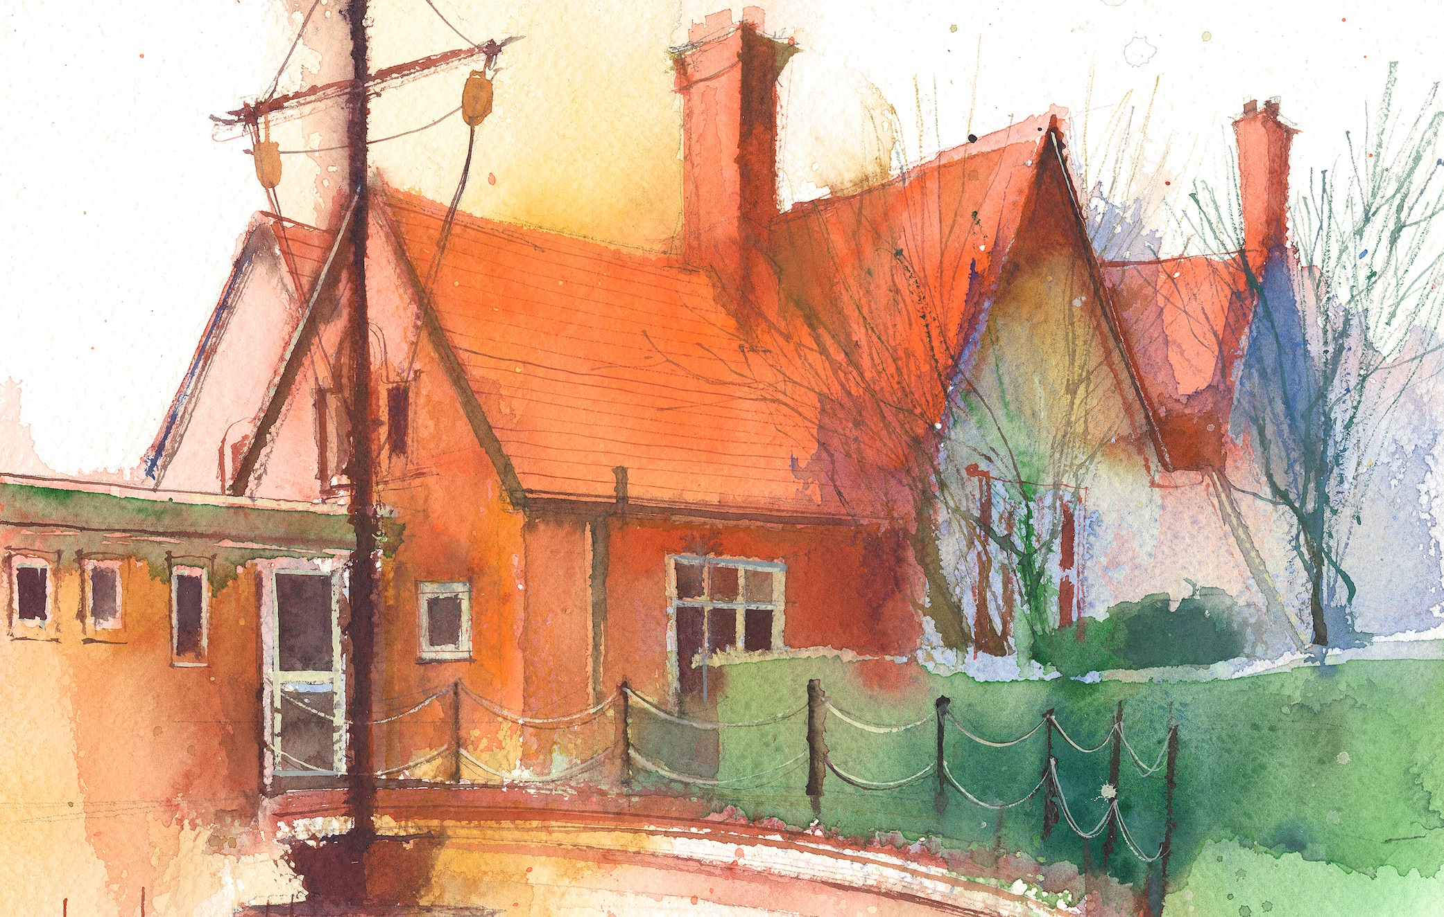

This timetable is available in the event that a Foundation 1 pupil is required to self-isolate, but the cohort remains open to other pupils.
Please visit the Foundation 1 Remote Learning Page on the school website to access any downloadable resources and activity sheets.

 | Session 1 |  | Session 2 |  | Additional Tasks
Monday  03.05.21 | BANK HOLIDAY |  | SUBJECT  BANK HOLIDAY |  | We also advise your child to complete the following tasks throughout the week:  - Practise writing their name; model it for them and ask them to copy it. If they need some extra support write their name in a colour and ask them to draw over it in a pencil.  - Talk about different patterns you see.  - Share books together talking about the pictures and predict what might happen next, talk about what has been read.  - Count objects in everyday life; stairs, cups, chairs.  - Encourage size language; which one has more? Which one is bigger?
Tuesday  04.05.21 | SUBJECT  By the end of this lesson your child should be able to:  - Begin to understand the need to respect and care for the natural environment and all living things.  - Explore colour and colour-mixing.  We recommend the following resources and activities to achieve this objective:  Watch the song about the animals and the interesting facts. Talk about the facts and the different animals that where in the song.  https://www.bbc.co.uk/iplayer/episode/p08qyzqg/maddie-the-zoo-and-you-songs-from-your-head-to-your-toes  Show the children a picture of a tiger ask them to not tell you what is and describe what it looks.  What would if feel like?  What do we think it eats?  Now tell the children to tell you what it is  Watch the video being a rhino keeper for the day. What did the Rhino need, what did Maddie do too look after the tiger . Do you think a tiger would be a good pet to have in your house?  https://youtu.be/jEQaRY4YpVo  split the children into two groups, talk about the colour of the tiger. Model using pastels to colour the tiger. Talk about using orange to colour it in then add black stripes. Ask the children to individually describe the tiger and what they know about them. |  | SUBJECT  By the end of this lesson your child should be able to:  - Enjoy listening to longer stories and can remember much of what happens  We recommend the following resources and activities to achieve this objective:  Ask the children if they can remember the animal we where talking about it this morning?  Tell the children you have a story about a tiger. Talk about the front cover, title, author, illustrator.  Read the story ‘The tiger who came to tea’ Talk about what the tiger did and what he ate. Would they like a tiger to come to their house for tea?  Split the children into 2 groups and model drawing food on the plate template for a tiger to visit their house.
Wednesday  05.05.21 | SUBJECT  By the end of this lesson your child should be able to:  - Collaborate with others to move a ball in different ways.  - Continue to develop their movement by jumping, climbing, hoping and  We recommend the following resources and activities to achieve this objective:  Warm up: On the field ask the children to move around in different ways and when they hear the whistle, they need to find a hoop to stand in.  Split the children into two groups to complete to activities  Activity 1;  Using a bench, and a hoop model to the children the different ways you can move; under, in, on, jumping, stepping, hopping. Give the children a turn and see how many different ways they can move.  Activity 2  Use a small ball to move in different ways. First move it round their body then move it different ways to a partner tell them they need to watch the ball and be ready for it to come to them. Encourage the children to kick, throw, roll. Can they do it slowly and quickly. What happens when they do it quickly?  After 10 mins children to swap and complete the other activity. |  | SUBJECT  By the end of this lesson your child should be able to:  - Recite numbers past 5.  - Say one number for each item in order: 1,2,3,4,5.  - Show ‘finger numbers’ up to 5.  - Link numerals and amounts: for example, showing the right number of objects to match the numeral, up to 5.  We recommend the following resources and activities to achieve this objective:  Sing number rhyme songs. (once I caught a fish alive, 5 current buns, 5 little men in a flying sauce, 5 little speckle frogs). Encourage the children to show finger numbers each time one is added or taken away. Choose children to write numbers on the board.  Throw snowballs with dots on and ask the children to get one each. Ask then to count the dots on their piece of paper. How many do they have can they recognise the numeral to match the amount. Ask them to find the number on the board.
Thursday  22.04.21 | SUBJECT  POLLING DAY |  | SUBJECT  POLLING DAY
Friday  23.04.21 | SUBJECT  By the end of this lesson your child should be able to:  - Understand ‘why’ questions, like: “Why do you think the caterpillar got so fat?”  - Use a wider range of vocabulary.  We recommend the following resources and activities to achieve this objective:  Use the clues to identify the animal that is being talked about. Ask the children why they think it is that animal? Have they ever seen that animal before? If so, where?  Encourage he children to use vocabulary to talk about each animal once the picture has been revealed. |  | SUBJECT  By the end of this lesson your child should be able to:  We recommend the following resources and activities to achieve this objective:

