Foundation 2 Weekly Timetable Week Commencing 12.12.22
To contact your child’s class teacher, please email schooloffice@dawpool.wirral.sch.uk or phone 0151 648 3412
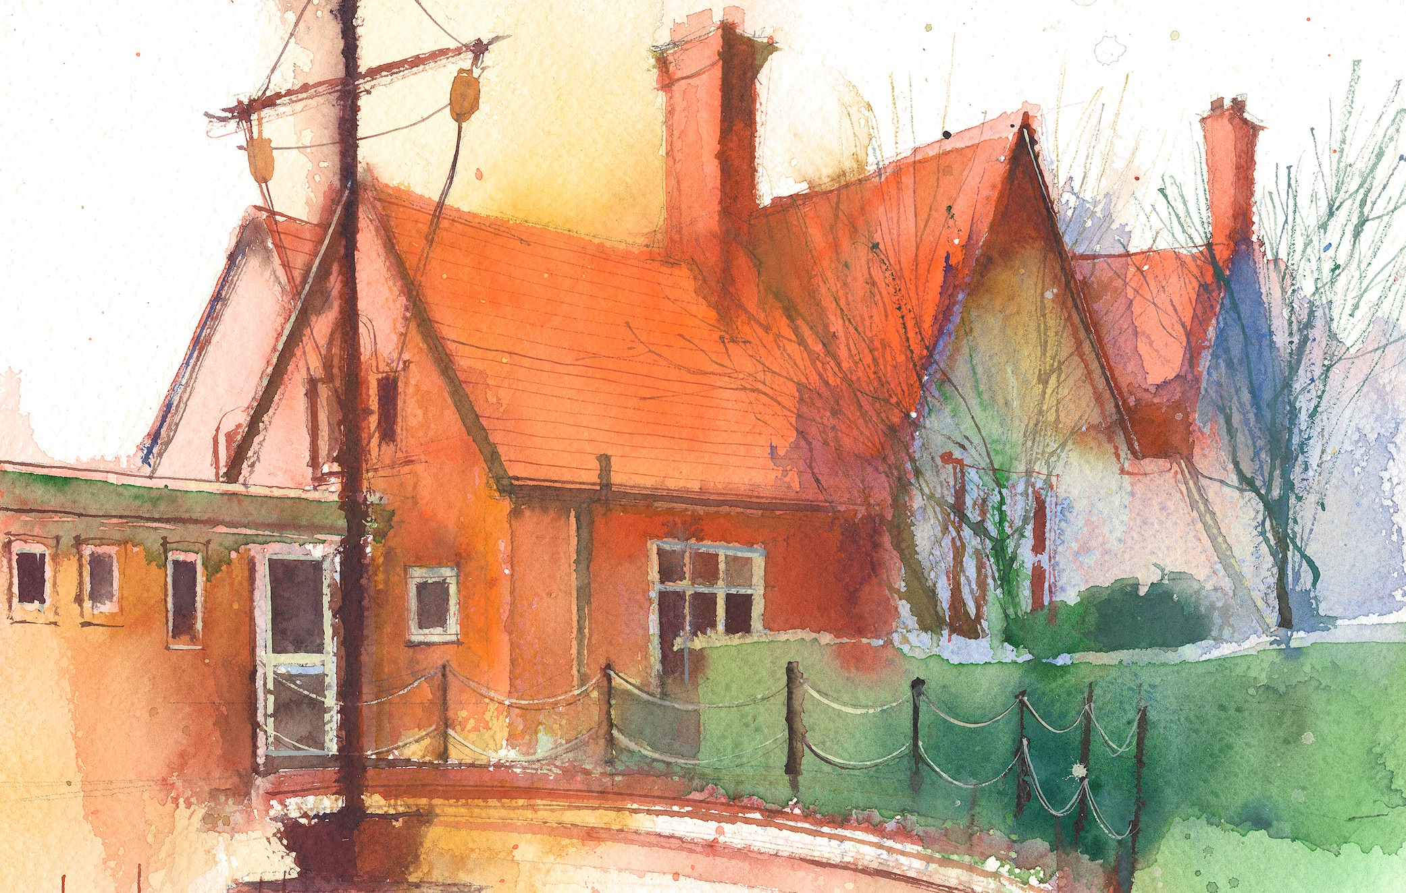

This timetable is available in the event that a Foundation 2 pupil is required to self-isolate at home, but the cohort remains open to other pupils.
Please visit the Foundation 2 Remote Learning Page on the school website to access any downloadable resources and activity sheets.

 | Session 1: 09:00-10:30 |  | Session 2: 10:50 – 12:00 |  | Session 3: 13:15 – 15:25
Monday  12/12/22 | Phonics  By the end of this lesson your child should be able to:  Recognise and say double letters e.g, tt rr. bb, gg as single sounds  We recommend the following resources and activities to achieve this objective:  Blending practice.  Children will complete activities in their individual rocket phonics workbooks.  (Week 12) |  | Phonics  By the end of this lesson your child should be able to:  Recognise and write double letters e.g. bb, rr, gg, tt  We recommend the following resources and activities to achieve this objective:  Segmenting practice.  Children will complete activities in their individual rocket phonics workbooks. |  | Topic  During the afternoons we will undertake activities linked to all areas of the Early Years Curriculum;  Prime Areas; Communication and Language;  Personal, Social and Emotional Development;  Physical Development.  Specific Areas; Literacy, Maths, Understanding the World and Expressive Arts and Design.  Afternoon sessions will also include RE, HeartSmart and Forest Schools.  Activities will be linked to our class topic which is ‘Where in the World’. We aim to use children’s films as a hook for learning to help us find out more about the world around us. Throughout the year we will select films that enable us to cover all requirements of the Early Years Curriculum.  We will talk about where the film is set and find out where this country is on a map. We will then the theme of the film as a way of guiding our planning.  PLEASE NOTE  The very nature of the EYFS curriculum enables us to go with the interests of the children. The activities we plan are for a guide only.  Staff can use and adapt activities or add additional activities and not cover others. It is all dependent on how and where the children’s interests take us.  Activities are designed to cover several weeks, if needed.  A copy of the current topic plan is available to view on the class website page.
Tuesday  13/12/22 | Phonics  By the end of this lesson your child should be able to:  Recognise and say some two syllable words e.g. sunset, laptop  We recommend the following resources and activities to achieve this objective:  Blending practice  Children will complete activities in their individual rocket phonics workbooks. |  | Phonics  By the end of this lesson your child should be able to:  Recognise and write some two syllable words e.g. sunset and laptop  We recommend the following resources and activities to achieve this objective:  Segmenting practice  Children will complete activities in their individual rocket phonics workbooks.
Wednesday  14/12/22 | Phonics  By the end of this lesson your child should be able to:  To consolidate learning of the sounds satipnmdgockeurhbfffl and CEW ‘I, the, to, go, no, into’.  To practice writing the CEW ‘into’  We recommend the following resources and activities to achieve this objective:  Children will complete activities in their individual rocket phonics workbooks. |  | Maths  By the end of this lesson your child should be able to:  Verbally count beyond 20, recognising the pattern in the number system.  We recommend the following resources and activities to achieve this objective:  We will practice counting to 30 in different voice styles, posh, mouse, witch, lion.  Can they children stamp/clap on each number?  Using the outdoor area, I will hide the number tiles around the whole outdoor area. The children will go on a hunt around and try and find a number.  When everyone has a number, we will work together to order them correctly
Thursday  15/12/22 | PARTY DAY |  | PARTY DAY
Friday  16/12/22 | PE  By the end of this lesson your child should be able to:  Revise and refine fundamental movement skills already acquired.  We recommend the following resources and activities to achieve this objective:  During this half term the children will use the hall space to undertake games and activities that require them to roll, crawl, walk, jump, run, hop, skip and climb.  Children will also learn to stop and change directions safely. |  | Maths  By the end of this lesson your child should be able to:  Understand the one more/one less relationship between consecutive numbers.  We recommend the following resources and activities to achieve this objective:  Sing a variety of number songs and rhymes using puppets and objects.  5 currant buns, 5 speckled frog, 5 little men in a flying saucer, 5 little ducks, ten green bottles.

