Summer Year 5 WP: 15.06.2026-.19.06.2026
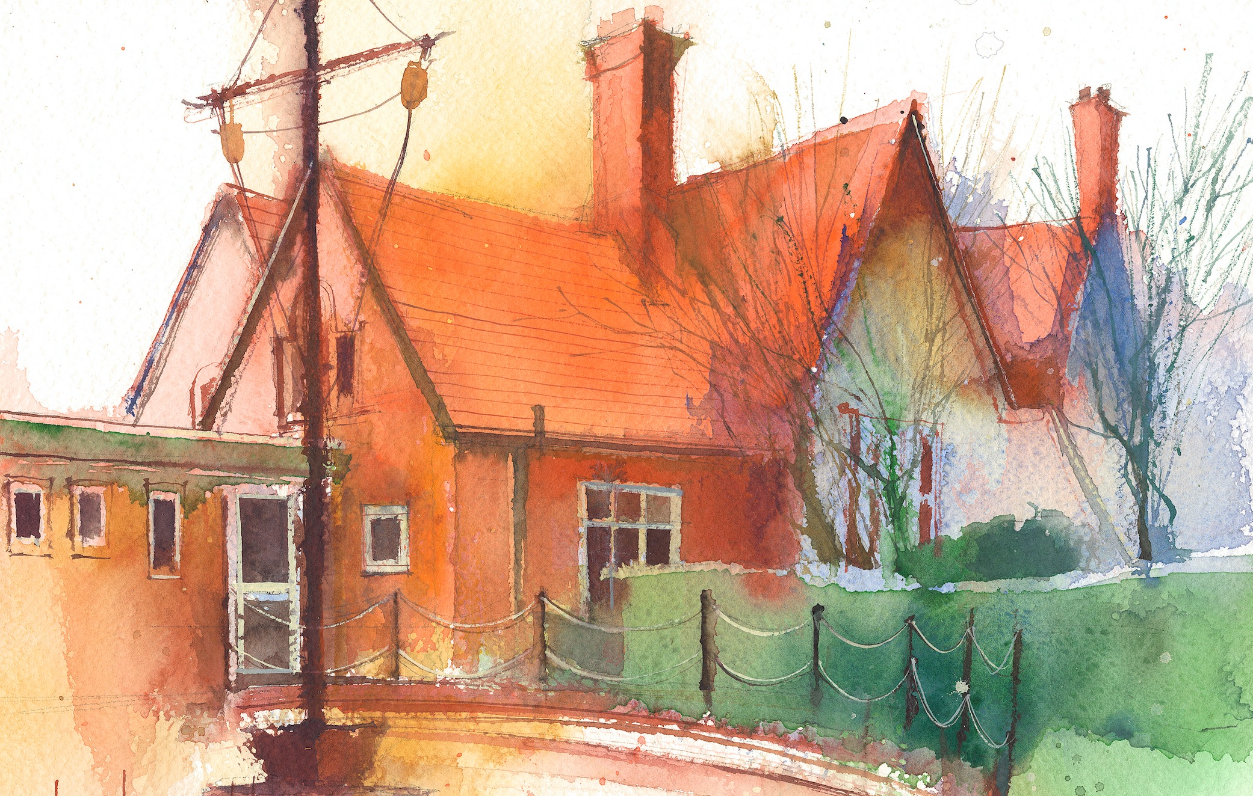
To contact your child’s class teacher, please email schooloffice@dawpool.wirral.sch.uk or phone 0151 648 3412
 | Lessons 09:00 - 10:30 |  | Lessons 10:45 - 12:15 |  | Lessons 13:15 - 15:30  (Incorporating 15-minute break) | Additional Tasks
Monday  15/06/26 | Mrs. McCann Plans  Spirituality Project, Me, Others, the World and God |  |  |  |  | Drama Club
Tuesday  16/06/26 | Maths  Fluent in five/ Rapid Reasoning  By the end of this lesson your child should be able to: know how to calculate angles on a straight line, lesson 5 |  | CDAT English  By the end of this lesson your child should be able to: plan a narrative for an original story with a moral message based in an unfamiliar setting with an environmental problem |  | Science  By the end of this lesson your child should be able to:. Explain that unsupported objects fall towards earth because of the force of gfravity  Picture news, British Values
Wednesday  17/06/26 | Maths to  Fluent in five/ Rapid Reasoning  By the end of this lesson your child should be able to: know how to measure angles around a point, lesson 6 |  | CDAT English  By the end of this lesson your child should be able to: write an engaging opening for their story using atmosphere, setting description and a hook sentence. |  | Art  To finish artwork started on Monday for our Spiritual project for the week.  Visit from Chris Jarvis to talk to children about Spirituality Project  Handwriting | Chess Club  Year 6 dance at Floral Pavillion, New Brighton
Thursday  18/06/26 | Maths  Fluent in five/ Rapid Reasoning  By the end of this lesson your child should be able to: know how to calculate lengths and angles in shapes, lesson 7  Singing and worship Assembly 9.10 |  | CDAT English  By the end of this lesson your child should be able to: carry on story building tension and conflict whilst discovering environmental damage. |  | Topic  By the end of this lesson your child should be able to: .find the rain forests of the earth on the globe and give reasons why deforestation is not good for the earth but also some reasons that some people do it. Can we think of alternative ways for them to earn money? | Choir/Drama  Netball final at CO-OP High School , Bebington
Friday  19/06/26 | Maths  Fluent in five/ Rapid Reasoning  By the end of this lesson your child should be able to: know how to distinguish between regular and irregular polygons. |  | CDAT English  By the end of this lesson your child should be able to finish story with an effective resolution with a conservation message. |  | Art  Finish Spirituality Project artwork  Spanish  Handwriting | Celebration of weeks work

