**Year 1 Weekly Timetable Week Commencing 25.09.23**

**To contact your child’s class teacher, please email** [**schooloffice@dawpool.wirral.sch.uk**](mailto:schooloffice@dawpool.wirral.sch.uk) **or phone 0151 648 3412**

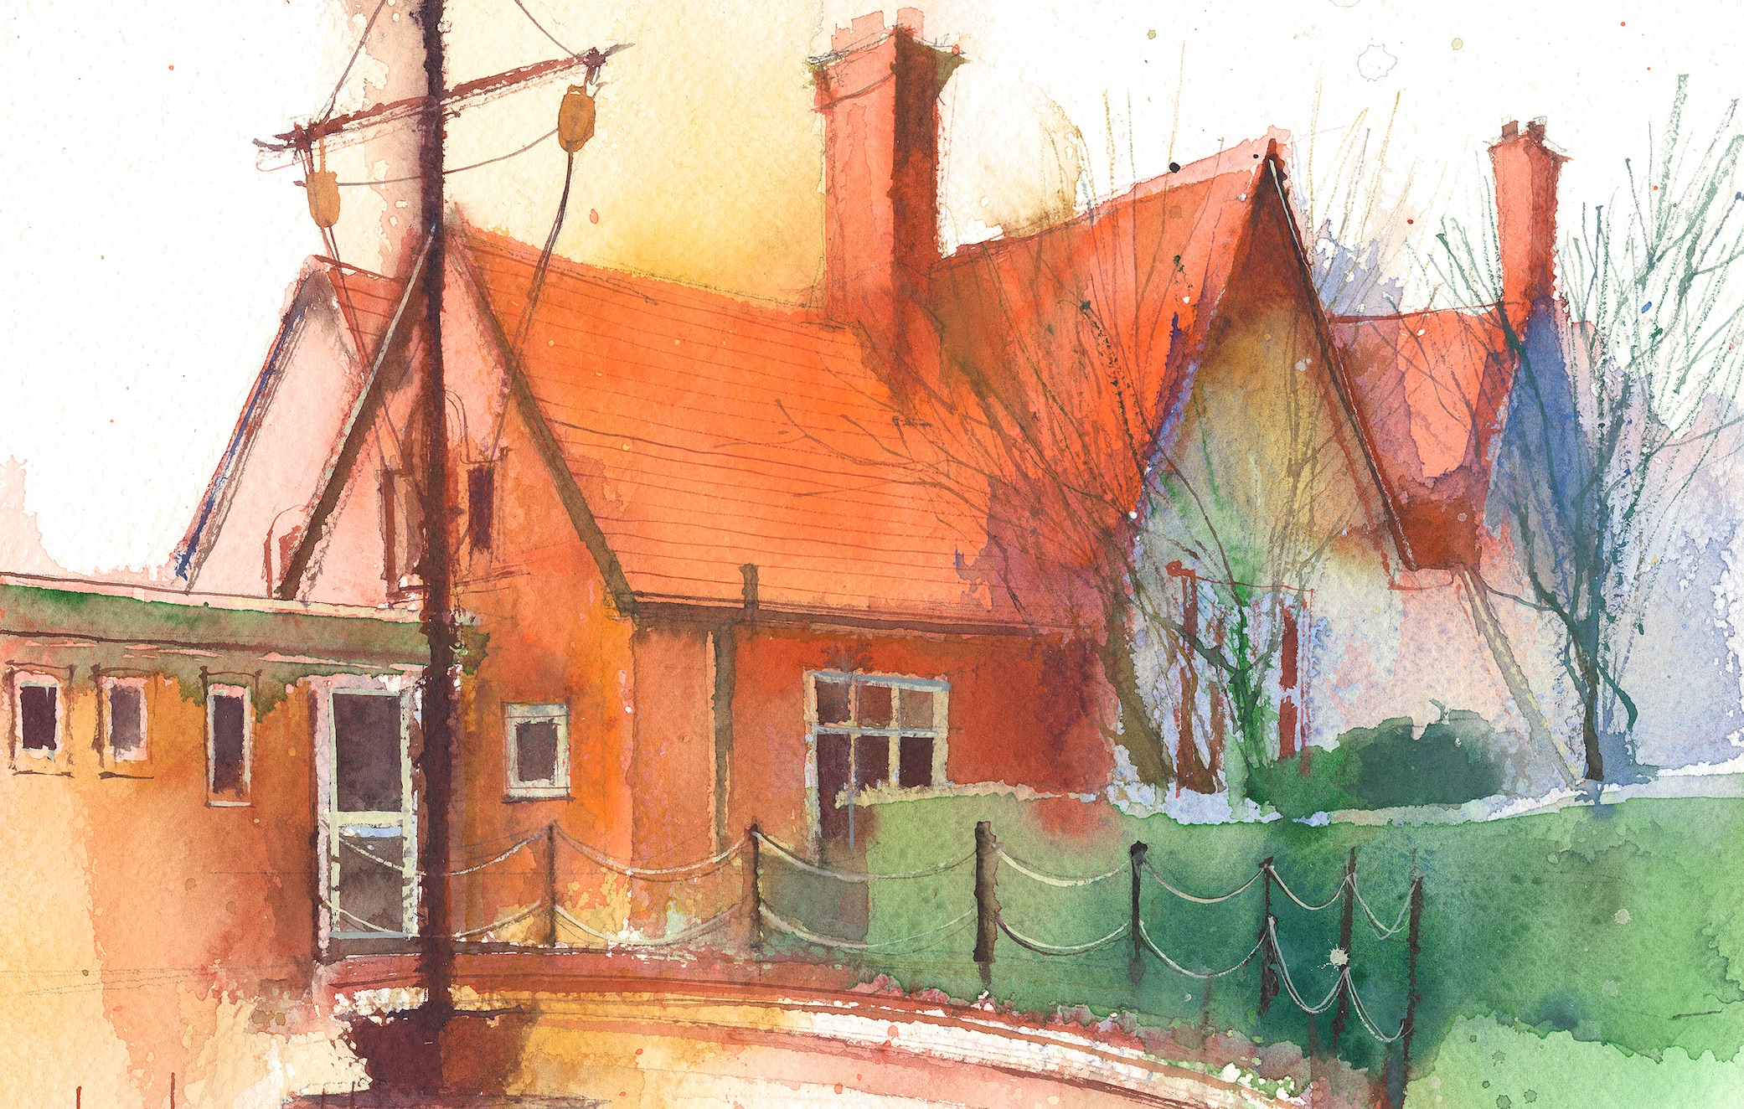

|  |  |  |  |  |  |  |
| --- | --- | --- | --- | --- | --- | --- |
|  | **Lessons 09:00 – 10:30** |  | **Lessons­­­­ 10:45 – 12:15** |  | **Lessons 13:15 – 15:30 (Incorporating 15-minute break)** | **Additional Tasks** |
| **Monday** | **Phonics:** igh as ie (blending practice)  **English:** Rising stars Spelling Fox challenge. I can write as many words with only a few letters. | **Maths:** I know how to backwards within 10 | **Mrs Mccann teaching ☺**  **HeartSmart**  Guided Reading groups | Useful Links / Other Recommended Activities  **Oak National Academy**  <https://classroom.thenational.academy/>  **BBC Bitesize**  <https://www.bbc.co.uk/bitesize>  **Purple Mash**  <https://www.purplemash.com/sch/dawpool#/>  **Recommended Reading List**  [See here](https://www.dawpool.wirral.sch.uk/website/recommended_reading_lists/577821) |
| **Tuesday** | **Phonics:** igh as ie (segmenting practice)  English: I can create a story map of the story and use it to retell the story. | **Maths:** I know how to count 1 less | **Science:** I can name the different parts of a tree.  **ICT:** I can login to purple mash with my own login and create an avatar.  Guided Reading groups |
| **Wednesday** | **Phonic**s: igh as y (blending practice)  **English:** I can talk about the feelings of characters in the story. | **Maths:** I know how to compare groups by matching 1-to-1 | **Forest School:** Identifying trees and their different parts.  **Music:** step 3 Hey you! I can learn a song and join in with rhythm games.  Guided Reading groups |
| **Thursday** | **Phonics:** igh as y (segmenting practice)  **English:** I can act out the story of Lila using the story map and create music to help. | **Maths:** I know how to compare numbers of objects. | **Topic. Geography:** I can identify human and physical features in Kenya  **Art:** I can mix primary colours to match the animal colours.  Guided Reading groups. |
| **Friday** | **Phonics:** Common exception word practice: come, do, so  **English:** Cracking Comprehension. I can answer questions based on a story. | **Maths:** I know how to compare numbers of objects. | **PE:** I can understand what hand eye coordination means and will start to develop their throwing, bouncing and rolling skills to refining their hand eye coordination skills.  **Golden Time:** Some special toys are brought in to play with! |