Foundation 2 Weekly Timetable Week Commencing 24.11.25
To contact your child’s class teacher, please email schooloffice@dawpool.wirral.sch.uk or phone 0151 648 3412
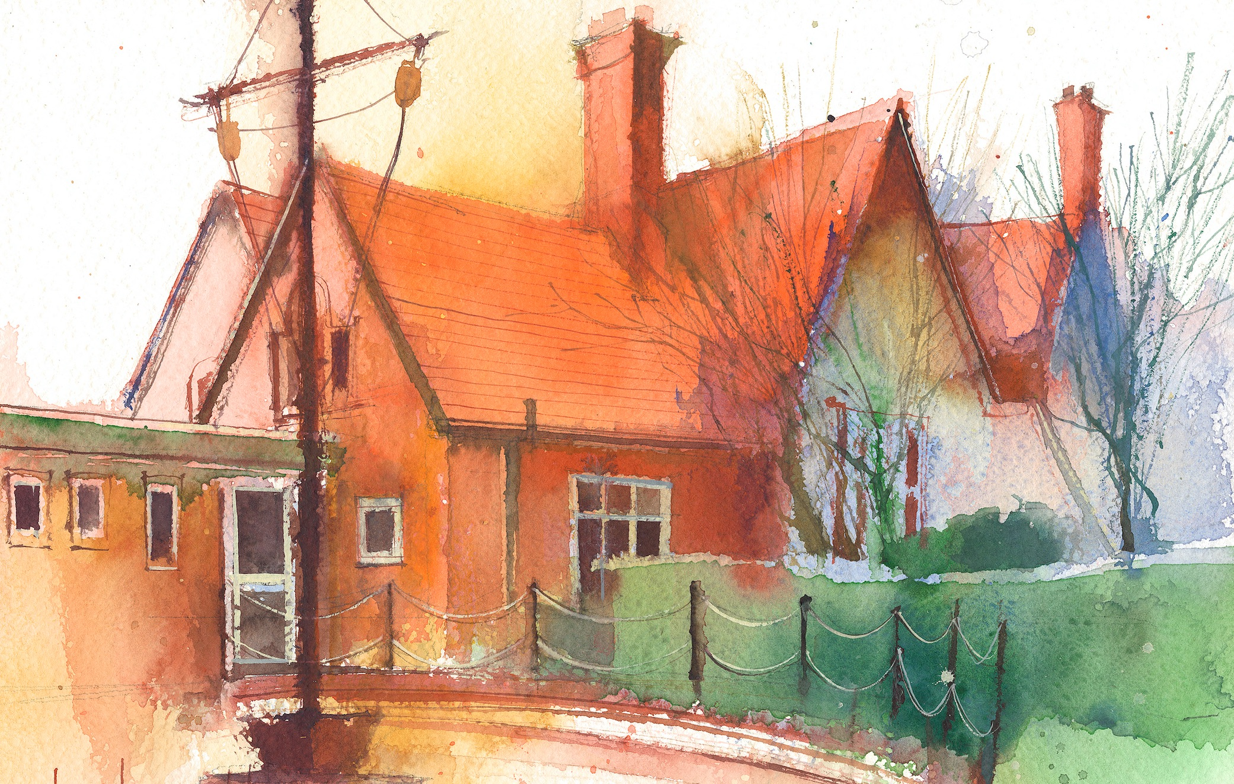

This timetable is available in the event that a Foundation 2 pupil is required to self-isolate at home, but the cohort remains open to other pupils.
Please visit the Foundation 2 Remote Learning Page on the school website to access any downloadable resources and activity sheets.

 | Session 1: 09:00-10:30 |  | Session 2: 10:50 – 12:00 |  | Session 3: 13:15 – 15:25
Monday | Phonics  By the end of this lesson your child should be able to:  Recognise and say the sound ‘f’  We recommend the following resources and activities to achieve this objective:  Blending practice.  Children will complete activities in their individual rocket phonics workbooks. |  | Maths  By the end of this lesson your child should be able to:  To understand the composition of numbers up to 8  We recommend the following resources and activities to achieve this objective:  Watch Numberblocks: eight. Go through the episode all the way through. Then re-watch, but pause at regular intervals to discuss the episode in PP, share what they have seen.  How do they know it is 8? |  | Topic  By the end of this lesson your child should be able to:  To understand the role a dentist plays in keeping us healthy  We recommend the following resources and activities to achieve this objective:Re-cap on the people who help us posters from last week.  No look at a large model mouth and toothbrush. Which person are we focussing on today? Talk about what the dentist does, how they help us, and why brushing is important.  Demonstrate brushing in small circles for 2 minutes. Use a 2 minute timer to see how long 2 minutes is. What else can they do in 2 minutes?
Tuesday | Phonics  By the end of this lesson your child should be able to:  Recognise and write the sound ‘f’  We recommend the following resources and activities to achieve this objective:  Segmenting practice.  Children will complete activities in their individual rocket phonics workbooks. |  | Maths  By the end of this lesson your child should be able to:  To link the number with its cardinal value.  We recommend the following resources and activities to achieve this objective:  Discuss Octoblock. Why is he called ‘octo’block? Can they think of any other things beginning with ‘octo’? Look at pictures of different objects linked to 8, Get the children to discuss them. How do they know they are ‘8’ PP discussion  For each objects count 1-8 together. Use the language ‘8 is 1 more than 7’ |  | Topic  By the end of this lesson your child should be able to:  To understand how we can keep our teeth healthy  We recommend the following resources and activities to achieve this objective:  When should we brush our teeth?  Discuss the times of the day we should brush our teeth to keep them healthy.  Together create a tooth visual timetable  - Wet toothbrush  - Add a small blob of toothpaste  - Brush in circles  - Spit, don’t rinse  - Brush twice a day
Wednesday | Phonics  By the end of this lesson your child should be able to:  Recognise and say the sound ‘ff’  We recommend the following resources and activities to achieve this objective:  Blending practice  Children will complete activities in their individual rocket phonics workbooks. |  | Maths  By the end of this lesson your child should be able to:  To find what comes before or after a given number.  We recommend the following resources and activities to achieve this objective:  Hand number tiles 1-8 out to the children. Can they help me put them in order?  What number do I start with? What number do I end with? Order the numbers together.  I will then ask which is 1st, which is 8th etc. Can they recall all the ordinal numbers 1-8? |  | Topic  By the end of this lesson your child should be able to:  To understand what germs are and the importance of hand washing.  We recommend the following resources and activities to achieve this objective:  The Dentist looks after teeth. Doctors and Nurses look after us if we are poorly. We can help keep germs away by washing hands.  “Germs are tiny creatures that can make us poorly. We can’t see them.”  Complete an activity to show how germs can stick to hands. Sprinkle a little glitter on my hands. Show how it sticks and spreads if you touch objects or shake hands. Emphasise that glitter represents germs. I will go around and shake hands with children. How many of my ‘germs’ are on the other children?  How can we get rid of the germs?  Using a bowl of warm soapy water we will wash hands properly to remove the ‘germs’
Thursday | Phonics  By the end of this lesson your child should be able to:  Recognise and write the sound ‘ff’’  We recommend the following resources and activities to achieve this objective:  Segmenting practice  Children will complete activities in their individual rocket phonics workbooks. |  | Maths  By the end of this lesson your child should be able to:  To partition numbers and recombine them to make the whole number.  We recommend the following resources and activities to achieve this objective:  Discuss Octoblock. How did they make 8?  Model 7+1=8 on the board  Are there any other ways of making 8?  Split children into PP and give each pair 8 cubes. Can they work together to find lots of different ways of making 8?  Ask children to share ideas and put them on the board. Model how this looks as a number sentence. |  | Topic  By the end of this lesson your child should be able to:  Understand food can help us stay healthy.  We recommend the following resources and activities to achieve this objective: Show the children pictures of different foods. Explain that some foods we can have lots of and some foods should just be special treat food.  Can we work together to sort them into two groups?  In provision time we will make healthy eating plates filled with different foods and we will play ‘Greedy Gorilla’  For snack all the children can help cut and prepare food to make a fruit salad.
Friday | PE  By the end of this lesson your child should be able to:  Move in a variety of different ways around the room including High and Low. To sequence a series of moves.  We recommend the following resources and activities to achieve this objective:  During this half term the children will be learning ball skills. How to handle, control and pass balls carefully.  Skills will be taught using scarves, balloons, beachballs, footballs and smaller soft balls. |  | Phonics  By the end of this lesson your child should be able to:  To learn to read and write the Common Exception word ‘no’  We recommend the following resources and activities to achieve this objective:  Children will complete activities in their individual rocket phonics workbooks. |  | Forest School  By the end of this lesson your child should be able to:  Collaborate with others  We recommend the following resources and activities to achieve this objective:  Work together to create minibeast hotels, art in nature, build dens, support each other getting in and out of the swinging hammock

