Year 1 Weekly Timetable Week Commencing 12.10.26
To contact your child’s class teacher, please email schooloffice@dawpool.wirral.sch.uk or phone 0151 648 3412
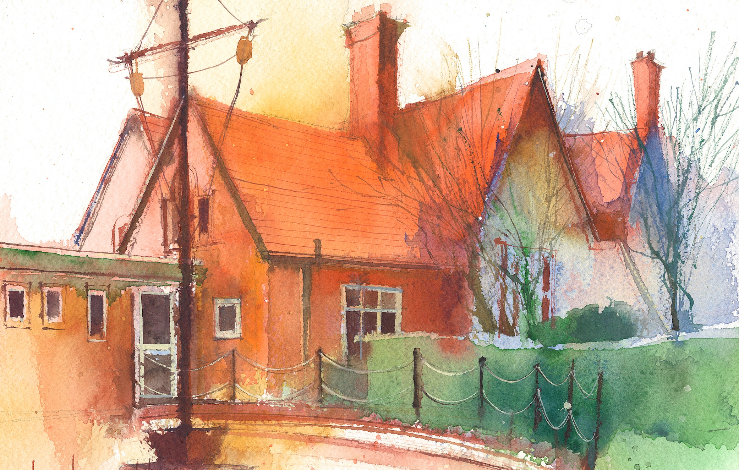

 | Lessons 09:00 – 10:30 |  | Lessons 10:45 – 12:15 |  | Lessons 13:15 – 15:30  (Incorporating 15-minute break) | Additional Tasks
Monday | Phonics: o-e  English  To write 2 sentences for our story.  Busy Learning  Whole School Worship |  | Maths  To understand parts and wholes  Busy Learning |  | Geography  To research and identify some of the key natural features of CapeTown  Busy Learning  Music | Useful Links / Other Recommended Activities  Oak National Academy  https://classroom.thenational.academy/  BBC Bitesize  https://www.bbc.co.uk/bitesize  Purple Mash  https://www.purplemash.com/sch/dawpool#/  Hit the button  https://www.topmarks.co.uk/maths-games/hit-the button
Tuesday | Phonics:o-e  English  To write 2 sentences for our story.  Busy Learning |  | Maths  To understand how to use part whole models  Busy Learning |  | Art  To make dark and light shades of colour  Busy Learning  Picture News
Wednesday | Phonics: ow  English  To write 2 sentences for our story.  Busy Learning |  | Maths  To know how to write addition sentences  Busy Learning |  | RE  To learn where our food comes from  Busy Learning  Heartsmart
Thursday | Phonics: ow  English  To write 2 sentences for our story.  Busy Learning |  | The Wirral Mental Health Support Team  Connect: Learning how to connect with others through kindness, sharing,  listening and playing together to support build positive relationships |  | Forest School/RE  Creating a sukkah  . Maths  To know how to write addition fact families.
Friday | Phonics: Tricky Word: have, there  English  To write 2 sentences for our story.  Celebration worship |  | Maths  To know how to find number bonds within 10  Busy Learning |  | PE  To create balance circuits.  Computing  Introduction to Purple Mash

