Year 1 Weekly Timetable Week Commencing 2.2.26
To contact your child’s class teacher, please email schooloffice@dawpool.wirral.sch.uk or phone 0151 648 3412
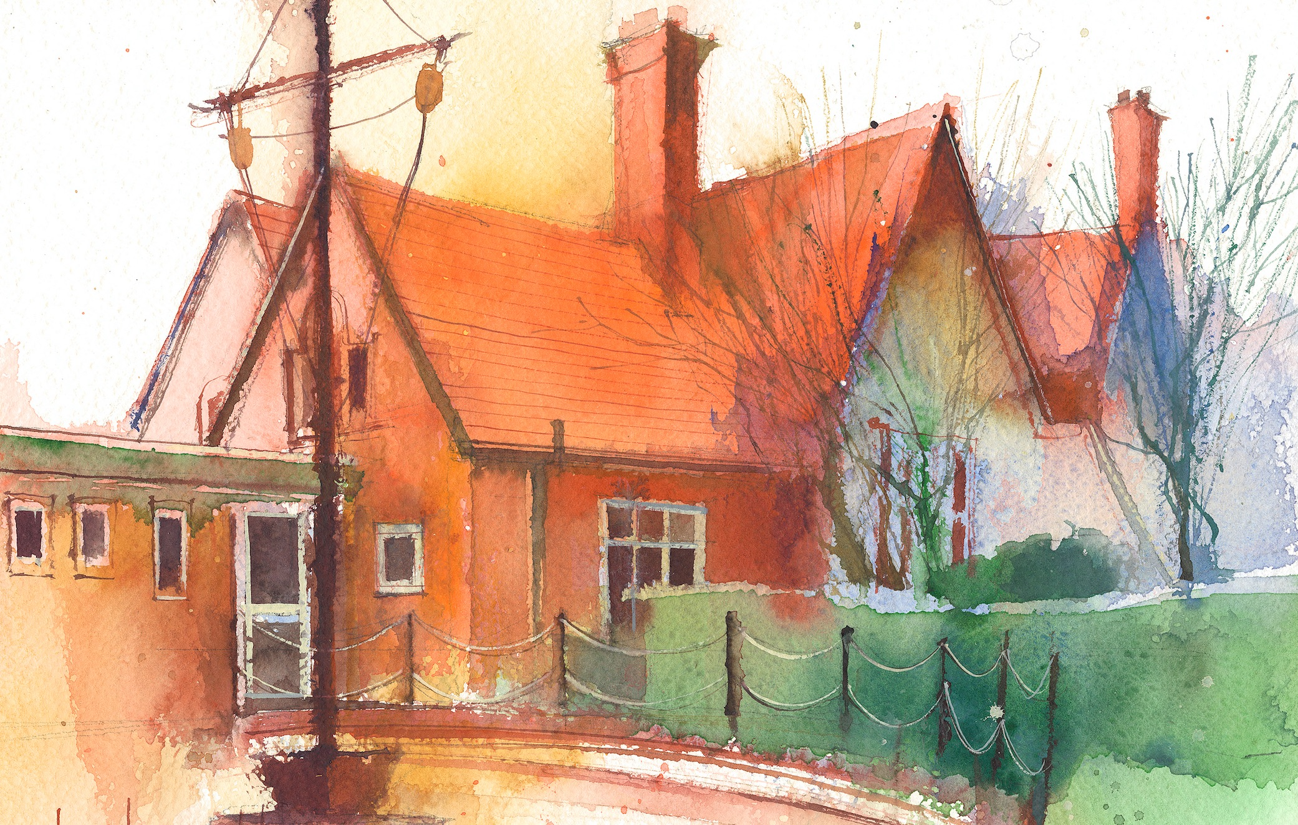

 | Lessons 09:00 – 10:30 |  |  | Lessons 10:45 – 12:15 |  | Lessons 13:15 – 15:30 (Incorporating 15-minute break) | Additional Tasks
Wednesday | Phonics: j as g (blending practise)  English: (SW lesson 1)  • I can write the sentence starters - First, then and next. |  |  | Forest School |  | See Mrs Broadbent’s plan | Remember the book fair is on this week. Why not pop in when you collect your child up from school. You will need to enter the school via the school office after hometime.
Thursday | Phonics: j as g (segmenting practise)  English: (SW lesson 2)  • I can write the sentence starters - First, then and next. | Singing Assembly |  | Maths: Assessment  ERIC/ GR - Blue 2, Red |  | Fin5  PE: (Gymnastics, session 3) The class will explore movements and balances different ways on the floor and on apparatus.  RE: Reviewing the unit and looking at all the stories of Jesus.
Friday | Phonics: Tricky words: oh, their  English: (SW lesson 3):  • I can read the recount aloud to an audience. | Celebration Assembly |  | Maths: Assessment  ERIC/ GR - Yellow, Green 2 |  | Fin5  History & Golden Time: Titanic. I know some different facts about the Titanic and the different parts of the ship.

