**Year 4 Weekly Timetable Week Commencing 30.06.25**

**To contact your child’s class teacher, please email** [**schooloffice@dawpool.wirral.sch.uk**](mailto:schooloffice@dawpool.wirral.sch.uk) **or phone 0151 648 3412**

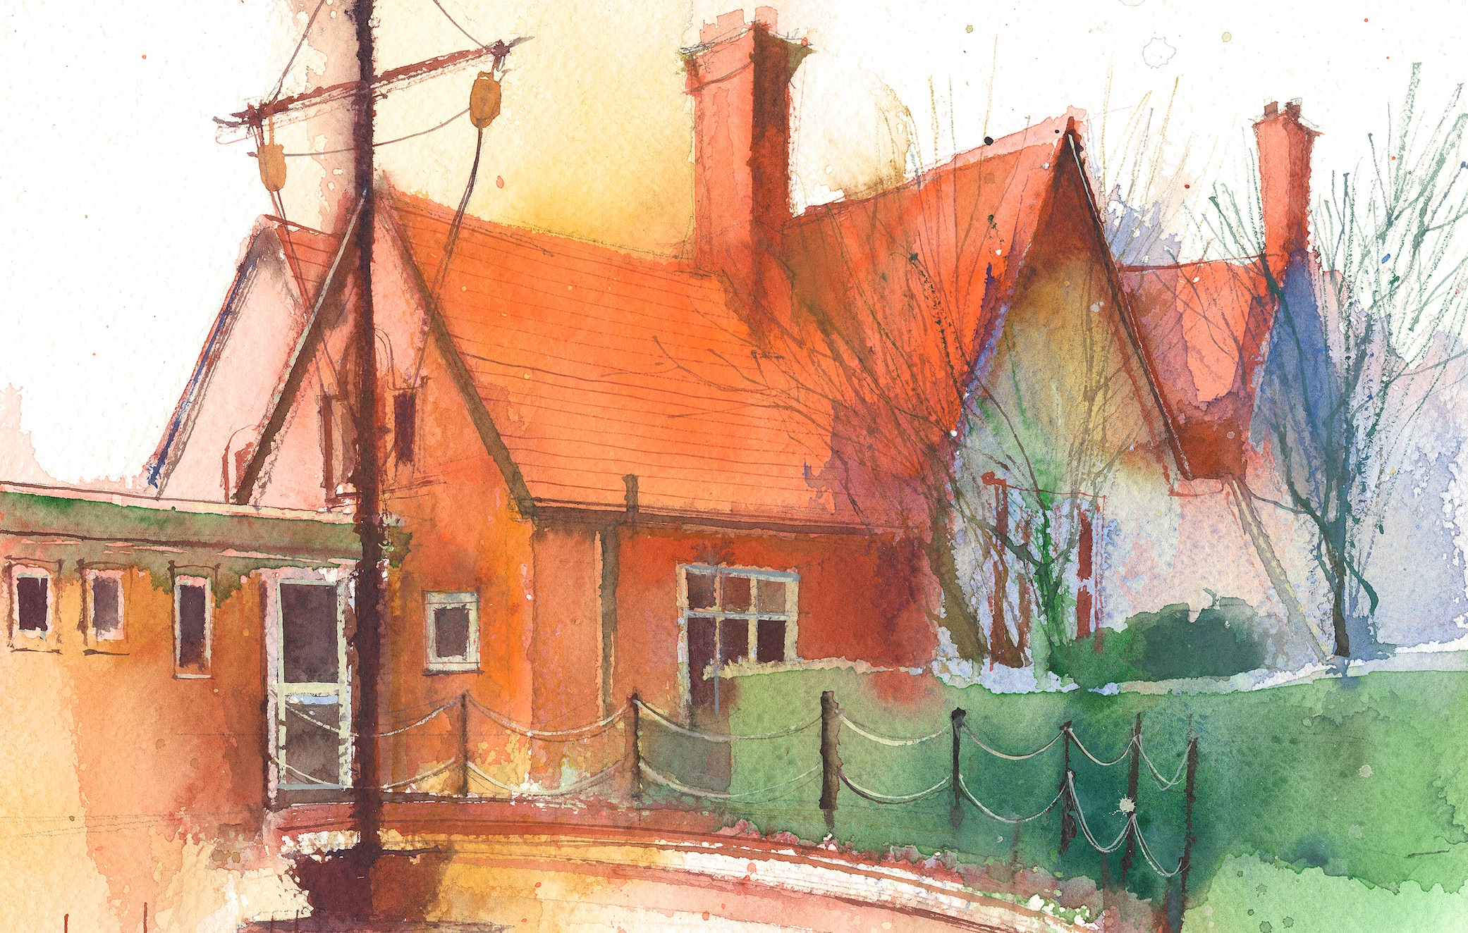

|  |  |  |  |  |  |  |
| --- | --- | --- | --- | --- | --- | --- |
|  | **Lessons 09:00 – 10:30** |  | **Lessons­­­­ 10:45 – 12:15** |  | **Lessons 13:15 – 15:30 (Incorporating 15-minute break)** | **Additional Tasks** |
| **Monday** |  |  |  | Useful Links / Other Recommended Activities  **Oak National Academy**  <https://classroom.thenational.academy/>  **BBC Bitesize**  <https://www.bbc.co.uk/bitesize>  **Purple Mash**  <https://www.purplemash.com/sch/dawpool#/>  **Recommended Reading List**  [See here](https://www.dawpool.wirral.sch.uk/website/recommended_reading_lists/577821) |
| **Tuesday** |  |  |  |
| **Wednesday** |  |  |  |
| **Thursday** | **Year 4 English Reading Comprehension**  By the end of this lesson your child should be able to:  **Understand and respond to the text and answer questions about the story.** | **Year 4 Maths**  By the end of this lesson your child should be able to:  **Understand how to convert between analogue and digital times.** | **Year 4 Science – Living Things and their Habitats**  By the end of this lesson your child should be able to:  **To be able to recognise that living things can be grouped in a variety of ways.**  **To be able to explore and use classification keys to help group, identify and name a variety of living things in their local and wider environment** |
| **Friday** | **Year 4 Maths**  By the end of this lesson your child should be able to:  **Know how to convert to 24-hour time.** | **Year 4 English**  By the end of this lesson your child should be able to:  **Know that verbs have tenses. This means past, present or future.** | **Year 4 RE Unit 4:6Prayer**  By the end of this lesson your child should be able to:  **Read traditional Christian prayers which include the Prayer of St. Francis and the Covenant Prayer of John Wesley What do these prayers reveal to us about God and Christian belief? Children highlight words and phrases in the prayers that reveal Christian belief**. |