**Year 4 Weekly Timetable Week Commencing: 08.09.2025**

**To contact your child’s class teacher, please email** [**schooloffice@dawpool.wirral.sch.uk**](mailto:schooloffice@dawpool.wirral.sch.uk) **or phone 0151 648 3412**

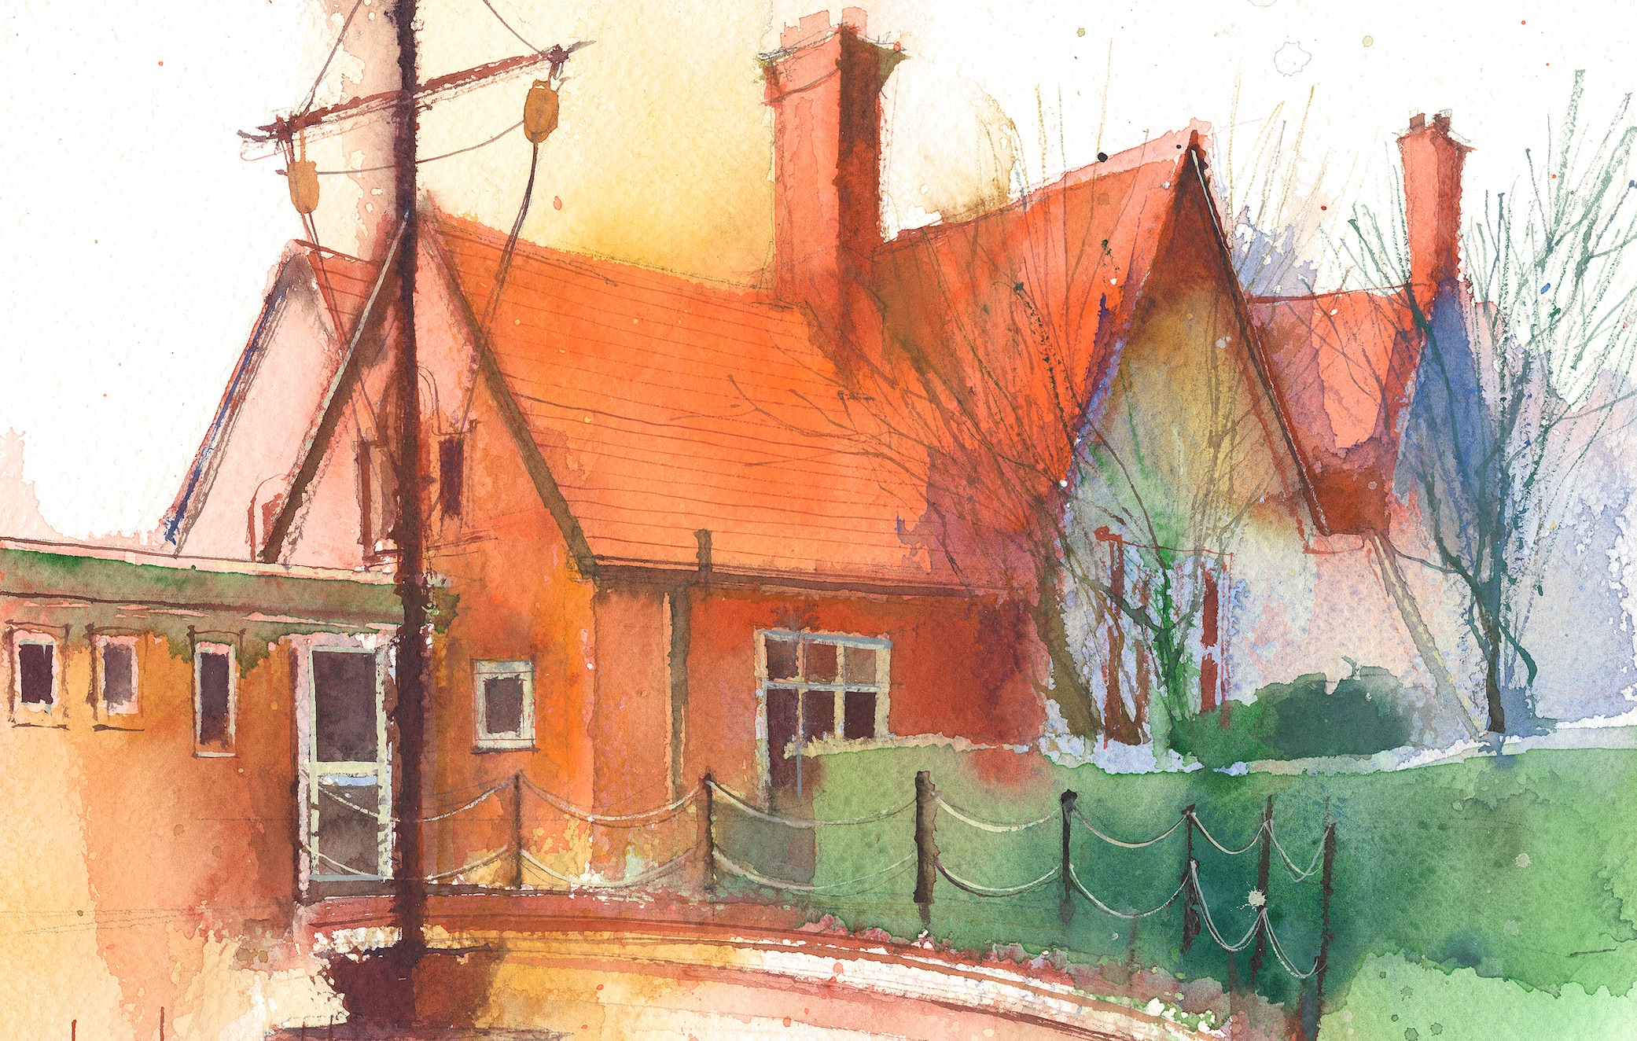

|  |  |  |  |  |  |  |
| --- | --- | --- | --- | --- | --- | --- |
|  | **Lessons 09:00 – 10:30** |  | **Lessons­­­­ 10:45 – 12:15** |  | **Lessons 13:15 – 15:30 (Incorporating 15-minute break)** | **Additional Tasks** |
| **Monday** | **Maths**  We are learning to :  Represent numbers to 10000  **Collective Worship**  **10:10** | **English**  Spelling: adding the prefix -in  Writing:  We are going to describe | **Computing**  E-safety  **Reading** | Useful Links / Other Recommended Activities  **Oak National Academy**  <https://classroom.thenational.academy/>  **BBC Bitesize**  <https://www.bbc.co.uk/bitesize>  **Purple Mash**  <https://www.purplemash.com/sch/dawpool#/>  **Times table practise:**  <https://www.timestables.co.uk/multiplication-tables-check/>  **Hit the button**  https://www.topmarks.co.uk/maths-games/hit-the-button |
| **Tuesday** | **Maths**  We are learning to:  Partition numbers to 10000 | **English**  We are going to:  Write using similes | **Class based worship/ Picture news** |
| **Wednesday** | .**Maths**  Arithmetic lesson | **Reading Comprehension**    **Class worship** | **RE**  Values in action  **Heart smart** |
| **Thursday** | **Sing worship 9:10**  **Maths**  We are learning to:  Partition in different ways | **English**  We are going to :  Collect vocabulary | **History**  Timeline  **PE 14:30** |
| **Friday** | **Maths**  We are learning to:  Find 1, 10, 100, 1000 more or less  **Celebration worship 10:10** | **English**  We are going to:  **Write a poem** | **Science**  Living things and their habitats  : I can group living things in different ways.  **Heart smart**  PSHCE Heartsmart: |