Foundation 1 Weekly Timetable Week Commencing 6.12.21
To contact your child’s class teacher, please email foundation2@dawpool.wirral.sch.uk
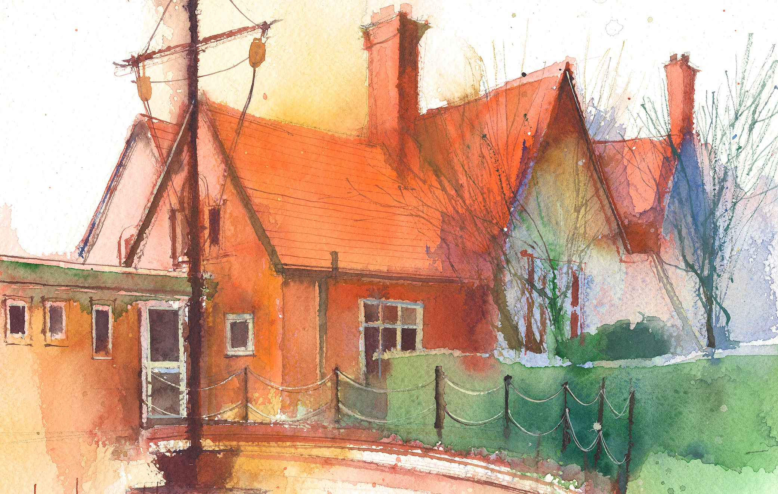

 | Session 1/registration |  | Session 2 |  | Session 3
Monday  6.12.21 | Maths  By the end of this lesson your child should be able to:  Recite numbers past 5. • Say one number for each item in order: 1,2,3,4,5. • Know that the last number reached when counting a small set of objects tells you how many there are in total (‘cardinal principle’)  We recommend the following resources and activities to achieve this objective:  Explain that need to find out how many children are in F1 today. How can we do this? – count all of the children.  Model counting the children by starting from the middle. Pretend to get muddled up and ask children of there is a better way so that I don’t get muddled up – starting with the children on the outside, pointing at each child as I count them.  Ask the helping hands to count the children to us to see how many are in school today. (Support if needed by modelling and walking around with them).  Write the total on the white board for children to see the numeral.  Can we count to that number?  Can we complete that many claps/jumps etc?  Maximise opportunities to count the children every time they are lining up throughout the day. |  | Literacy  By the end of this lesson your child should be able to:  - Engage in extended conversations about stories, learning new vocabulary  We recommend the following resources and activities to achieve this objective:  Show ‘One Snowy Night’ by Christina Butler.  Discuss front cover and make predictions about the story.  Read the story and discuss.  What celebration is the story about?  How did the Hedgehog and his friends prepare for Christmas? |  | Literacy  By the end of this lesson your child should be able to:  - Engage in extended conversations about stories, learning new vocabulary  We recommend the following resources and activities to achieve this objective:  Re-cap the Christmas story  Model how to sequence using pictures.  What came first/beginning?  What happened next? What happened at the end?  Leave activity in continuous provision
Tuesday  7.12.21 | Maths  By the end of this lesson your child should be able to:  Recite numbers past 5. • Say one number for each item in order: 1,2,3,4,5. • Know that the last number reached when counting a small set of objects tells you how many there are in total (‘cardinal principle’)  We recommend the following resources and activities to achieve this objective:  Explain that need to find out how many children are in F1 today. How can we do this? – count all of the children.  Model counting the children by starting from the middle. Pretend to get muddled up and ask children of there is a better way so that I don’t get muddled up – starting with the children on the outside, pointing at each child as I count them.  Ask the helping hands to count the children to us to see how many are in school today. (Support if needed by modelling and walking around with them).  Write the total on the white board for children to see the numeral.  Can we count to that number?  Can we complete that many claps/jumps etc?  Maximise opportunities to count the children every time they are lining up throughout the day. |  | RE  By the end of this lesson your child should be able to:  I can retell the Christmas story. Look at a bible, what do children think it is?  Retell the story of the first Christmas. Retell as an interactive story with props and use the children to help. Stop at different points in the story to ask ‘what do you think happened next’?  We recommend the following resources and activities to achieve this objective:  Watch the first Christmas on:  https://www.youtube.com/watch?v=wmio42mjcIs https://www.youtube.com/watch?v=sz8rm_wGRa0  ACTIVITIES  Recreating the Christmas story through a range of props  - Small world retelling of story  - Dress up in the role play  RESOURCES -  - nativity set  - Good News Bible  - YouTube or video clips of the first Christmas  - nativity play props for telling the story  - small world construction  Cut and stick nativity story sequencing.  PE  By the end of this lesson your child should be able to:  Increasingly be able to use and remember sequences and patterns of movements which are related to music and rhythm.  We recommend the following resources and activities to achieve this objective:  TASKS:  WARM UP – Stuck in the mud.  ACTIVITY  Dance to the superman song, copying all of the actions. |  | Maths  By the end of this lesson your child should be able to:  Understand position through words alone – for example, “The bag is under the table,” – with no pointing.  We recommend the following resources and activities to achieve this objective:  Watch youtube clip – where’s the monkey? Positional language video.  Use a Christmas/winter themed teddy and a model a selection of positional language examples.  The teddy is under the chair.  The teddy is behind….  Challenge children to put the teddy in different places and describe to peers where they have put it. ‘The teddy is…..’  Leave activity out in continuous provision.
Wednesday  8.12.21 | Maths  By the end of this lesson your child should be able to:  Recite numbers past 5. • Say one number for each item in order: 1,2,3,4,5. • Know that the last number reached when counting a small set of objects tells you how many there are in total (‘cardinal principle’)  We recommend the following resources and activities to achieve this objective:  Explain that need to find out how many children are in F1 today. How can we do this? – count all of the children.  Model counting the children by starting from the middle. Pretend to get muddled up and ask children of there is a better way so that I don’t get muddled up – starting with the children on the outside, pointing at each child as I count them.  Ask the helping hands to count the children to us to see how many are in school today. (Support if needed by modelling and walking around with them).  Write the total on the white board for children to see the numeral.  Can we count to that number?  Can we complete that many claps/jumps etc?  Maximise opportunities to count the children every time they are lining up throughout the day. |  | Communication and Language  By the end of this lesson your child should be able to:  - Sing a large repertoire of songs.  We recommend the following resources and activities to achieve this objective:  Song a section of Christmas songs/nursery rhymes of children’s choice. Give children opportunities come stand in front of their peers and sing a song of their choice.  Remind children the importance of showing respect to others whilst they are singing and to applaud their efforts at the end. |  | R.S.E.  By the end of this lesson your child should be able to:  - tell other people great things about us  We recommend the following resources and activities to achieve this objective:  Children to sit in circle and recap the rules  - only speak when you are holding the ball  - look at the person speaking  - listen to what they have to say  Roll the ball across the circle and ask whoever it rolls to, to complete the sentence “The best thing about me is…”  Pass the ball onto someone else in the circle to complete the sentence.  Change the sentences each time to keep the interest:  - I can…  - My favourite thing to do is…  - I am loved by…  Activity: Using an outline of a person, ask the children to decorate the person as themselves and draw around it some things they like to do / their favourite things
Thursday  9.12.21 | Maths  By the end of this lesson your child should be able to:  Recite numbers past 5. • Say one number for each item in order: 1,2,3,4,5. • Know that the last number reached when counting a small set of objects tells you how many there are in total (‘cardinal principle’)  We recommend the following resources and activities to achieve this objective:  Explain that need to find out how many children are in F1 today. How can we do this? – count all of the children.  Model counting the children by starting from the middle. Pretend to get muddled up and ask children of there is a better way so that I don’t get muddled up – starting with the children on the outside, pointing at each child as I count them.  Ask the helping hands to count the children to us to see how many are in school today. (Support if needed by modelling and walking around with them).  Write the total on the white board for children to see the numeral.  Can we count to that number?  Can we complete that many claps/jumps etc?  Maximise opportunities to count the children every time they are lining up throughout the day. |  | Communication and language/Understanding the World  By the end of this lesson your child should be able to:  Recognise that people have different beliefs and celebrate special times in different ways.  Understand ‘why’ questions, like: “Why do you think the caterpillar got so fat?”  Develop their communication  We recommend the following resources and activities to achieve this objective:  Show children a selection of Christmas photographs and discuss each one.  Invite children to describe what is shown in each photo and how they are used during Christmas celebrations.  Encourage children to ask questions to find out more and check they understand what they have found out. |  | Phase 1 phonics  By the end of this lesson your child should be able to:  Talk about and produce different body percussion sounds  We recommend the following resources and activities to achieve this objective:  Phonics with Felix – body percussion  https://content.twinkl.co.uk/resource/29/73/t-p-1636-phase-1-phonics-lesson-3-body-percussion_ver_1.mp4?__token__=exp=1638181140~acl=%2Fresource%2F29%2F73%2Ft-p-1636-phase-1-phonics-lesson-3-body-percussion_ver_1.mp4%2A~hmac=9f432de30f3cb59c01a2fe16135703288edea9e1a1b9dc77eb9b4e0536939d85  Ask children if they would like to stand up and model a body percussion sound to their peers.
Friday  10.12.21 | Maths  By the end of this lesson your child should be able to:  Recite numbers past 5. • Say one number for each item in order: 1,2,3,4,5. • Know that the last number reached when counting a small set of objects tells you how many there are in total (‘cardinal principle’)  We recommend the following resources and activities to achieve this objective:  Explain that need to find out how many children are in F1 today. How can we do this? – count all of the children.  Model counting the children by starting from the middle. Pretend to get muddled up and ask children of there is a better way so that I don’t get muddled up – starting with the children on the outside, pointing at each child as I count them.  Ask the helping hands to count the children to us to see how many are in school today. (Support if needed by modelling and walking around with them).  Write the total on the white board for children to see the numeral.  Can we count to that number?  Can we complete that many claps/jumps etc?  Maximise opportunities to count the children every time they are lining up throughout the day. |  | Forest School/outdoor  By the end of this lesson your child should be able to:  - Use all their senses in hands-on exploration of natural materials.  - Explore collections of materials with similar and/or different properties.  - Talk about what they see, using a wide vocabulary  - Begin to understand the need to respect and care for the natural environment and all living things.  We recommend the following resources and activities to achieve this objective:  Go into the forest school area.  Allow children time to explore.  Encourage vocabulary the natural environment and surrounding.  Encourage team work between peers to build friendships  OR  Use bikes and scooters  Trim trail  Playground  Field |  | Literacy  By the end of this lesson your child should be able to:  - Engage in extended conversations about stories, learning new vocabulary  We recommend the following resources and activities to achieve this objective:  Sing a selection of songs and rhymes of children choice.  Story sack/what’s in the bag linked to current topic this week.

