Year 1 Weekly Timetable Week Commencing 06.12.21
To contact your child’s class teacher, please email schooloffice@dawpool.wirral.sch.uk or phone 0151 648 3412
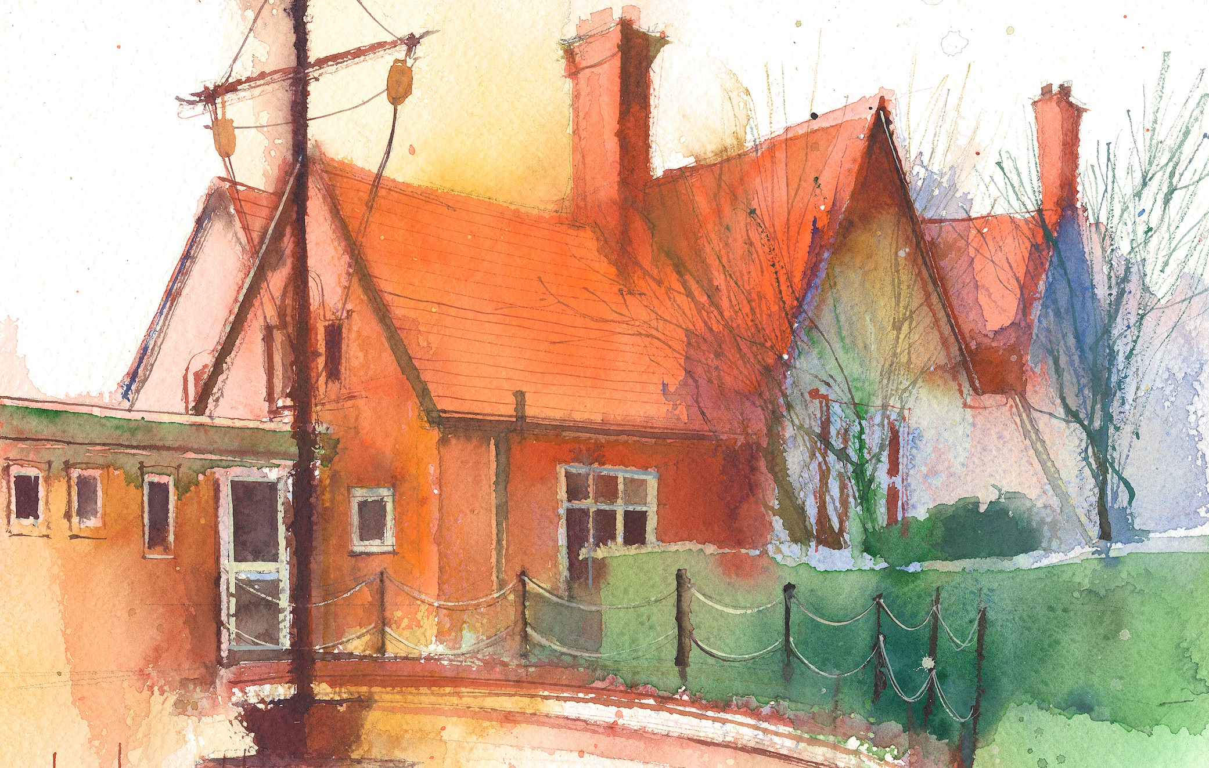

This timetable is available in the event that a Year 1 pupil is required to self-isolate at home, but the cohort remains open to other pupils.
Please visit the Year 1 Remote Learning Page on the school website to access any downloadable resources and activity sheets.

 | Session 1: 09:00-09:20 | Session 2: 09:20-10:30 |  | Session 2: 10:50 – 12:10 |  | Session 3: 13:15 – 15:30 (Incorporating 15-minute break) | Additional Tasks
Monday | Phonics  By the end of this lesson your child should be able to: *Reads words consistent with their phonic knowledge by sound blending.  *Spell words by identifying sounds in them and representing the sounds with a letter or letters  We recommend the following resources and activities to achieve this objective:  PPT- ‘Level 3 Graphemes’  Worksheet | Assembly/Art  By the end of this lesson your child should be able to:  *Speak clearly and confidently in front of my class and others  *Use my voice to sing songs  *Move to the pulse and use actions  We recommend the following resources and activities to achieve this objective:  Nativity script and songs |  | Art  By the end of this lesson your child should be able to:  *Use pencils to create different lines of thickness  *Identify primary and secondary colours  We recommend the following resources and activities to achieve this objective:  Christmas calendars- trees in different seasons (card, tree template, paint) |  | Assembly/Art  By the end of this lesson your child should be able to:  *Speak clearly and confidently in front of my class and others  *Use my voice to sing songs  *Move to the pulse and use actions  We recommend the following resources and activities to achieve this objective:  Nativity script and songs | We also advise your child to complete the following tasks this week:  Ensure they have access to a variety of different books. Some to attempt to read themselves, others that are read to them.  Encourage them to look for the sounds and tricky words taught this week.  Practise writing independently. Most words can be written phonetically. However, tricky words must now be written correctly.  Ensure all letters are formed correctly – most letters start at the top.  Practise number formation. Ensuring there are no ‘nosey’ numbers.  If your child wears trainers with laces for PE, please could you work on helping them tie their own laces.
Tuesday | Phonics  By the end of this lesson your child should be able to: *Reads words consistent with their phonic knowledge by sound blending.  *Spell words by identifying sounds in them and representing the sounds with a letter or letters  We recommend the following resources and activities to achieve this objective:  PPT- ‘Digraphs and trigraphs’  Worksheet | Maths  By the end of this lesson your child should be able to:  *Count one more and one less  We recommend the following resources and activities to achieve this objective:  PPT  Worksheet |  | English  By the end of this lesson your child should be able to:  *Identify doing words  We recommend the following resources and activities to achieve this objective:  Worksheet  PPT  https://www.youtube.com/watch?v=M-_Wky0BNk0  https://www.youtube.com/watch?v=6jwYTZdUVi0 |  | Art  By the end of this lesson your child should be able to:  *Use scissors to cut out shapes  *Create Christmas train using the shapes  We recommend the following resources and activities to achieve this objective:  Card  Template  Scissors
Wednesday | Handwriting  By the end of this lesson your child should be able to:  We recommend the following resources and activities to achieve this objective: |  |  | R.E.  By the end of this lesson your child should be able to:  We recommend the following resources and activities to achieve this objective: |  | Science  By the end of this lesson your child should be able to:  We recommend the following resources and activities to achieve this objective:
Thursday | Phonics  By the end of this lesson your child should be able to:  *Reads words consistent with their phonic knowledge by sound blending.  *Spell words by identifying sounds in them and representing the sounds with a letter or letters  We recommend the following resources and activities to achieve this objective:  PPT- ‘Vowel digraphs’  Worksheet | Maths  By the end of this lesson your child should be able to:  *Compare a group of objects  We recommend the following resources and activities to achieve this objective:  PPT  Worksheet |  | English  By the end of this lesson your child should be able to:  *Write a letter to Father Christmas  *Use finger spaces consistently.  * Write on the lines consistently.  * Start with a capital letter.  * Can start using a full stop.  We recommend the following resources and activities to achieve this objective:  - Phonics- Yes/No sentences (mixture of phase 3 sounds)  - Writing- letter  - Handwriting- sheet  - Grammar- verbs  - Guided Reading  - Independent Reading |  | PE  By the end of this lesson your child should be able to:  *Make my body curl, tense, stretched and relaxed  *Control my body when travelling and balancing  *Copy sequences  *Roll, curl, balance and travel in different ways  We recommend the following resources and activities to achieve this objective:  Let your child be active during this time either outside or inside.  Can they follow a Joe Wicks video?  Or  Cosmic Yoga?
Friday | Phonics  By the end of this lesson your child should be able to:  *Reads words consistent with their phonic knowledge by sound blending.  *Spell words by identifying sounds in them and representing the sounds with a letter or letters  We recommend the following resources and activities to achieve this objective:  PPT- ‘Trigraphs’  Worksheet | Maths  By the end of this lesson your child should be able to:  *Compare objects  We recommend the following resources and activities to achieve this objective:  PPT  Worksheet |  | English  By the end of this lesson your child should be able to:  *Write a letter to Father Christmas  *Use finger spaces consistently.  * Write on the lines consistently.  * Start with a capital letter.  * Can start using a full stop.  We recommend the following resources and activities to achieve this objective:  - Phonics- Yes/No sentences (mixture of phase 3 sounds)  - Writing- letter  - Handwriting- sheet  - Grammar- verbs  - Guided Reading  - Independent Reading |  | Music  By the end of this lesson your child should be able to:  *Listen and appraise  *Use my voice to sing songs  *I can play tuned and untuned instruments musically  We recommend the following resources and activities to achieve this objective:  Charanga scheme  (Find a song appropriate to listen to at home- can they sing along? Can they make up actions?)

