Year Weekly Plan: 0.8.12.25 to 12.12.2025
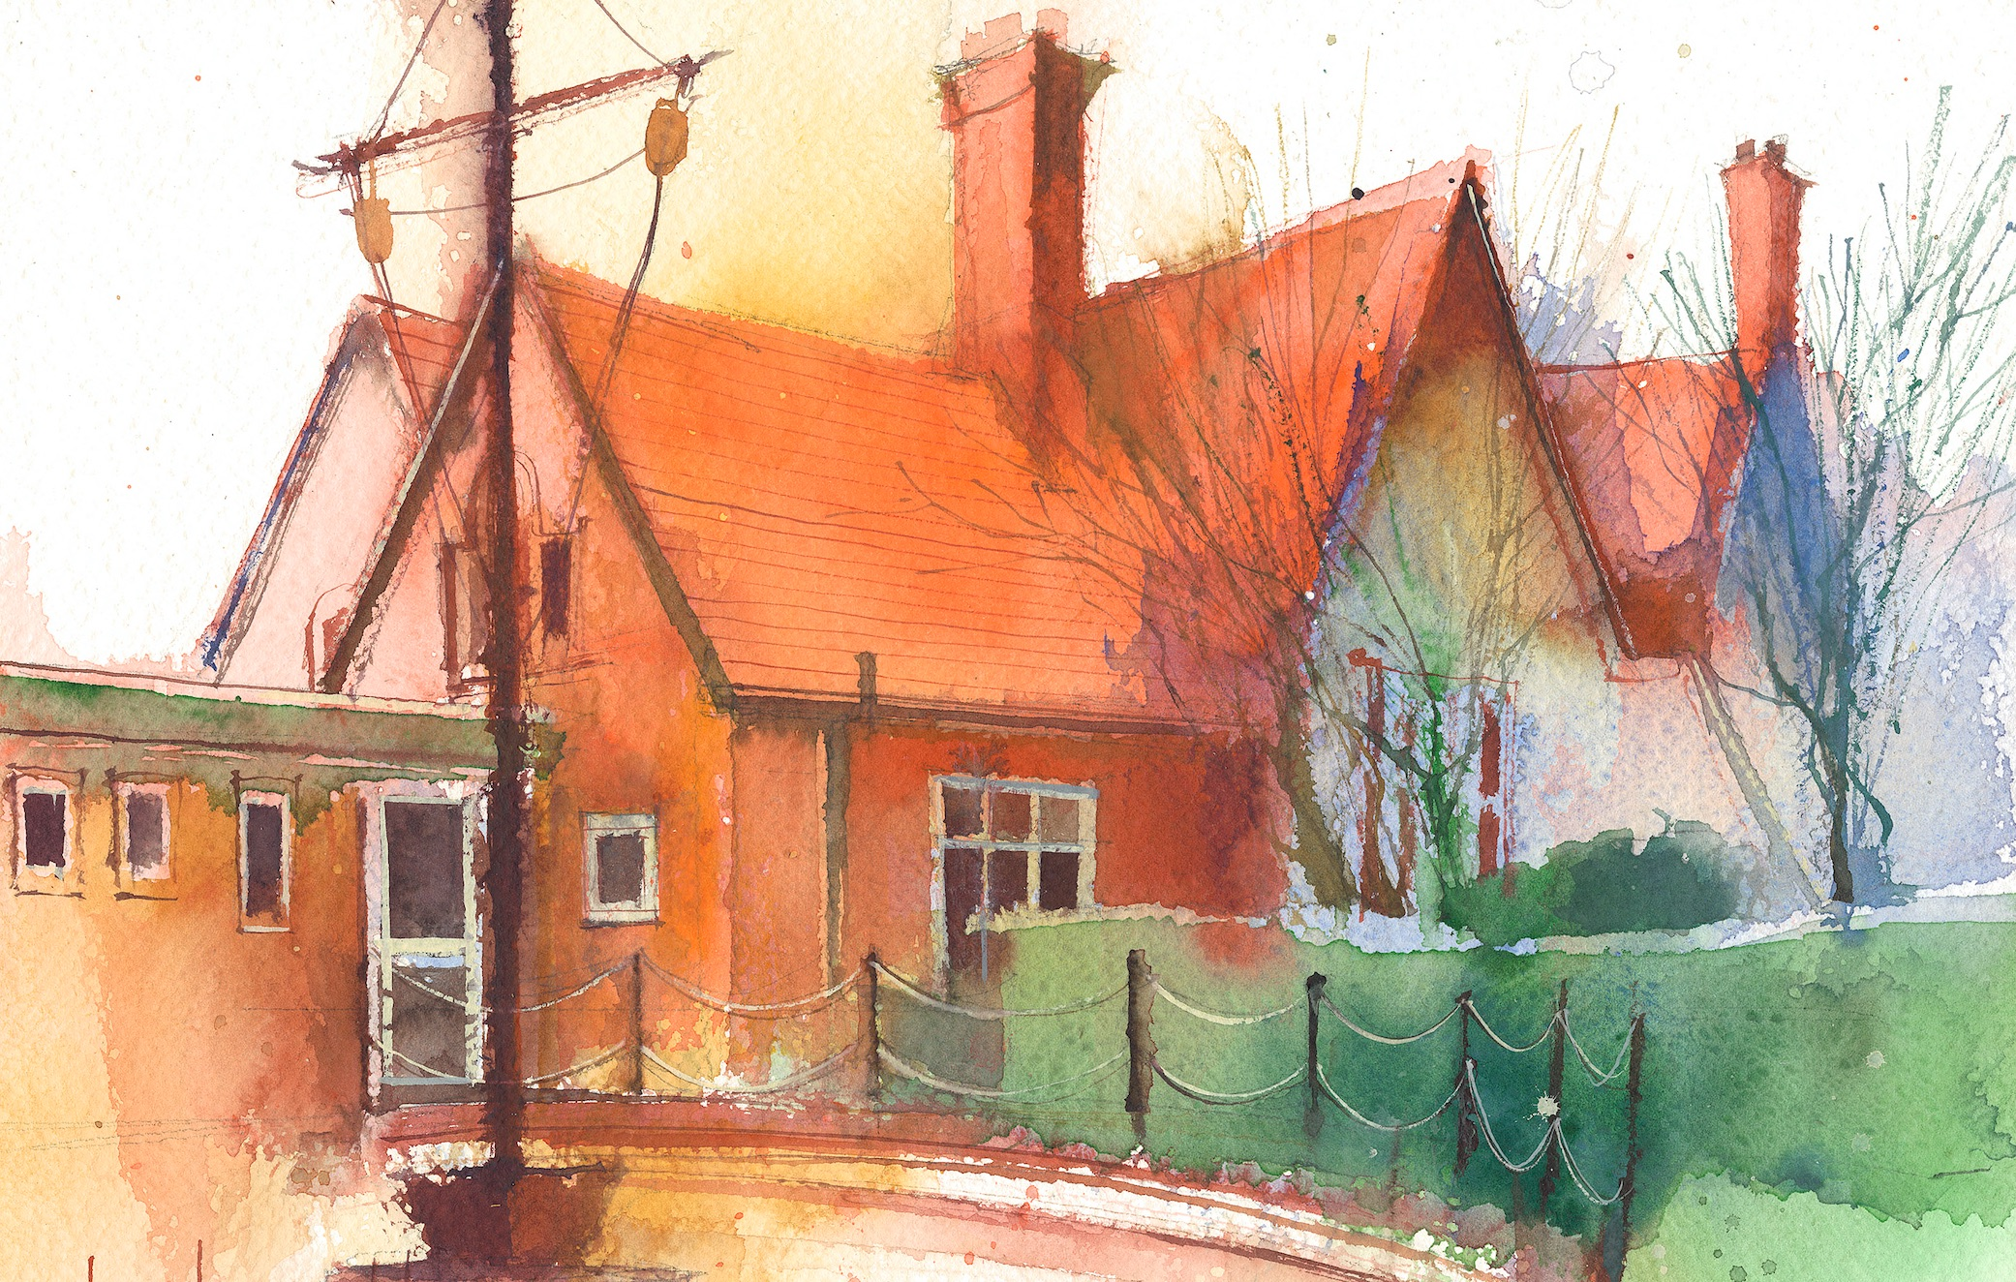
To contact your child’s class teacher, please email schooloffice@dawpool.wirral.sch.uk or phone 0151 648 3412
 | Lessons 09:00 - 10:30 |  | Lessons 10:45 - 12:15 |  | Lessons 13:15 - 15:30  (Incorporating 15-minute break) | Additional Tasks
Monday  08/12/25 | Maths  Fluent in Five, Rapid Reasoning and Arithmetic By the end of this lesson your child should be able to:  • To demonstrate fluency in key mathematical concepts as part of the fluent in five and rapid reasoning tasks.  • To develop increasing accuracy in weekly arithmetic tasks. |  | Reading Comprehension  By the end of this lesson your child should be able to demonstrate the following across a range of fiction, non-fiction and poetry texts:  • To identify unfamiliar vocabulary and phrases.  • Retrieve literal and inferred meanings from the given text  • Sequence and retell events from the  text with detail. |  | Music  • Carol Concert Song Rehearsals  HeartSmart  By the end of this lesson your child should be able to: • To know when and how to ask for help and who to go to.
Tuesday  09/12/25 | Maths  Fluent in five/ Rapid Reasoning  By the end of this lesson your child should be able to: know how to add a mixed number and a fraction.Lesson 11 |  | Power of Reading  Writing spelling words into sentences.  All words have ly ending, make sure everyone sees the root word for all our spellings over the last two weeks |  | Science  By the end of this lesson your child should be able to: make their own sundial and use them. We will discuss how we can use them to help us work out the average number of daylight hours per month  Picture news, British Values | .
Wednesday  10/12/25 | Maths  Visit to Storyhouse.  Leave school 9.00am  Return 1.15 pm. Late lunch  Beauty and the Beast |  | Beauty and the Beast |  | Beauty and the Beast | Staff Meeting/Chess
Thursday  11/12/25 | Music  9.00 -10.30 KS1 Singing  Practice for carol service |  | Power of Reading  By the end of this lesson your child should be able to: a comprehension “An Astronauts Guide to Life on Earth” which will tie in with the end of our Earth and Space topic. |  | Carol Servicce at Saint Chad’s  Leave school at 1.30 for 2.15 start, some children to be picked up from church and the rest to come back to school. | Choir
Friday  12/12/25 | Maths  Fluent in five/ Rapid Reasoning  By the end of this lesson your child should be able to: know how to add two mixed numbers.Lesson 12 |  | English  By the end of this lesson your child should be able to: do a recount/eyewitness account of out trio to Beauty and the Beast. |  | IT  By the end of this lesson your child should be able to: understand data bases and how they can be used.  RE  By the end of this lesson your child should be able to: understand about the bible unit 5.2 , How does the birth of Jesus fit into Gods Big Story Questful RE . Look at a number of videos showing the nativity story relating to the two bible versions in the gospels. | Celebration of weeks work.  Santa Dash

