**Weekly Timetable Year Group WC 19th May 2025**

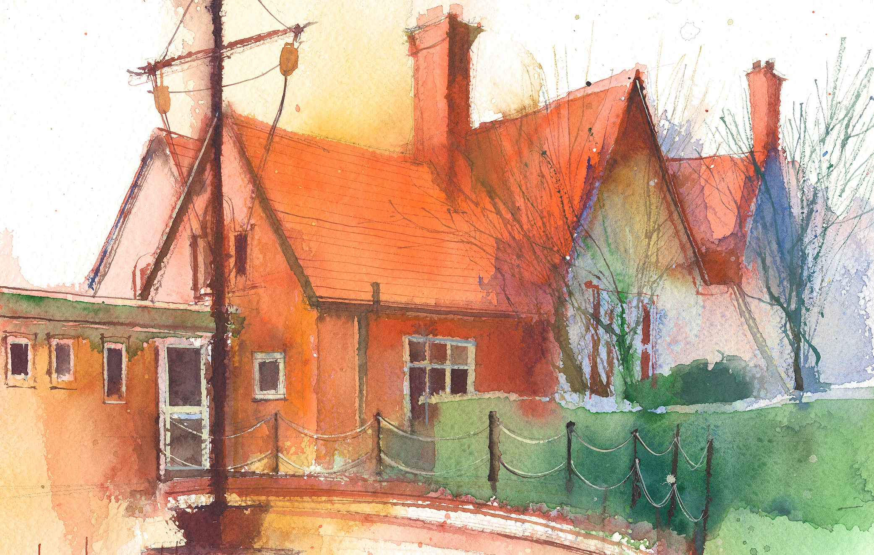

|  |  |  |  |  |  |  |
| --- | --- | --- | --- | --- | --- | --- |
|  | **Lessons 09:00 – 10:30** |  | **Lessons­­­­ 10:45 – 12:15** |  | **Lessons 13:15 – 15:30 (Incorporating 15-minute break)** | |
| **Monday** | **Maths Multiplication and division B**  Maths  By the end of this lesson your child will:  To know how to multiply a 4-digit number by a 2-digit number  Third Space Teaching slides based on lesson 5 and related worksheets and resources | Literacy (POR)  Children finish diary entry based on story up to chapter 2. Read the next chapter of the book in preparation for following lesson. | Topic work (South America)  Children to research and record information about one country in South America. Use Google docs to create their own information booklet. | P. E.  Running  Relay running using the quick starts from complete P.E. lesson 3 |
| **Tuesday** | **SPORTS DAY** | **SPORTS DAY** | MRS WOOD TO COVER Y5 PPA | |
| **Wednesday** | Mrs Hall | Mrs Hall | Mrs Hall | |
| **Thursday** | Maths  By the end of this lesson your child will:  Know how to solve multiplication problems  Third Space Teaching slides based on lesson 6 and related worksheets and resources | Literacy (POR)  Create a playscript Playscript based on  an imaginary conversation between Maia and a character she would like to share her news with (perhaps Clovis) about Miss Minton and her plan. The children should discuss their thoughts about Miss Minton as a character, the plan itself, Maia’s thoughts and feelings about her life in the Carters’ house and what the plan means to her. | Questful R.E.  Explore the role of women in the Old Testament.  Deborah from the Book of Judges  Unit 5.5 Old Testament women | |
| **Friday** | **Maths**  By the end of this lesson your child will:  Learn how to solve short division sums  Third Space Teaching slides based on lesson 7 and related worksheets and resources | Computing (Year 4)  This unit introduces year 4 into the “Making Music” Unit 4.9 in Purple mash scheme of work. | Science (Forces)  By the end of this lesson your child will:  Explain that unsupported objects fall towards the Earth because of the force of gravity acting between the Earth and the falling object. Working scientifically: · To use test results to make predictions to set up further comparative and fair tests. | |

**Weekly**

Worship (Mon & Fri) 10:10-10:30

HeartSmart (20-minutes per week)

Picture News (20-minutes per week)

No Outsiders (20-minutes per week)

My Happy Mind (20-minutes per week)

Reading for Pleasure (at least 10-minutes per day)

**Weekly**

Maths (daily)

Rapid Reasoning / Fluent in Five (daily)

Power of Reading x 3

Punctuation & Grammar x1

Spelling x1

Reading Comprehension x1

RE

Science

PE

**Weekly / Fortnightly / Blocked**

History

Geography

DT

Art

Music

Computing (MFL) KS2

(Y3/4 September – Feb)

(Y5/6) February – July)