Foundation 2 Weekly Timetable Week Commencing 13.04.26
To contact your child’s class teacher, please email schooloffice@dawpool.wirral.sch.uk or phone 0151 648 3412
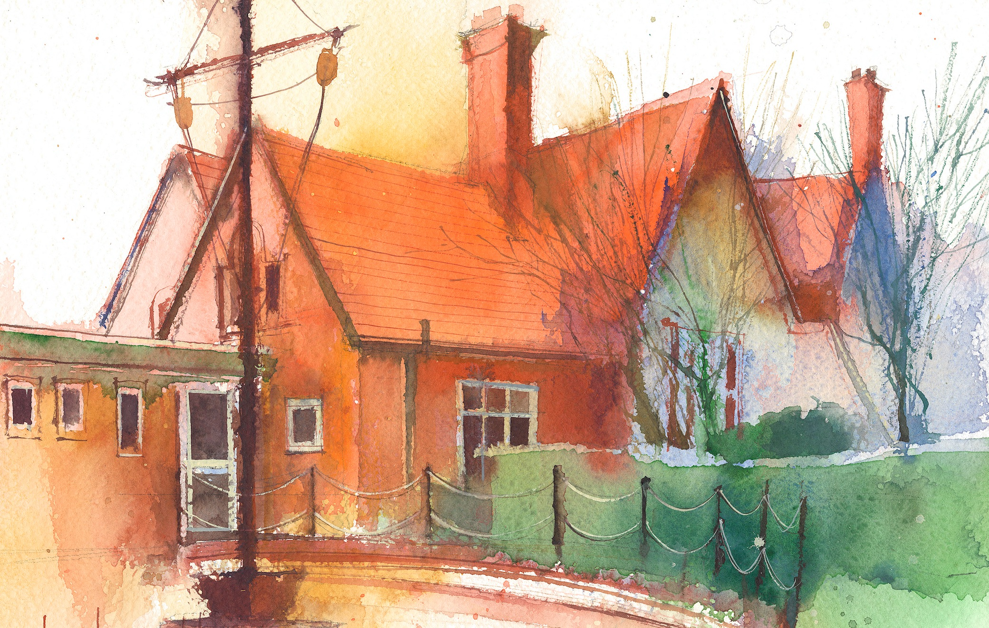

This timetable is available in the event that a Foundation 2 pupil is required to self-isolate at home, but the cohort remains open to other pupils.
Please visit the Foundation 2 Remote Learning Page on the school website to access any downloadable resources and activity sheets.

 | Session 1: 09:00-10:30 | Session 2: 10:50 – 12:00 | Session 3: 10:50 – 12:00 | Session 4: 10:50 – 12:00
Monday | Literacy  Adult Led Focus  Marvellous Moon Map  Look at the cover and discuss what they think the story might be about. PP to build ideas.  Next look at the first 2 pages. What do they think about where the mouse lives?  Does it look like a nice place, a scary place?  Introduce the concept of the word adjectives, words which help us describe things. Can they think of some adjectives to describe the picture?  PP to share ideas.  Focus Task – Write some key adjectives on the board. Deep, dark, gloomy, spooky, | Phonics  By the end of this lesson your child should be able to:  Consolidate Learning of ch,sh,th  We recommend the following resources and activities to achieve this objective:  Blending practice.  Children will complete activities in their individual rocket phonics workbooks. | Maths  By the end of this lesson your child should be able to:  Children will understand the order of numbers to 10, use a number line to count forwards and backwards, and compare numbers using the number line.  We recommend the following resources and activities to achieve this objective:  Lay out numbers 0–10 on the floor  Explain that this is a numberline to help us count forwards and backwards to 10  I will select some children to physically move along the number line.  Ensure children start from 0.  Call out instructions: “Stand on number 3” , “Jump two numbers forward” “What number is between 4 and 6?” | Topic  What is dark?  Introduce the Topic shelf and explain our new topic is ‘Light and Dark’.  Ask:  “What do you think dark means?”  “When do we see darkness?”  PP to share ideas.  Note down ideas they make and guide them to the answer ‘Darkness happens when there is no light’.
Tuesday | Literacy  Adult Led Focus  Read the next two pages where we meet bear and see mouse’s underground house.  He wants to go to the moon. What can you see in the house?  He really wants to go to the moon doesn’t he!  Mouse says he wants to go to the moon on his own. Why? Is that a good idea?  Think of reasons for and against him going alone.  Focus Task – Look at the image of the mouse and fill in the speech bubble with “I will go on my own” dictated sentence. | Phonics  By the end of this lesson your child should be able to:  Consolidate learning of ng, ai, ee  We recommend the following resources and activities to achieve this objective:  Segmenting practice.  Children will complete activities in their individual rocket phonics workbooks. | Maths  By the end of this lesson your child should be able to:  Children will understand the order of numbers to 10, use a number line to count forwards and backwards, and compare numbers using the number line.  We recommend the following resources and activities to achieve this objective:  Lay out numbers 0–10 on the floor  Call out “Jump 1 more than 5” or “Jump 2 back from 7”  Children physically hop to the answer  Use small objects (beanbags) to mark positions  Other children to have whiteboards and record the number they land on as they go along. | Topic  Exploring shadows and reflections  Re-cap on yesterday’s light and dark ideas.  Show pictures or objects (sun, torch, stars, night sky)  Sort into “light” and “dark” groups  Ask: When do we see these? Day or night?  Go into a dark room and use the torches to explore objects that absorb light and create shadows and objects that reflect light.
Wednesday | Literacy  Adult Led Focus  Read the next two pages where mouse makes his map.  A map helps us see where things are and how to get from one place to another.  If you were travelling to the moon, what things might you go past?  Focus Task – Write down a list with a selection of their ideas.  Highlight the words that are tricky, using phonemes they don’t yet know and those which they do know. | Phonics  By the end of this lesson your child should be able to:  Consolidate learning of igh, oa  We recommend the following resources and activities to achieve this objective:  Blending practice  Children will complete activities in their individual rocket phonics workbooks. | Maths  By the end of this lesson your child should be able to:  Children will understand the order of numbers to 10, use a number line to count forwards and backwards, and compare numbers using the number line.  We recommend the following resources and activities to achieve this objective: Show two numbers on the number line (e.g., 3 and 7).  Ask:  “Which is more/the biggest number?”  “Which is fewer/the smallest number?”  “How do you know?”  Use toys, fingers, or markers to jump along the line and see the difference. | PE  By the end of this lesson your child should be able to:  Understand why it is important to take turns when playing a game.  We recommend the following resources and activities to achieve this objective:  Keep discussing the following questions as we go through the lesson. Why do we need to take turns? Why do we need to stay in a space when we are running?  Warm up by playing follow my leader in pairs. Number 1 leads the way and number 2 must follow. Number 1 can call out different ways to move and number 2 copies.  In pairs, pupils take turns being the shark (attacker) and fish (defender). The shark follows the fish around the space following and copying their pathway. On your command, the fish must try and avoid being caught (tagged) by the shark. Swap roles.  Do pupils take turns? Can the fish avoid being caught by the shark? Pupils can use tag rugby tags to imitate a fishes tail. This provides the sharks with something to try to tag.
Thursday | Literacy  Adult Led Focus  Read the next two pages where bear talks about the things they need to pack for the trip.  Discuss in PP things you would take with you to the moon? What would be important?  Focus Task – Write down a list with a selection of their ideas.  Discuss what a list looks like. Numbered at the start with one or two words, we are not building a sentence. | Phonics  By the end of this lesson your child should be able to:  Learn to write the digraph ‘oo/oo’  We recommend the following resources and activities to achieve this objective:  Segmenting practice  Children will complete activities in their individual rocket phonics | Maths  By the end of this lesson your child should be able to:  Children will understand the order of numbers to 10, use a number line to count forwards and backwards, and compare numbers using the number line.  We recommend the following resources and activities to achieve this objective: Show children a number line with missing numbers  Ask: “What number comes here?”  Encourage children to count along to fill gaps.  Start at 0 to help | RE  By the end of this lesson your child should be able to:  Recognise that people have different beliefs and celebrate special times in different ways.  We recommend the following resources and activities to achieve this objective:  Read the story ‘Guess How Much I Love You’ by Sam McBratney. How could we show how much we love someone?  Jesus showed his love by dying on the cross  As a class make our own version of the book suggesting your own measurements of love.  Ask the children to draw pictures of themselves doing something special for someone they love. Can they explain their picture and why they chose to draw that particular scene. Record in your floor book.  Create a prayer tree using heart shapes instead of leaves. The children can draw and write prayers on the hearts thanking God for the people who love them and for his love for us.
Friday | Literacy  Adult Led Focus  Read the next four pages up until Mouse sees a strange creature in the woods. What could it be?  Discuss in PP what it might be?  Focus Task – Write down some of their ideas for what might be in the woods.  I will draw my own picture of the creature and label it  Sharp teeth  Green spots  Big red eyes | Phonics  By the end of this lesson your child should be able to:  Consolidate their learning of Common Exception words all, are  We recommend the following resources and activities to achieve this objective:  Children will complete activities in their individual rocket phonics workbooks. | Maths  By the end of this lesson your child should be able to:  Children will understand the order of numbers to 10, use a number line to count forwards and backwards, and compare numbers using the number line.  We recommend the following resources and activities to achieve this objective:  Use a toy to “walk along the number line”  Tell a story: “The frog jumps from 2 to 5 – how many jumps did it take?”  Children act it out or draw the jumps | Heart Smart  By the end of this lesson your child should be able to:  Fake is a mistake  Differentiate between words that are true and untrue  Boris says ‘Kind and true words fill our hearts with love”  We recommend the following resources and activities to achieve this objective:  Read ‘Boris the Robot’ and ask the children: What does the Scrapman say to Boris?  How does Boris feel when he listens to the Scrapman? (Look at Boris’ expression, body language, etc.)  Is what the Scrapman says about Boris true?  Who says kind and true things to Boris in the story?  How does Boris feel when he listens to Amber and Josh? Show the children the slides and read the sentences one by one. Tell the children if they think the sentence is true, to put their thumbs up or if they think it is a lie to put their thumbs down.  Who would they listen to - the Scrapman or the children? Which words would they want to use with their friends - unkind words like the Scrapman or kind words like the children?

