**Foundation 2 Weekly Timetable Week Commencing 29.9.25**

**To contact your child’s class teacher, please email** [**schooloffice@dawpool.wirral.sch.uk**](mailto:schooloffice@dawpool.wirral.sch.uk) **or phone 0151 648 3412**

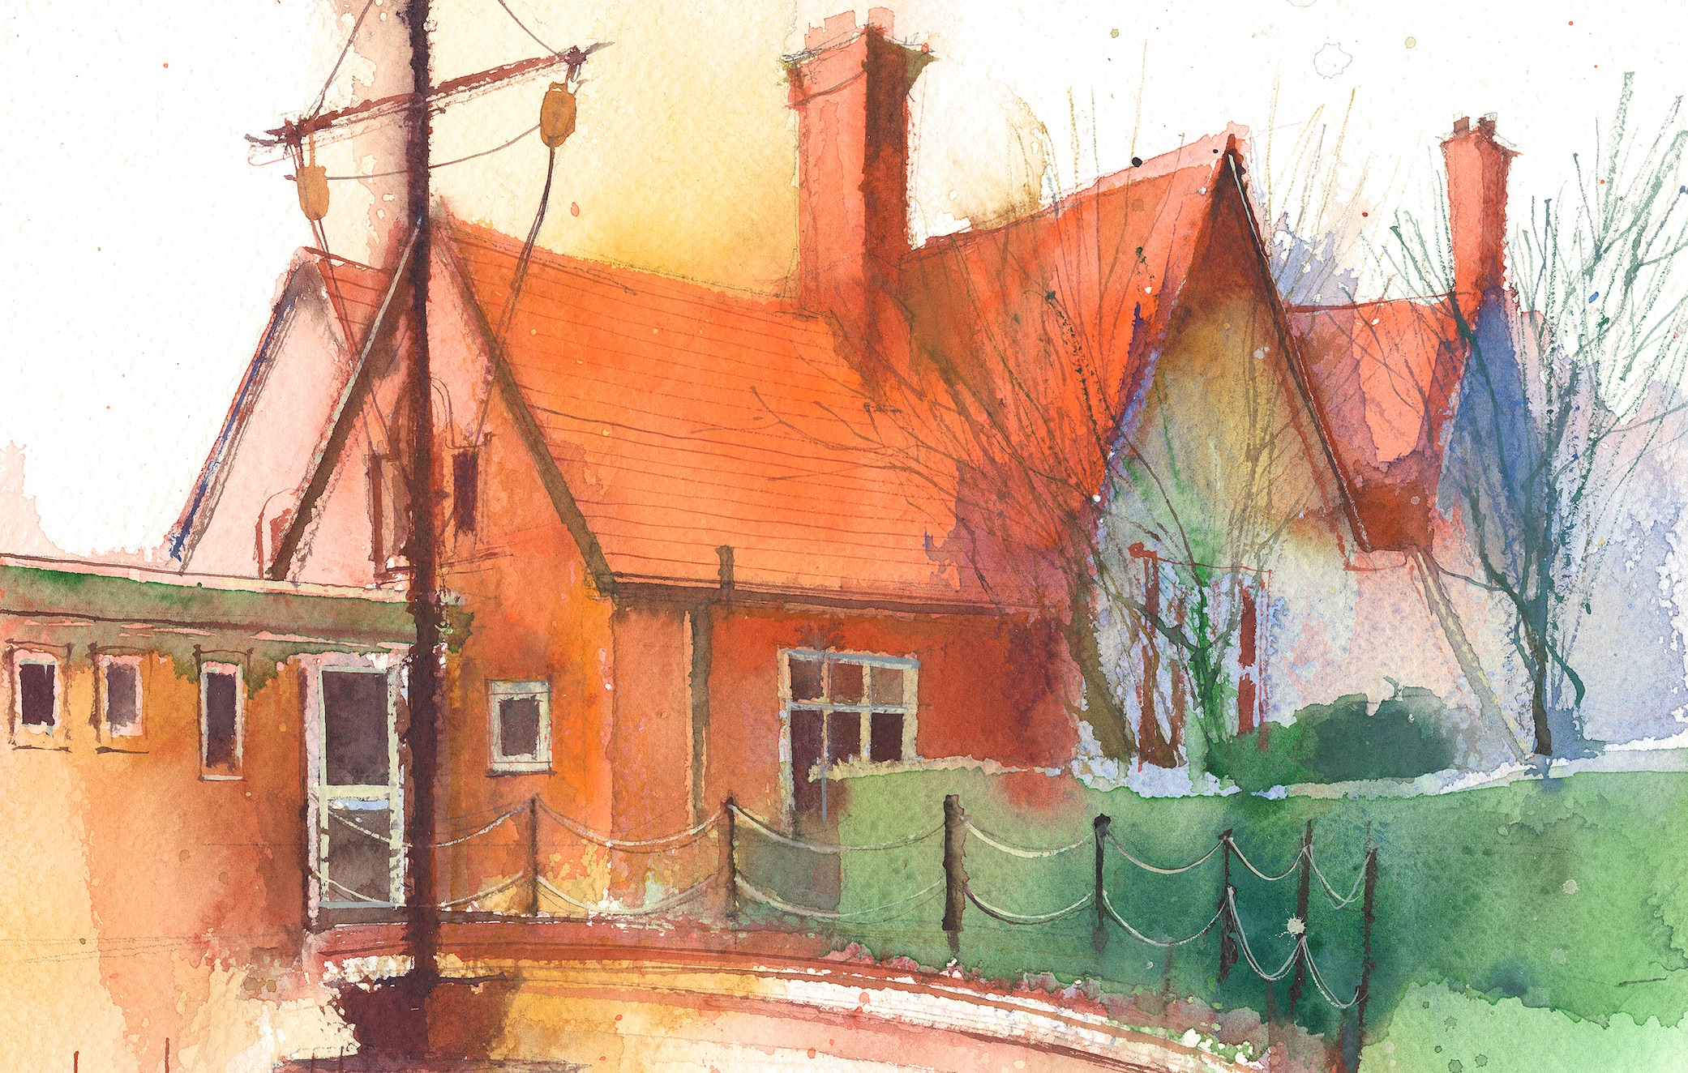

This timetable is available in the event that a Foundation 2 pupil is required to self-isolate at home, but the cohort remains open to other pupils.

Please visit the Foundation 2 **Remote Learning Page** on the school website to access any downloadable resources and activity sheets.

|  |  |  |  |  |  |
| --- | --- | --- | --- | --- | --- |
|  | **Session 1: 09:00-10:30** |  | **Session 2: ­­­­ 10:50 – 12:00** |  | **Session 3: 13:15 – 15:25** |
| **Monday** | **Phonics**  **By the end of this lesson your child should be able to:**  Recognise and say the sound ‘p’  **We recommend the following resources and activities to achieve this objective:**  Blending practice.  Children will complete activities in their individual rocket phonics workbooks. | **Maths**  **By the end of this lesson your child should be able to:**  *To understand the composition of the number 3*  **We recommend the following resources and activities to achieve this objective:**  Read the story of The Three Little Pigs. As we go through the story write down and represent the number 3 in different ways every time it is mentioned in the story.  Can they say what this weeks number is?  Encourage the children to sit with a partner and practice writing the number 3 on each others backs, with their fingers. | **Topic**  During the afternoons we will undertake activities linked to all areas of the Early Years Curriculum;  **Prime Areas**; Communication and Language;  Personal, Social and Emotional Development;  Physical Development.  **Specific Areas**; Literacy, Maths, Understanding the World and Expressive Arts and Design.  Afternoon sessions will also include RE, HeartSmart and Forest Schools.  Our current RE topic is ‘Special Times’. Planning for this can be found on the website.  Activities will be linked to our class topic which is ‘Where in the World’. We aim to use children’s books as a hook for learning to help us find out more about the world around us. Throughout the year we will select books that enable us to cover all requirements of the Early Years Curriculum.  We will talk about where the book is set and find out where this country is on a map. We will then use the theme of the book as a way of guiding our planning.  **PLEASE NOTE**  The very nature of the EYFS curriculum enables us to go with the interests of the children. The activities we plan are for a guide only.  Staff can use and adapt activities or add additional activities and not cover others. It is all dependent on how and where the children’s interests take us.  Activities are designed to cover several weeks, if needed.  A copy of the current topic plan is available to view on the class website page. |
| **Tuesday** | **Phonics**  **By the end of this lesson your child should be able to:**  Recognise and write the sound ‘p’  **We recommend the following resources and activities to achieve this objective:**  Segmenting practice.  Children will complete activities in their individual rocket phonics workbooks. | **Maths**  **By the end of this lesson your child should be able to:**  *To link the number symbol with its cardinal number value*  **We recommend the following resources and activities to achieve this objective:**  Watch BBC iplayer Numberblocks  ‘Three’ Discuss the episode and concepts taught.  Can they go and stand in groups of three?  Count together to check they are a three. |
| **Wednesday** | **Phonics**  **By the end of this lesson your child should be able to:**  Recognise and say the sound ‘n’  **We recommend the following resources and activities to achieve this objective:**  Blending practice  Children will complete activities in their individual rocket phonics workbooks. | **Maths**  **By the end of this lesson your child should be able to:**  *Subitise - To recognise quantities without counting.*  **We recommend the following resources and activities to achieve this objective:**  On the carpet lay out the giant tens frame and tell the children what it is called.  Place three teddies into the first three spaces. Together count 1:1 each of the bears. Move them into different spaces. How may do we have now? How do they know? Count again and check. – repeat. |
| **Thursday** | **Phonics**  **By the end of this lesson your child should be able to:**  Recognise and write the sound ‘n’  **We recommend the following resources and activities to achieve this objective:**  Segmenting practice  Children will complete activities in their individual rocket phonics workbooks. | **Maths**  **By the end of this lesson your child should be able to:**  To be able to recognise and name a triangle and their properties.  **We recommend the following resources and activities to achieve this objective:**  Put hand in a bag and describe a shape to the children “It has three straight sides and three sharp pointy corners”. Can they name it?  Show them the triangle and repeat with different shaped and sized triangles. |
| **Friday** | **PE**  **By the end of this lesson your child should be able to:**  *Revise and refine fundamental movement skills already acquired.*  **We recommend the following resources and activities to achieve this objective:**  During this half term the children will use the hall space to undertake games and activities that require them to roll, crawl, walk, jump, run, hop, skip and climb.  Children will also learn to stop and change directions safely. | **Phonics**  **By the end of this lesson your child should be able to:**  *To re-cap on ‘satipn’*  **We recommend the following resources and activities to achieve this objective:**  Children will complete activities in their individual rocket phonics workbooks. |