Week 2 Year 5 Weekly Plan: 17.11.2025 21.11.2025
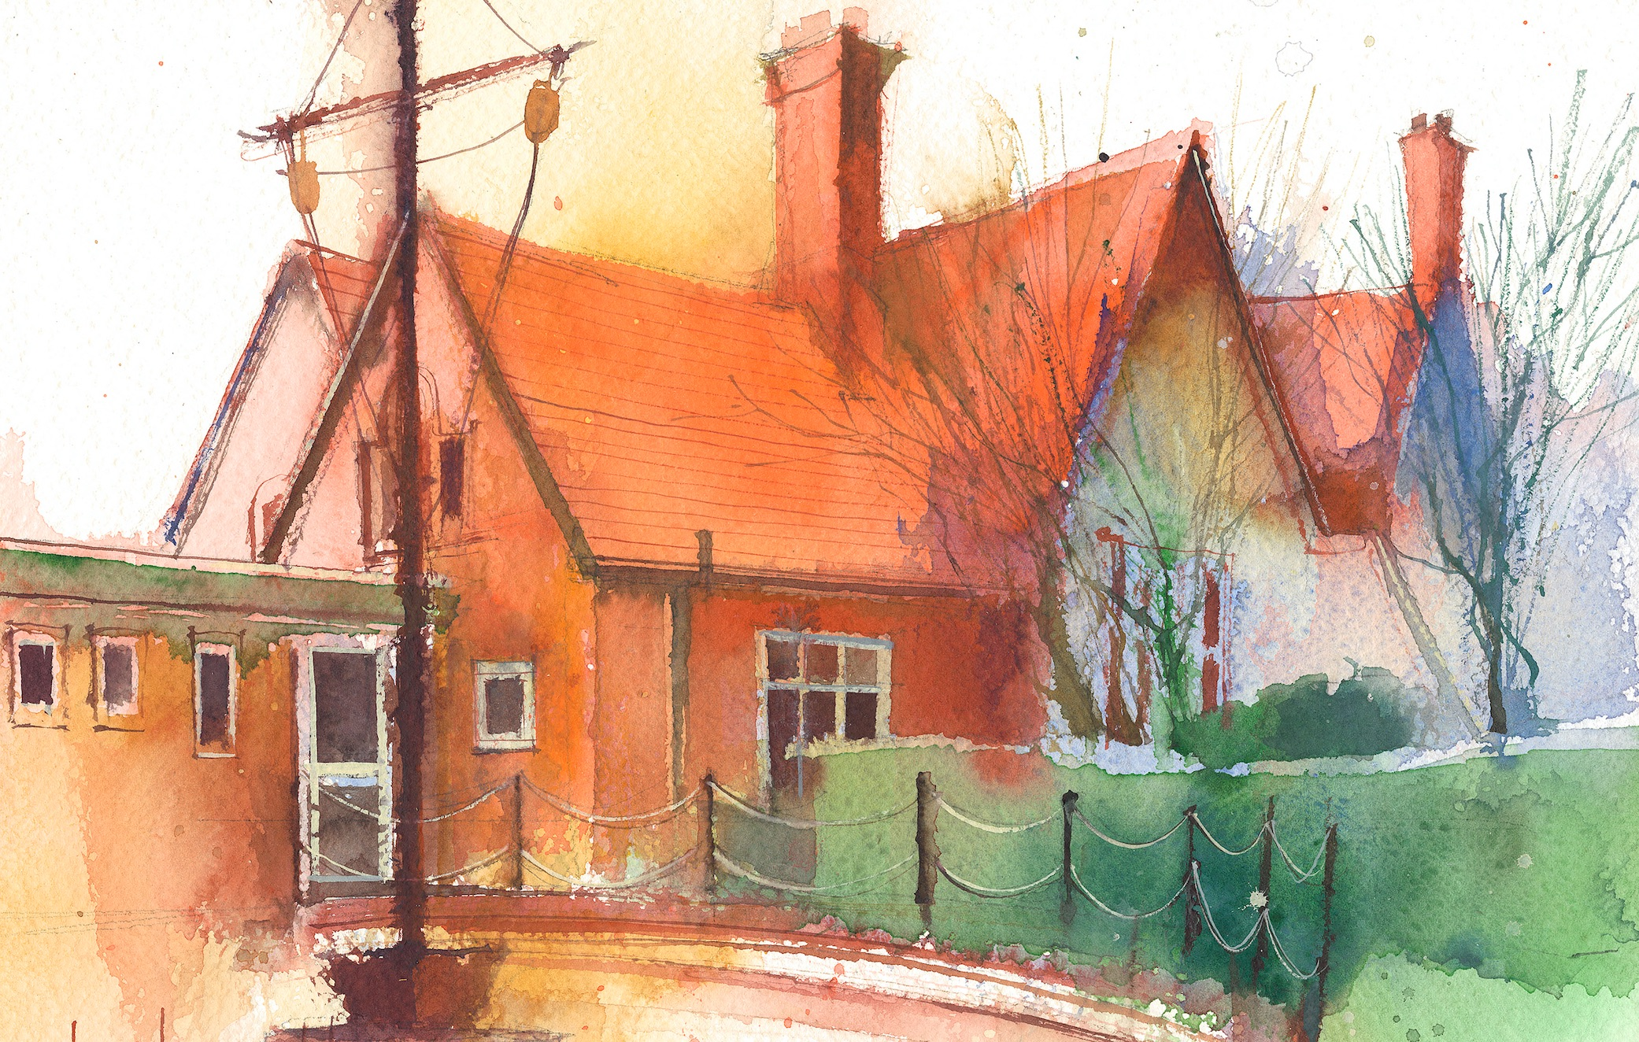
To contact your child’s class teacher, please email schooloffice@dawpool.wirral.sch.uk or phone 0151 648 3412
 | Lessons 09:00 - 10:30 |  | Lessons 10:45 - 12:15 |  | Lessons 13:15 - 15:30  (Incorporating 15-minute break) | Additional Tasks
Monday  17/1125 | Maths  Fluent in five/ Rapid Reasoning  By the end of this lesson your child should be able to: know how to convert from improper fractions to mixed numbers. Lesson 4 Fractions |  | Power of Reading  By the end of this lesson your child should be able to: ·Write and eyewitness narrative account of the battle between the Goddess Athena and Arachne |  | Art  To complete our animal posters from Cheshires Wonderful Wildlife posters using vibrant colours.  Handwriting
Tuesday  18/11/25 | Maths  Fluent in five/ Rapid Reasoning  By the end of this lesson your child should be able to: know how to convert mixed numbers to proper fractions. Lesson 5 Fractions  {flu jabs} |  | Power of Reading  By the end of this lesson your child should be able to: To find the definition of any words they don’t know and then write new spellings into sentences. They will use a different sentence starter in each sentence. |  | Topic  By the end of this lesson your child should be able to: draw their own temple column design using either Doric, Ionic or Corinthian design  Picture news, British Values | .
Wednesday  19/1125 | Maths  Fluent in five/ Rapid Reasoning  By the end of this lesson your child should be able to: To demonstrate fluency in key mathematical concepts as part of the fluent in five and rapid reasoning tasks. • To develop increasing accuracy in weekly arithmetic tasks. |  | Reading Comprehension  By the end of this lesson your child should be able to demonstrate the following across a range of fiction and non-fiction text types:  • To identify unfamiliar vocabulary and phrases. #  • Retrieve literal and inferred meanings from the given text.  • Sequence and retell events from the text with detail. |  | Music  By the end of this lesson your child should be able to: • Begin to recognise the basic style indicators of jazz music • Listen and appraise the music Cotton tail by Ben Webster • Play the tune/head and improvisation sections of ‘The Three Note Bossa.’  HeartSmart  By the end of this lesson your child should be able to: • identify lies they believe/listen to? • suggest opposing truths to those lies? • describe how listening to and believing lies makes them feel? • describe how listening and believing truth makes them feel? | Chess
Thursday  20/11/25 | Maths  Walker Art Gallery Trip . |  | Power of Reading  Walker Art Gallery Trip.  To find out more about the story of Echo and Narcissus |  | PE  By the end of this lesson your child should be able to: play in a hockey game using the hockey stick correctly.  SPAG  Unit 7 Sentences, direct speech, Nelson Grammar book 5 | Choir
Friday  21/11/25 | Maths  Fluent in five/ Rapid Reasoning  By the end of this lesson your child should be able to: compare fractions less than 1. |  | English  By the end of this lesson your child should be able to: we will listen to the story of Echo and Narcissus. We will act out the story in small groups before doing some hot seating.  Spelling test |  | IT  RE,  By the end of this lesson your child should be able to: understand about the 5.2 unit what do you think is the most important part of the Christmas story Questful RE. | Celebration of weeks work

