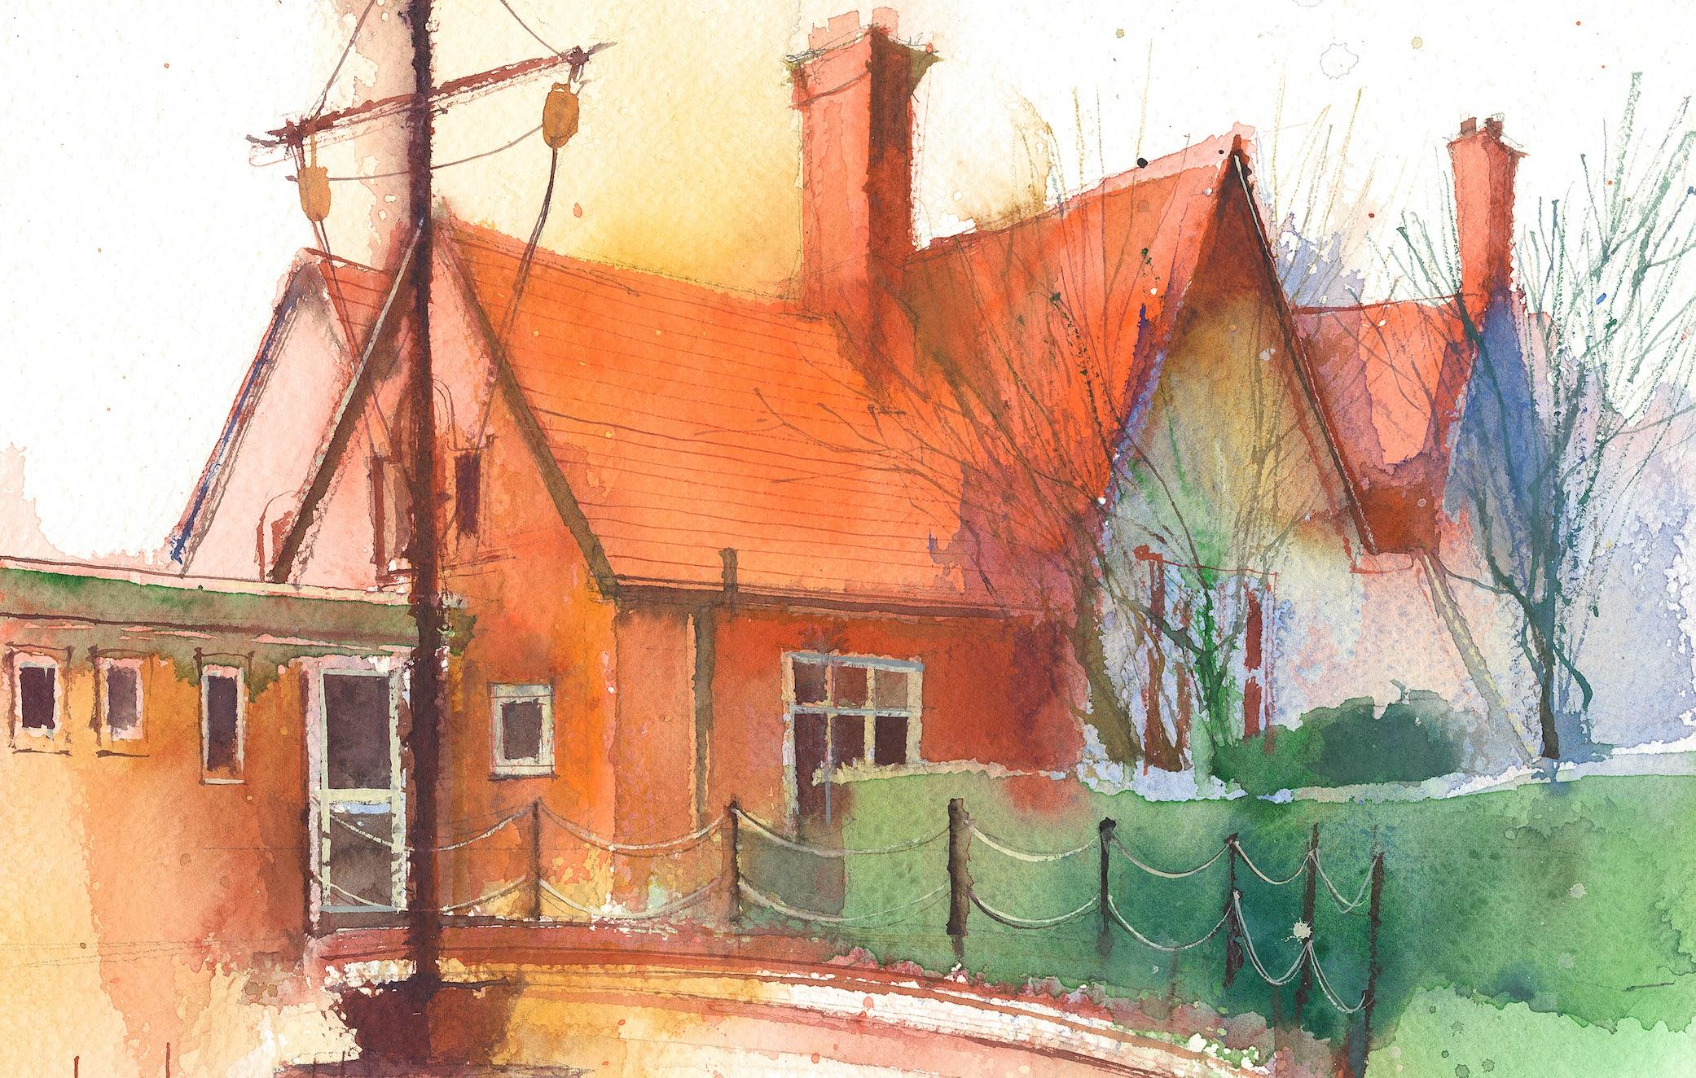
Year 1 Weekly Timetable Week Commencing 20.04.26
To contact your child’s class teacher, please email schooloffice@dawpool.wirral.sch.uk or phone 0151 648 3412

 | Lessons 09:00 – 10:30 |  |  | Lessons 10:45 – 12:15 |  | Lessons 13:15 – 15:30 (Incorporating 15-minute break) | Additional Tasks
Thursday | Phonics: Phonics recap phase 3, 4 and 5. Guided Reading.  English:  • To continue to learn to tell the Retell version of Troll Swap.  • To use ‘but’ to join two sentences. | Fashion  show! |  | Maths: (+ and - in 20)  Handwriting and Nessy. |  | Fin5  Forest School/RE:  • I can learn about baptism through special objects.
Friday | Phonics: Phonics recap phase 3, 4 and 5. Guided Reading.  English:  • Recall today’s section of Story Map in pairs  •Record Retell version in one/two sentences  •To use ‘and’ to join two phrases. | Celebration Assembly |  | Maths: (+ and - in 20)  Handwriting and Nessy. |  | Fin5  PE:  • I can learn how to attack in a game of tag-rugby.  Computing:  To follow and create simple instructions on a device.  Golden Time!

