Year 1 Weekly Timetable Week Commencing 16.05.22
To contact your child’s class teacher, please email schooloffice@dawpool.wirral.sch.uk or phone 0151 648 3412
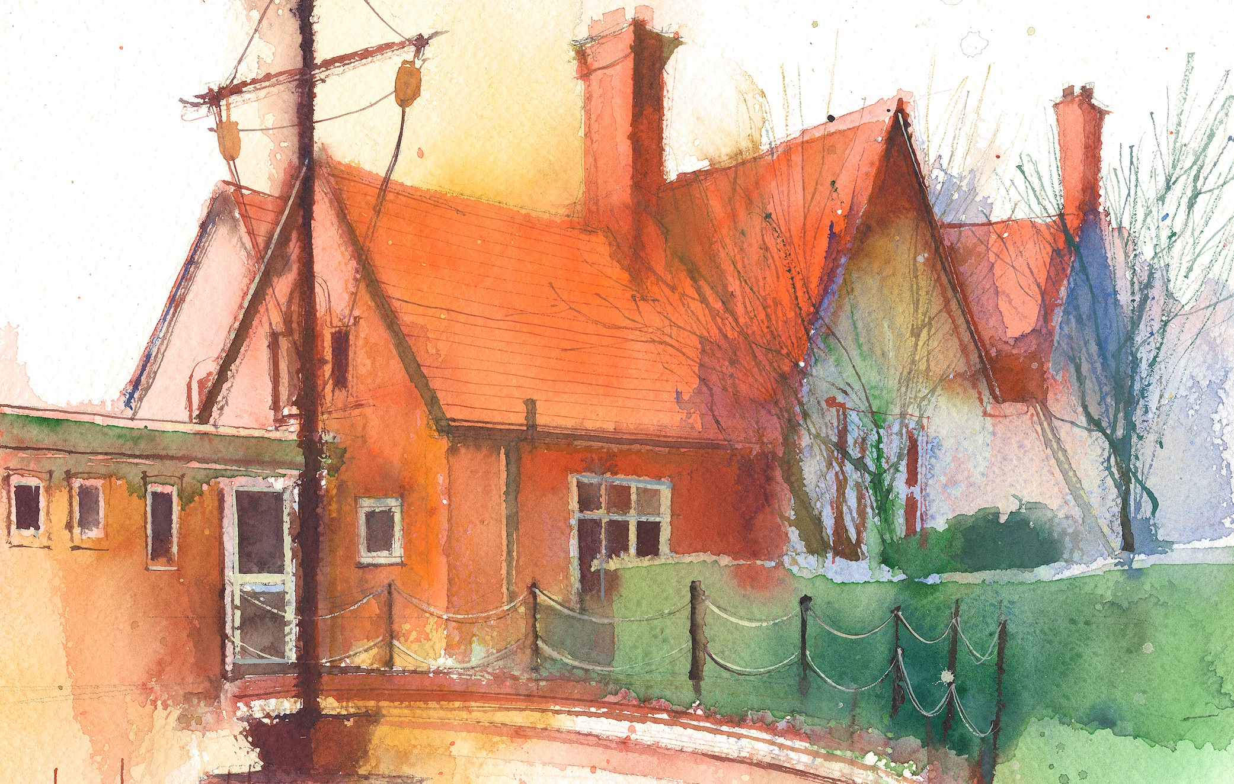

This timetable is available in the event that a Year 1 pupil is required to self-isolate at home, but the cohort remains open to other pupils.
Please visit the Year 1 Remote Learning Page on the school website to access any downloadable resources and activity sheets.

 | Session 1: 09:00-09:20 | Session 2: 09:20-10:30 |  | Session 2: 10:50 – 12:10 |  | Session 3: 13:15 – 15:30 (Incorporating 15-minute break) | Additional Tasks
Monday | Phonics  By the end of this lesson your child should be able to: *Reads words consistent with their phonic knowledge by sound blending.  *Spell words by identifying sounds in them and representing the sounds with a letter or letters  We recommend the following resources and activities to achieve this objective:  PPT- Phase 5  Worksheet | Maths  By the end of this lesson your child should be able to:  *Sharing (recap)  We recommend the following resources and activities to achieve this objective:  Worksheet |  | English  By the end of this lesson your child should be able to:  *Re-read and respond to an illustration  We recommend the following resources and activities to achieve this objective:  https://www.youtube.com/watch?v=Vkq8K812hwQ  Plan:  Read aloud the next paragraph (up to “…princesses were coming from all over the world to visit.”)  ▪ _Ask children to work in groups to discuss their understanding of what might be meant by a ‘big tea party’. Have any of them heard of or attended a tea party before? If not, what do they imagine might happen there? What other parties or celebrations have children attended? What sort of things might happen at one of these events? What do they imagine to be the best thing to do or see or eat at a celebration?  ▪ _Children may benefit from exploring videos or photos of tea parties or afternoon tea experiences to support their understanding of what type of luxury might be expected at the palace: china cups, tea pots, finger sandwiches, scones, fresh cream and intricately decorated cakes (e.g. https://www.youtube.com/watch?v=FxdXBLL4fKM).  ▪ _Explore with the class some of the categories that you might need to consider if the Queen needed your help to plan her tea party. List these on the board or flip chart. They might include: food, entertainment, games/activities, dress code, etc.  ▪ _In their groups, ask children to create a mind map on which they can make note of all of their ideas for each of these areas. Remind them that the guests for this tea party are coming from all over the world, can they make their list of ideas reflect the diversity of the guests?  If the Queen wants “princes and princesses from all of the world” to attend her tea party, what will we need to include on the invitation? What information will they need in order to be able to attend? And, what further information might we choose to include to persuade them that they want to attend?  - Create an invitation altogether through shared writing to help for independent writing this week. |  | Topic  By the end of this lesson your child should be able to:  *Describe a seaside town in the UK  We recommend the following resources and activities to achieve this objective:  PPT  Worksheet  https://www.youtube.com/watch?v=TSjfRPs4LL4 | We also advise your child to complete the following tasks this week:  Ensure they have access to a variety of different books. Some to attempt to read themselves, others that are read to them.  Encourage them to look for the sounds and tricky words taught this week.  Practise writing independently. Most words can be written phonetically. However, tricky words must now be written correctly.  Ensure all letters are formed correctly – most letters start at the top.  Practise number formation. Ensuring there are no ‘nosey’ numbers.  If your child wears trainers with laces for PE, please could you work on helping them tie their own laces.
Tuesday | Phonics  By the end of this lesson your child should be able to: *Reads words consistent with their phonic knowledge by sound blending.  *Spell words by identifying sounds in them and representing the sounds with a letter or letters  We recommend the following resources and activities to achieve this objective:  PPT- Phase 5  Worksheet | Maths  By the end of this lesson your child should be able to:  *Grouping (recap)  We recommend the following resources and activities to achieve this objective:  Worksheet |  | English  By the end of this lesson your child should be able to:  *Create an invitation  *Use finger spaces consistently.  *Write on the lines consistently.  *Start with a capital letter.  *Can use a full stop and question marks  We recommend the following resources and activities to  achieve this objective:  - Phonics- Phase 5 Yes/No questions  - Phonics- Phase 5 activities  - Writing- Write an invitation to the Queen’s tea party  - Handwriting  - Guided Reading  - Independent Reading  Children rotate these activities across Tuesday, Thursday and Friday! |  | Phonics  By the end of this lesson your child should be able to: *Reads words consistent with their phonic knowledge by sound blending.  *Spell words by identifying sounds in them and representing the sounds with a letter or letters  We recommend the following resources and activities to achieve this objective:  PPT- Phase 5  Worksheet
Wednesday | Handwriting  By the end of this lesson your child should be able to:  We recommend the following resources and activities to achieve this objective: |  |  | R.E.  By the end of this lesson your child should be able to:  We recommend the following resources and activities to achieve this objective: |  | Science  By the end of this lesson your child should be able to:  We recommend the following resources and activities to achieve this objective:
Thursday | Phonics  By the end of this lesson your child should be able to: *Reads words consistent with their phonic knowledge by sound blending.  *Spell words by identifying sounds in them and representing the sounds with a letter or letters  We recommend the following resources and activities to achieve this objective:  PPT- Phase 5  Worksheet | Maths  By the end of this lesson your child should be able to:  *Know how to find a half  We recommend the following resources and activities to achieve this objective:  Worksheet  PPT |  | English  By the end of this lesson your child should be able to:  *Create an invitation  *Use finger spaces consistently.  *Write on the lines consistently.  *Start with a capital letter.  *Can use a full stop and question marks  We recommend the following resources and activities to  achieve this objective:  - Phonics- Phase 5 Yes/No questions  - Phonics- Phase 5 activities  - Writing- Write an invitation to the Queen’s tea party  - Handwriting  - Guided Reading  - Independent Reading |  | PE  Multi-skills- Running and Jumping  By the end of this unit all children should be able to:  *Begin to run at different speeds  *Move along some basic pathways  *Use the correct technique for jumping as high and far as they can  *Explore different types of jumps  *Land safely  *Make a simple sequence of jumps  We recommend the following resources and activities to achieve this objective:  Let your child be active during this time either outside or inside.  Can they follow a Joe Wicks video?
Friday | Phonics  By the end of this lesson your child should be able to: *Reads words consistent with their phonic knowledge by sound blending.  *Spell words by identifying sounds in them and representing the sounds with a letter or letters  We recommend the following resources and activities to achieve this objective:  PPT- Phase 5  Worksheet | Maths  By the end of this lesson your child should be able to:  *Know how to find a half  We recommend the following resources and activities to achieve this objective:  Worksheet  PPT |  | English  By the end of this lesson your child should be able to:  *Create an invitation  *Use finger spaces consistently.  *Write on the lines consistently.  *Start with a capital letter.  *Can use a full stop and question marks  We recommend the following resources and activities to  achieve this objective:  - Phonics- Phase 5 Yes/No questions  - Phonics- Phase 5 activities  - Writing- Write an invitation to the Queen’s tea party  - Handwriting  - Guided Reading  - Independent Reading |  | Phonics  By the end of this lesson your child should be able to: *Reads words consistent with their phonic knowledge by sound blending.  *Spell words by identifying sounds in them and representing the sounds with a letter or letters  We recommend the following resources and activities to achieve this objective:  PPT- Phase 5  Worksheet

