Year 6 Weekly Timetable Week Commencing 05.01.26
To contact your child’s class teacher, please email schooloffice@dawpool.wirral.sch.uk or phone 0151 648 3412
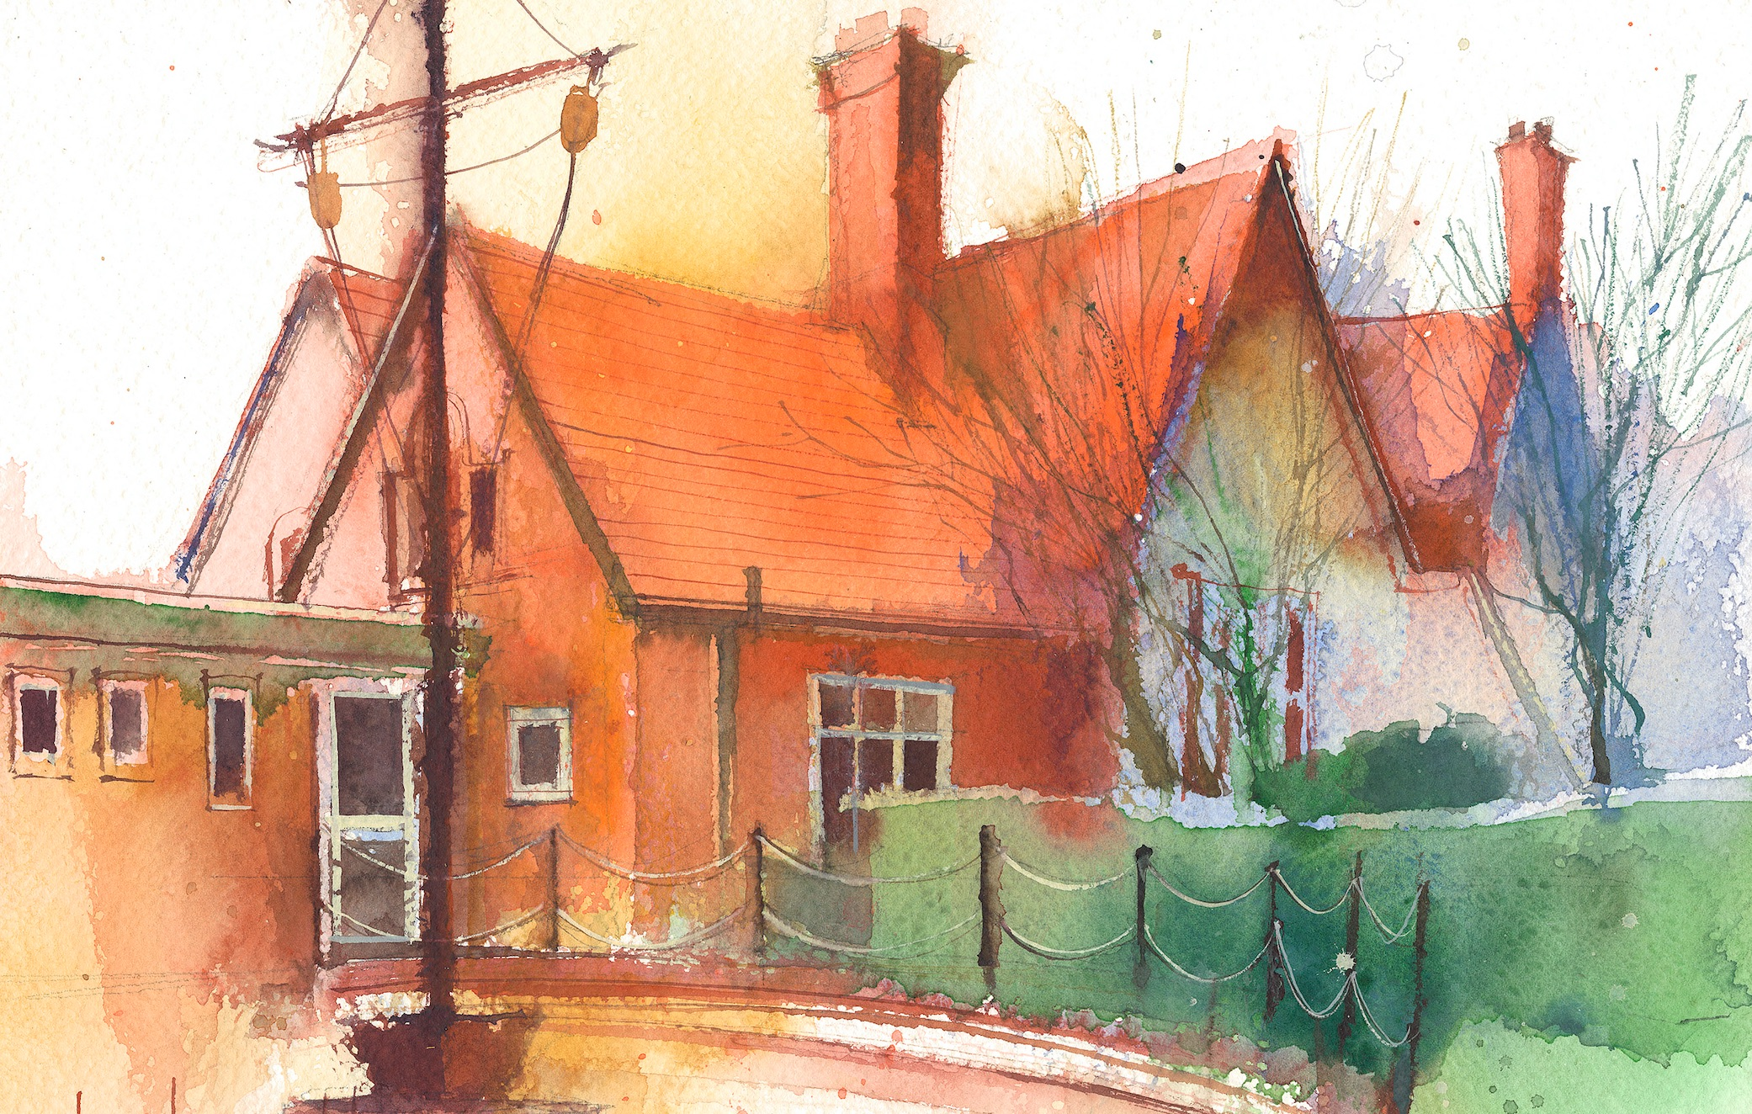

Mrs Croft Monday – Friday

 | Lessons 09:00 – 10:30 |  | Lessons 10:45 – 12:15 |  | Lessons 13:15 – 15:30  (Incorporating 15-minute break) | Additional Tasks
Monday | INSET DAY |  | INSET DAY |  | INSET DAY | - Write a short letter to me (Mrs Croft) introducing yourself. Let me know your likes, dislikes and your favourite subjects.  - BBC bitesize:  https://www.bbc.co.uk/bitesize/levels/zbr9wmn
Tuesday | Fluent in Five/Rapid Reasoning and Arithmetic  Objective:  - To improve mental and written arithmetic strategies and algorithms within a timed period.  Maths  Objective:  - To be able to identify the value of a digit within a decimal. |  | English: Narrative  Objectives:  - I can use a range of appropriate subordinating conjunctions for time.  - I can use basic punctuation and capital letters correctly. |  | PE: Athletics  Objectives  - Specialist teacher in to teach the children Athletics.  RSHE:  Objectives  - Get to know the teacher. This lesson will be a chance for the children to get to know me.
Wednesday | Fluent in Five/Rapid Reasoning and Arithmetic  Objective:  - To improve mental and written arithmetic strategies and algorithms within a timed period.  Maths  Objective:  - To be able to identify the value of a digit within a number less than 1. |  | English: Narrative  Objectives:  - I can use inverted commas and other punctuation to indicate speech.  - I can integrate dialogue to convey character and advance the action.  - I can use basic punctuation and conjunctions correctly. |  | PPA – Mrs Croft  Mrs McCann RE/Computing
Thursday | Fluent in Five/Rapid Reasoning and Arithmetic  Objective:  1.To improve mental and written arithmetic strategies and algorithms within a timed period.  Maths  Objective:  - To be able to round decimals. |  | English: Narrative  Objectives:  - I can use embedded clauses with ‘who’ ‘that’ or ‘which’.  - I can use commas for parenthesis.  - I can use basic punctuation, conjunctions and check my spelling. |  | Science: The Circulatory system  Objective:  - I can identify and name the main parts of the human circulatory system.  Art:  Objective:  - I can research the WW2 work of Ethel Leotine Gabain and suggest the inspiration behind the artwork.
Friday | Fluent in Five/Rapid Reasoning and Arithmetic  Objective:  1.To improve mental and written arithmetic strategies and algorithms within a timed period.  Maths  Objective:  - To know how to add and subtract decimals. |  | English: Narrative  Objectives:  - I can use a range of subordinating conjunctions for condition.  - I can use basic punctuation, conjunctions and check my spelling. |  | History:  - I can identify the period of World War II on a timeline and explain how it links to different time periods.  - I can describe the key events that led to the start of WW2 using significant dates.

