**Year 4 Weekly Timetable Week Commencing: 06.10.25**

**To contact your child’s class teacher, please email** [**schooloffice@dawpool.wirral.sch.uk**](mailto:schooloffice@dawpool.wirral.sch.uk) **or phone 0151 648 3412**

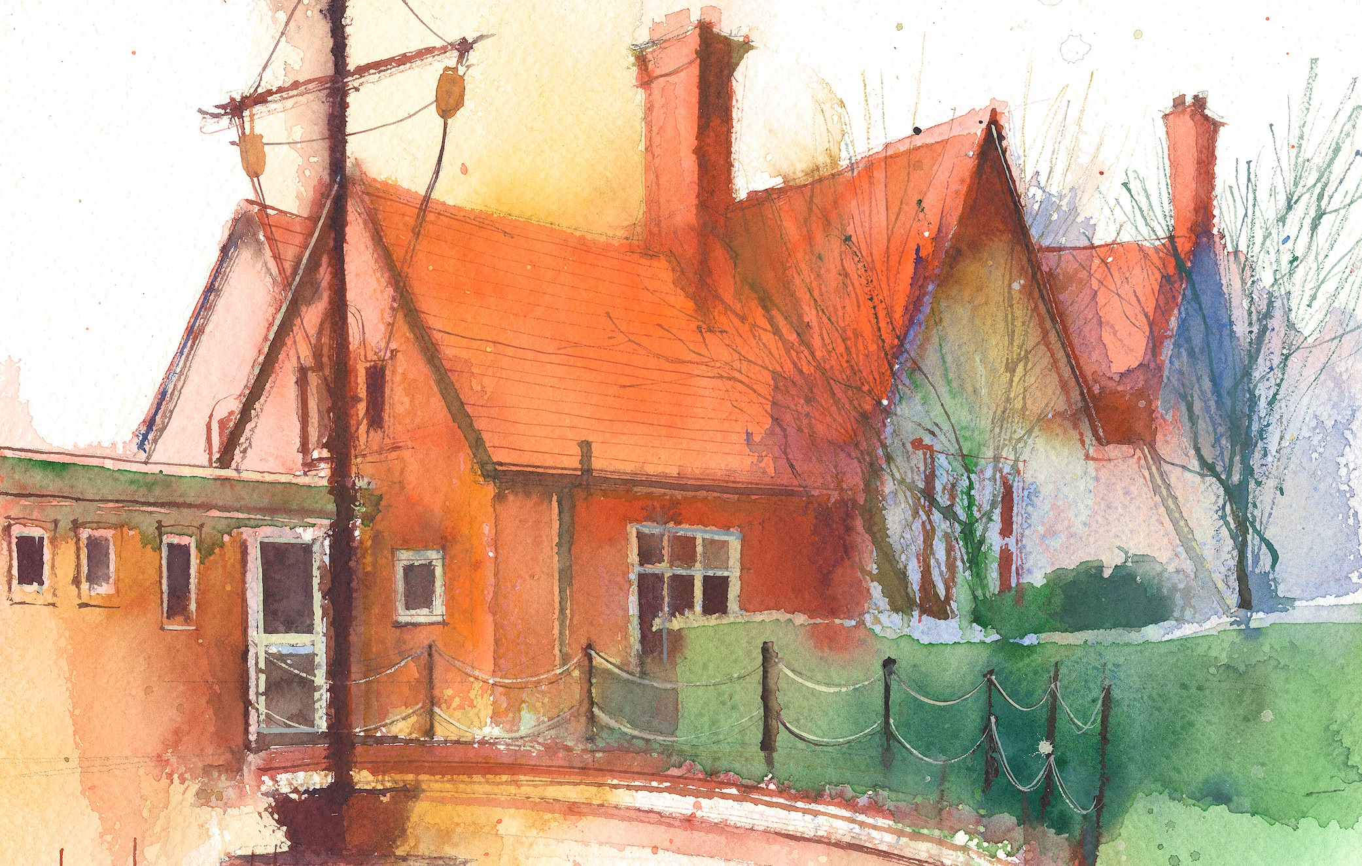

|  |  |  |  |  |  |  |
| --- | --- | --- | --- | --- | --- | --- |
|  | **Lessons 09:00 – 10:30** |  | **Lessons­­­­ 10:45 – 12:15** |  | **Lessons 13:15 – 15:30 (Incorporating 15-minute break)** | **Additional Tasks** |
| **Monday** | **Maths**  To add and subtract 1, 10s, 100s and 1000s  **Collective Worship**  **10:10** | **English – spelling and grammar**  Scrapyard expanded noun phrases | **Computing**  E-safety  PSHE Heart smart | Useful Links / Other Recommended Activities  **Oak National Academy**  <https://classroom.thenational.academy/>  **BBC Bitesize**  <https://www.bbc.co.uk/bitesize>  **Purple Mash**  <https://www.purplemash.com/sch/dawpool#/>  **Times table practise:**  <https://www.timestables.co.uk/multiplication-tables-check/>  **Hit the button**  https://www.topmarks.co.uk/maths-games/hit-the-button |
| **Tuesday** | **Class based worship/ Picture news**  **Maths**  To add numbers up to 4 digits | **English- The Iron man**  To create a recipe for The iron Man | **Science**  To develop criteria to identify, group and classify a range of animal species. |
| **Wednesday** | .  **Maths**  To add with one regroup | **English- The Iron Man**  Direct and indirect speech | **History**  To investigate life in Ancient Rome by looking at its buildings |
| **Thursday** | **Sing worship 9:10**  **Maths**  To add with regrouping | **Music- Ukulele**  **English-**  To identify features of a newspaper | **English continued**  **PE 14:15**  Tag rugby with Clare Mount |
| **Friday** | **Maths**  Times tables and  Arithmetic lesson  **Celebration worship 10:10** | **English**  Comprehension | **Art:**  Roman patterns  **RE**  Values in religious texts |