Foundation 2 Weekly Timetable Week Commencing 23.03.26
To contact your child’s class teacher, please email schooloffice@dawpool.wirral.sch.uk or phone 0151 648 3412
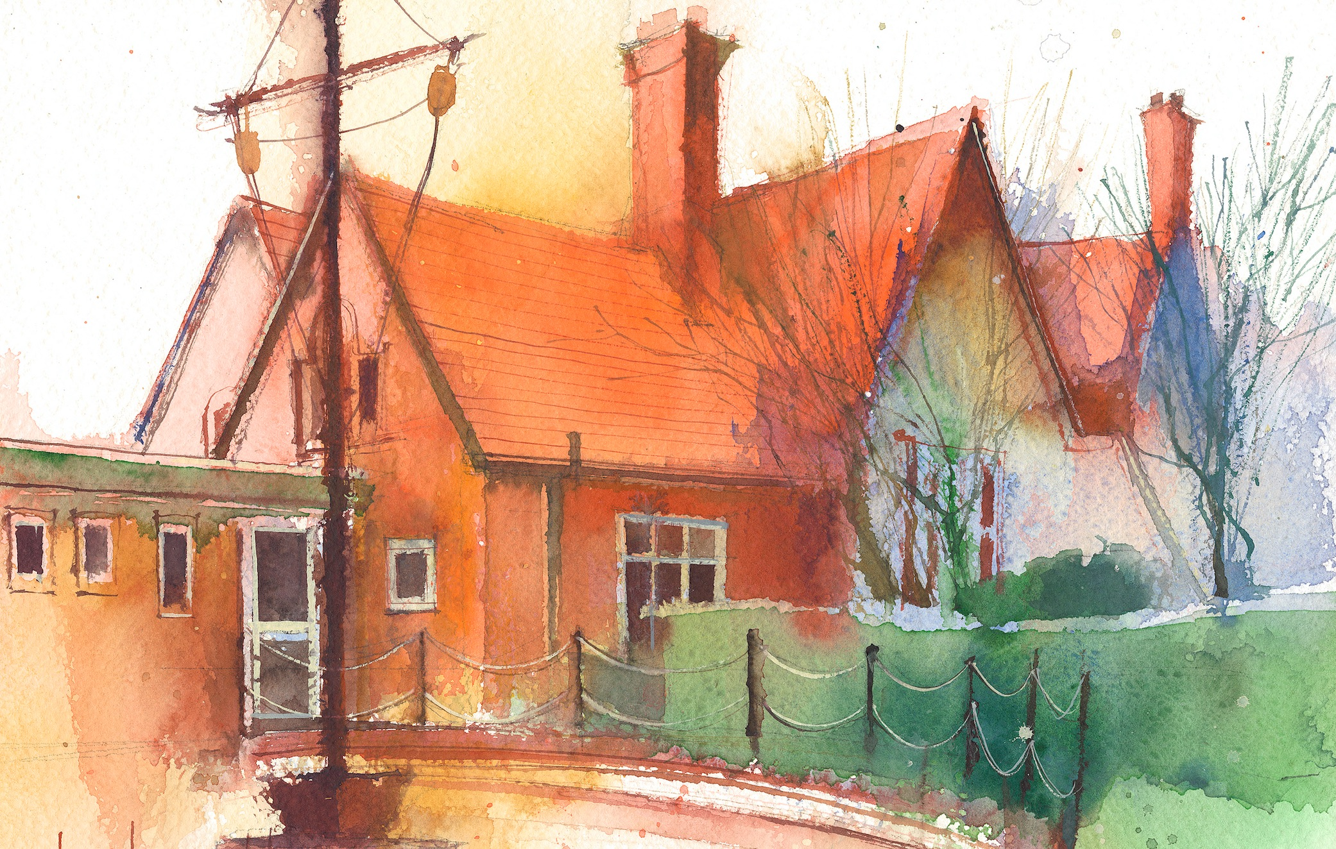

This timetable is available in the event that a Foundation 2 pupil is required to self-isolate at home, but the cohort remains open to other pupils.
Please visit the Foundation 2 Remote Learning Page on the school website to access any downloadable resources and activity sheets.

 | Session 1: 09:00-10:30 | Session 2: 10:50 – 12:00 | Session 3: 10:50 – 12:00 | Session 4: 10:50 – 12:00
Monday | Literacy  Read the section where the chick scratches, wriggles and rolls with the pig.  Can they wriggle and roll?  Focus Task  Model a question the pig might ask chick. “Can you scratch?”  Can they children work together to answer the question?  Write the answer. “Yes, I can scratch.” | Phonics  By the end of this lesson your child should be able to:  To learn to read the digraph ‘Short oo’  We recommend the following resources and activities to achieve this objective:  Blending practice.  Children will complete activities in their individual rocket phonics workbooks. | Maths  By the end of this lesson your child should be able to:  What is Length? To be able to see the difference between long and short  We recommend the following resources and activities to achieve this objective:  Discuss what length is.  Show children a range of long and short things, socks, pencils, rulers,  Which one is taller, which one is shorter, how do we know  Use cubes to measure and count  Then do teacher and student – which one is taller and shorter | Topic  By the end of this lesson your child should be able to:  To retell a familiar story in their own words  We recommend the following resources and activities to achieve this objective:  Read The Very Hungry Caterpillar by Eric Carle.  Discuss the lifecycle of a butterfly as we go.  What do caterpillars really eat?  Discuss cocoon/chrysalis again.  Sequence the story together.
Tuesday | Literacy  Read the section of the story where chick returns home to find the eggs have hatched. Were our predictions about what was in the egg correct?  Focus Task - Open the plastic eggs. Inside each one will be a word. Read each word. When all the words are out can they try and build the sentence?  In the egg is a chick. | Phonics  By the end of this lesson your child should be able to:  To write the digraph ‘short oo’  We recommend the following resources and activities to achieve this objective:  Segmenting practice.  Children will complete activities in their individual rocket phonics workbooks. | Maths  By the end of this lesson your child should be able to:  Measuring from a starting point. To understand that objects have to be straight to measure them  We recommend the following resources and activities to achieve this objective:  Get multiple pieces of ribbon of different lengths, put them all so they are the same length, with curves. Discuss how one is actually longer but we haven’t straightened it out. How can we solve the problem. Have a starting line that all the ribbons start from, then we make sure all ribbons are straight so we can see which one is taller.  Give all children a piece of string, find something in the room that is taller/shorter than your string. | Topic  By the end of this lesson your child should be able to:  To understand the need for a Healthy Lifestyle.  We recommend the following resources and activities to achieve this objective:  Discuss the food the caterpillar ate in the story. Which is Healthy/Unhealthy?  What is a Healthy lifestyle?  Why is it important to have a healthy lifestyle?  What else would help us stay healthy?  Discuss sleep, limited technology, drinking water, exercise, tooth care.  PP to discuss  During provision play Greedy Gorilla together and undertake a sorting activity with different images of foods. Work with a friend to sort them into healthy/unhealthy .
Wednesday | Literacy  Read the last page of the story where the chick has fun in the barnyard.  Focus Task - Have images of a goose, lamb, pony and pig. Inside the eggs have the words ‘jump, run, scratch and skip’.  Can they match the picture with the word?, capital letter, full stop) | Phonics  By the end of this lesson your child should be able to:  To read the digraph ‘long oo’  We recommend the following resources and activities to achieve this objective:  Blending practice  Children will complete activities in their individual rocket phonics workbooks. | Maths  By the end of this lesson your child should be able to:  Standardised Units. To look at using a standardised unit to measure  We recommend the following resources and activities to achieve this objective:  Have two objects, one long and one a foot longer. Measure one with short socks and one with long socks, say that both objects are 3 socks long.  Discuss that we need to use the same measures for both objects. | Topic  By the end of this lesson your child should be able to:  To understand the need for a healthy diet.  We recommend the following resources and activities to achieve this objective:  Discuss a healthy diet again and create a list of as many fruits and vegetables as they can.  Design and make fruit kebabs for snack.
Thursday | Literacy  Read the whole story again  Focus Task - Complete a story map, using actions for each part of the story to help us re-tell it.  Ask the question. What was their favourite part of the story?  Discuss in PP.  Model writing a sentence of the board using a capital letter at the start, finger spaces between words and a full stop at the end. | Phonics  By the end of this lesson your child should be able to:  To write the digraph ‘long oo’  We recommend the following resources and activities to achieve this objective:  Segmenting practice  Children will complete activities in their individual rocket phonics | PE  By the end of this lesson your child should be able to:  The focus of the learning is to explore different movements using different parts of the body and move their bodies to music.  We recommend the following resources and activities achieve this objective.  This Half Term the focus in PE is ‘Dance’. Lessons will be led by specialists form Claremont School | Maths  By the end of this lesson your child should be able to:  Organising objects by length. To identify differences in similar lengths.  We recommend the following resources and activities to achieve this objective:  Discuss how we can see things that are very different in length, but it is harder with objects that are nearly the same length.  Get a range of sticks that are very close in height, have the children work in groups to order them from shortest to tallest.  As a fun last activity, the children must order themselves from shortest to tallest, working together.
Friday | RE  By the end of this lesson your child should be able to:  How do people show they love you? How do you show your love for others? How did Jesus show his love for us?  We recommend the following resources and activities to achieve this objective:  Read the story ‘Guess How Much I Love You’ by Sam McBratney. How could we show how much we love someone?  Jesus showed is love by dying on the cross.  As a class make our own version of the book suggesting your own measurements of love.  Ask the children to paint pictures of themselves doing something special for someone they love. Ask them to explain their painting and why they chose to paint that particular scene. Record in your floor book.  Create a prayer tree using heart shapes instead of leaves. The children can draw and write prayers on the hearts thanking God for the people who love them and for his love for us. | Forest Schools  By the end of this lesson your child should be able to:  Talk about the world around them.  We recommend the following resources and activities to achieve this objective:  Children to work collaboratively to build dens, make minibeast hotels and ‘cook’ forest food. | Phonics  By the end of this lesson your child should be able to:  Consolidate their learning of Common Exception words ‘her, they’’  We recommend the following resources and activities to achieve this objective:  Children will complete activities in their individual rocket phonics workbooks. | Heart Smart  By the end of this lesson your child should be able to:  ‘Don’t hold onto what’s wrong’ – Friendship.  Why is it important to say sorry  We recommend the following resources and activities to achieve this objective:  Read the story, ‘Grumpy Frog’ by Ed Vere to the children. After reading, ask the following questions to discuss the  story:  • What happens when Grumpy Frog doesn’t win?  • Look at the page where Rabbit offers to be Frog’s friend. How does Frog upset Rabbit?  • What happens when Frog says sorry at the end of the story?  • What might have happened if Frog hadn’t said sorry?  Talk about why it is important to say sorry. Boris says, ‘Saying sorry means we can carry on having fun with our friends.’

