Year 2 Weekly Timetable Week Commencing 11.01.21
To contact your child’s class teacher, please email year2@dawpool.wirral.sch.uk
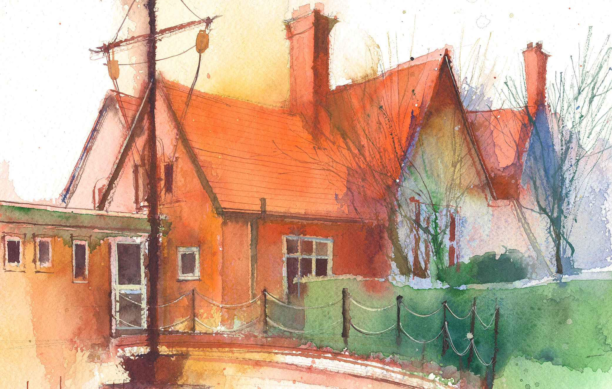

This timetable is available in the event that all Year 2 pupils are required to learn at home. Please visit the Year 2 Remote Learning Page to
access any downloadable resources and activity sheets. The assessed task should be submitted to the teacher at the end of each day via Purple Mash.

 | Session 1: 09:00-10:30 |  | Session 2:10:45 – 12:15 |  | Session 3: 13:15 – 15:30 (Incorporating 15-minute break) | Assessed task
Monday  11.01.21 | Grammar  By the end of this lesson your child should be able to: Use the past and present tense correctly when writing a sentence.  We recommend the following resources and activities to achieve this objective:https://www.bbc.co.uk/teach/supermovers/ks1-english-verb-tenses-with-karim-hacker/zr7gt39  Click on the link above and watch Hacker and Karim teach you about the past and present tense. You will need to move about! Have fun!  Complete the attached past and present sheet. You can write them on paper if you don’t want to print them. There are two options. Choose the sheet that best suits your child’s ability. |  | Maths  By the end of this lesson your child should be able to: To be able to recall and use the 2 times table.  We recommend the following resources and activities to achieve this objective: Please follow the attached lesson plan and attached worksheets. You can write the equations out if you don’t want to print them. |  | History  By the end of this lesson your child should be able to: Learn about London's origin, focusing on how it began as a Roman settlement by the banks of the River Thames nearly 2000 years ago.  We recommend the following resources and activities to achieve this objective :https://classroom.thenational.academy/lessons/how-did-london-begin-6wu64c  Click on the above link and follow the lesson. | Login to Purple Mash to submit today’s assessed task:  Complete the 2do on times tables.
Tuesday  12.01.21 | English-writing and grammar  By the end of this lesson your child should be able to: retell a story in their own words. Write adjectives to describe animals.  We recommend the following resources and activities to achieve this objective: https://www.facebook.com/readingriddle/videos/2280753058892214/  Click on the link above and listen to the story of Vlad and the Great fire of London read by the author Kate Cunningham. Vlad is a flea and Boxton is a rat and they tell the story of what happened in the Great fire of London from their point of view. I have attached sheets to complete about adjectives in the story. Choose the one that best suits your child’s ability. Remember an adjective is a describing word that tells you something about the thing you are describing. If you don’t want to print the sheets you can draw a picture of Vlad the flea and Boxton the rat and write some adjectives about them. |  | Maths  By the end of this lesson your child should be able to: To be able to understand and learn the 5 times table.  We recommend the following resources and activities to achieve this objective: Please follow the attached lesson plan and worksheets. |  | Science  By the end of this lesson your child should be able to: Understand how a human changes as they grow.  We recommend the following resources and activities to achieve this objective: Please follow the attached powerpoint. It has a voice over from me to enable your child to complete it a little more independently. I have attached a task to complete after the powerpoint. | Can you name the stages a human goes through when they grow? Reply on our class blog on purplemash please.
Wednesday  13.01.21 | English-writing  By the end of this lesson your child should be able to: Write a description using capital letters and full stops for sentences.  We recommend the following resources and activities to achieve this objective:  Look at the pages I have attached from the story of Vlad and the great fire of London. What characteristics make a good friend? Talk to the person you are learning with about what makes a good friend. Why is Boxton the rat a good friend? Can you write a description of what makes a good friend? Remember to use capital letters and full stops and challenge yourself to write as many sentences as you can. Take care to use joined up handwriting and after you have finished your writing, check your spelling of words we have been learning in our spelling lessons. You can ask your parent to email me a picture of your writing if you like so I can see how well you have done. |  | Maths  By the end of this lesson your child should be able to: To be able to recall and use the 5 times table.  We recommend the following resources and activities to achieve this objective: Please follow the attached lesson plan and worksheets. Below is a link to a game to practise the 5 times table.  https://www.timestables.co.uk/5-times-table.html |  | Art  By the end of this lesson your child should be able to: understand what background and foreground means in a picture.  We recommend the following resources and activities to achieve this objective: I have attached a ppt to follow, explaining how to make a picture with a background and foreground. It is based on The Great Fire of London. If you don’t have any chalks you can use felt tips or coloured pencils. You don’t need to use black paper for your building outlines if you don’t have any, you can just use white paper or any other dark colour. | Can you write one sentence on our class blog on purplemash about what makes a good friend?
Thursday  14.01.21 | Spelling  By the end of this lesson your child should be able to:  recognise that the ‘n’ sound is sometimes spelled with ‘kn’ or ‘g’  We recommend the following resources and activities to achieve this objective: Uploaded activity sheet - with step by step instructions. |  | Maths  By the end of this lesson your child should be able to: To be able to understand and learn the 10 times table.  We recommend the following resources and activities to achieve this objective: Follow the attached lesson plan and then have a go at this timestable game. You can practise 2’s, 5’s and 10’s but feel free to practice any others such as 3’s and 4’s. as the quick recall of these is vital as children get progress in Maths. https://www.topmarks.co.uk/maths-games/hit-the-button |  | P.E.  By the end of this lesson your child should be able to: Move to a beat and learn their 2 and 5 times tables whilst moving around!  We recommend the following resources and activities to achieve this objective:  https://www.bbc.co.uk/teach/supermovers/ks1-maths-the-2-times-table-with-bridget-the-lioness/zrrx92p  https://www.bbc.co.uk/teach/supermovers/ks1-maths-the-5-times-table/zhbm47h  Click on the hyperlinks above and follow the movements activities. Have Fun! | Purple Mash Blog – reply to the question set by Mrs McCann
Friday  15.01.21 | Reading comprehension  By the end of this lesson your child should be able to: discuss the text provided, retrieve answers from the text and give opinions that link to the given text.  We recommend the following resources and activities to achieve this objective: Read aloud the text ‘Something Else to your child. Then read it again together – pausing to explain any unfamiliar words.  - Ask your child the ‘Listening Questions’.  - Move on to the written questions sheet – your child may need support to read some or all of the questions.  - Answers have been provided. |  | Maths  By the end of this lesson your child should be able to: Have quick recall of the 2, 5 and 10 times tables.  We recommend the following resources and activities to achieve this objective: See attached lesson plan and use link above to play game again. |  | ICT  By the end of this lesson your child should be able to:  Use Free Code Chimp (Purple Mash) to design a background and add characters.  We recommend the following resources and activities to achieve this objective:  Teaching notes and video tutorials have been provided. | Save your Purple Mash task in your online folder when it is complete.

