Spring Year 5 Weekly Plan: 23.03.2026-.27.03.2026
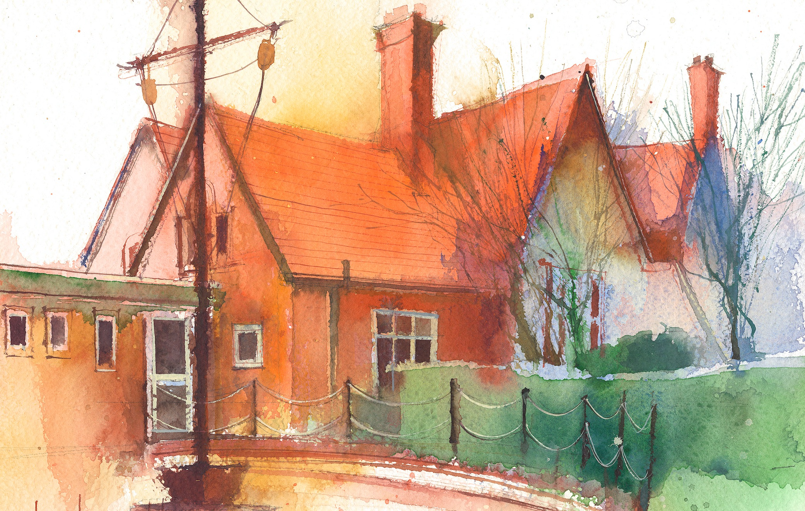
To contact your child’s class teacher, please email schooloffice@dawpool.wirral.sch.uk or phone 0151 648 3412
 | Lessons 09:00 - 10:30 |  | Lessons 10:45 - 12:15 |  | Lessons 13:15 - 15:30  (Incorporating 15-minute break) | Additional Tasks
Monday  23/03/26 | - Mrs McCanns Plans |  |  |  |  | Drama Club
Tuesday  24/03/26 | Maths  Fluent in five/ Rapid Reasoning  By the end of this lesson your child should be able to: to know how to measure the perimeter of a shape. Lesson 1 |  | CDAT English  By the end of this lesson your child should be able to: produce a variety of headlines and subheadings for the news paper article on the “ The Impossible dream” of Phille Petit for the Dawpool News. |  | Science  By the end of this lesson your child should be able to: complete the living things and their habitats assessment sheets  Practise for Easter Service | Future Medics Club
Wednesday  25/03/26 | Maths to  Practise for the Easter Service |  | CDAT English  By the end of this lesson your child should be able to: Watch a clip of the real walk. Write sentences using who or which to describe Phillipe’s movements on the wire using relative clauses for detail. |  | Easter Service at Saint Chad’s | Chess Club
Thursday  26/03/26 | Maths  Fluent in five/ Rapid Reasoning  By the end of this lesson your child should be able to: find the area of a rectangle. |  | CDAT English  By the end of this lesson your child should be able to: map out a report from the first step to the legacy of the towers. To use a checklist of what they need to put into their report for first draft. |  | Topic  By the end of this lesson your child should be able to: .to make their own study of Brazil and produce educational poster/fact file and then answer a comprehension sheet on Brazil. | Choir/Drama Netball Club
Friday  27/30/26 | Maths  Fluent in five/ Rapid Reasoning  By the end of this lesson your child should be able to: know how to find the area of a compound shape. |  | CDAT English  By the end of this lesson your child should be able to: write a polished final newspaper report with heading and subheading. |  | IT  By the end of this lesson your child should be able to: Practise for South American day Assembly: Practise for South American day Assembly  Handwriting | Celebration of weeks work  School Disco  5pm -6.30pm

