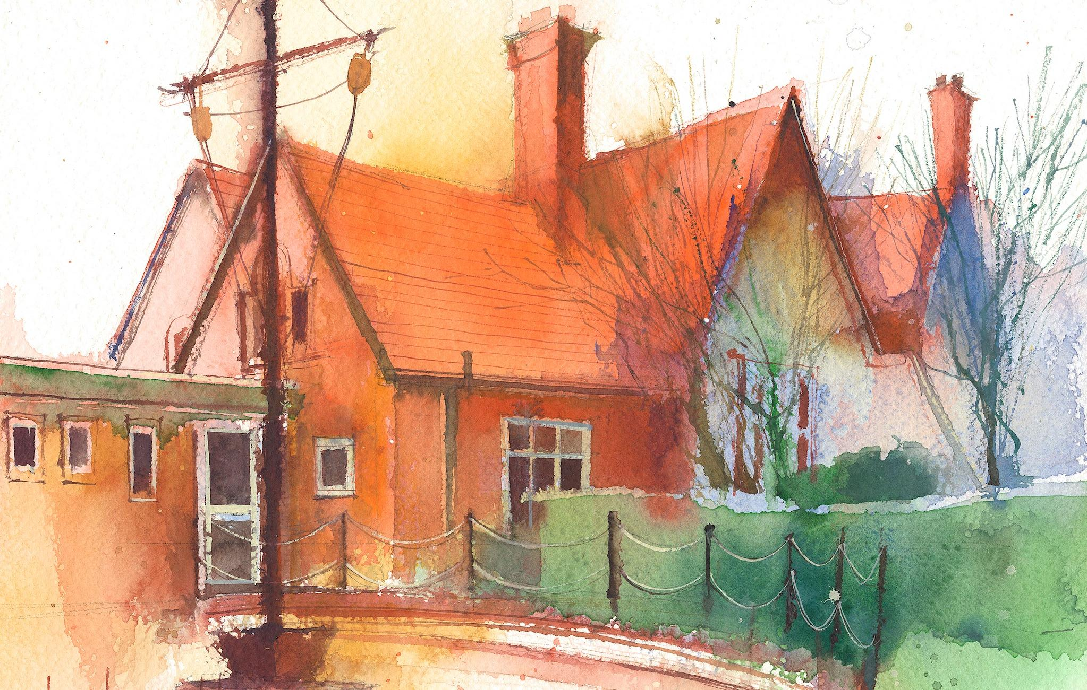
Year 1 Weekly Timetable Week Commencing 29.6.26
To contact your child’s class teacher, please email schooloffice@dawpool.wirral.sch.uk or phone 0151 648 3412

 | Lessons 09:00 – 10:30 |  |  | Lessons 10:45 – 12:15 |  | Lessons 13:15 – 15:30 (Incorporating 15-minute break) | Additional Tasks
Wednesday | Transition day | O  P  A  L  Assembly |  |  |  | See Mrs Broadbent’s plan | Remember PE day has changed to Mondays.  We will continue to do Forest School on Thursdays.
Thursday | Phonics  English: (lesson 4)  • I can write using time connectives. | Singing  Assembly |  | Maths, no. to 100: (lesson 2) To know how to partition numbers within 100 into tens and ones.  ERIC/ GR |  | Fin5  Forest School/RE: Seeing how dirty our hands get at forest school and linking it to Jesus washing the disciples feet.
Friday | Phonics  English: (lesson 5):  • I can write using time connectives. . | Celebration  Assembly |  | Maths, no. to 100: (lesson 3) To know how to use a number line to 100  ERIC/ GR |  | Fin5  RE:  • I can compare the differences between the world that Jesus grew up in and the world we are growing up in.  Golden Time

