Year 5 Weekly Timetable Week Commencing 11.01.21
To contact your child’s class teacher, please email year5@dawpool.wirral.sch.uk
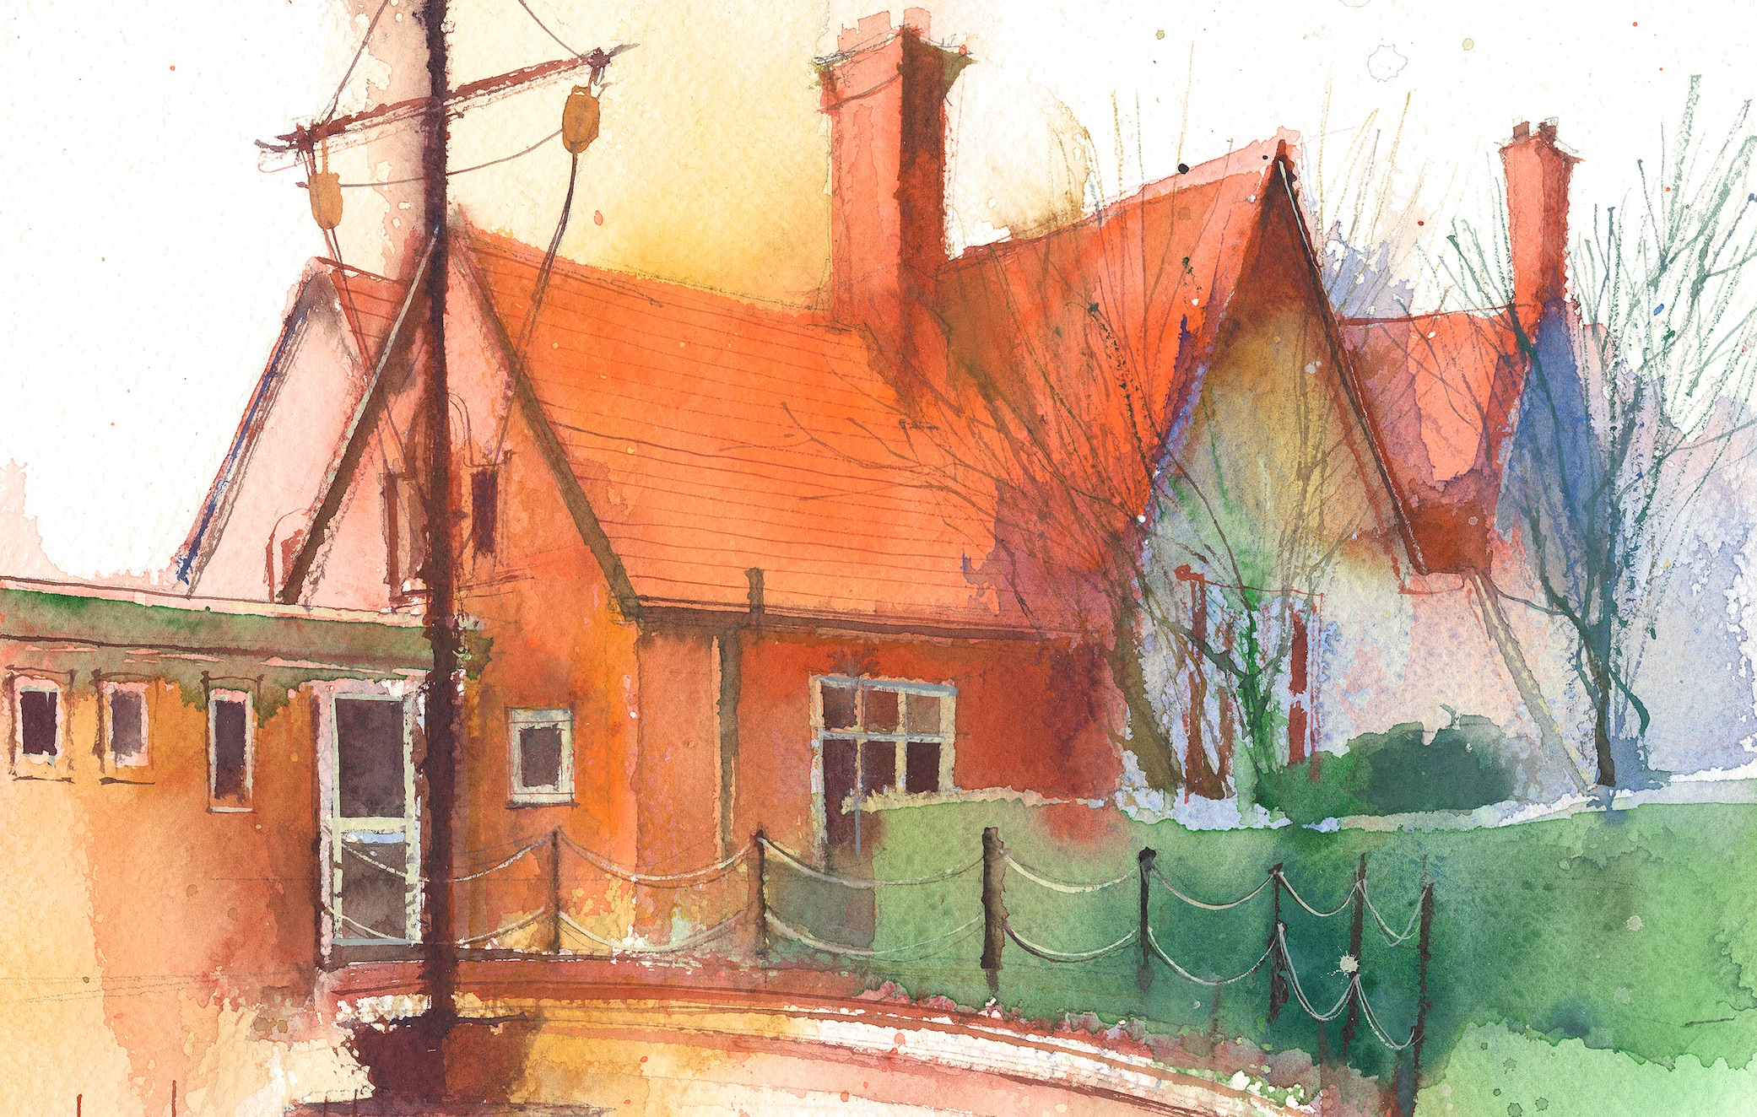

This timetable is available in the event that all Year 5 pupils are required to self-isolate at home. Please visit the Year 5 Remote Learning Page to
access any downloadable resources and activity sheets. The assessed task should be submitted to the teacher at the end of each day Purple Mash.

 | Session 1: 09:00-10:30 |  | Session 2:10:45 – 12:15 |  | Session 3: 13:15 – 15:30 (Incorporating 15-minute break) | Assessed Task
Monday  11.01.20 | SUBJECT  By the end of this lesson your child should be able to:  To improve reading and understanding comprehension skills using a fiction text.  We recommend the following resources and activities to achieve this objective:Cracking Comprehension |  | SUBJECT  By the end of this lesson your child should be able to: To know that angles on a straight line add up to 180 degrees.  To calculate the values of missing angles on a straight line.  We recommend the following resources and activities to achieve this objective: See links to powerpoints and resources on daily home learning planner. |  | SUBJECT(s)  By the end of this lesson your child should be able to: To review and analyse a computer game.  To be able to describe some of the elements that make a successful game.  To begin the process of designing a game.  We recommend the following resources and activities to achieve this objective: Lesson 1 Game Creator activities… evaluate and plan a game using set 2Do task. | Login to Purple Mash to submit today’s assessed task:  I will check your game greator plans on Purple Mash this week.
Tuesday  12.01.21 | MATHS  By the end of this lesson your child should be able to:  Multiply three-digit numbers by two-digit numbers.  We recommend the following resources and activities to achieve this objective:  Third Space Slides |  | ENGLISH  By the end of this lesson your child should be able to:  Understand and use the myth of Theseus and the Minotaur.  We recommend the following resources and activities to achieve this objective:  Use the link on the timetable and summarise the key points from the story and describe Theseus fully. Draw a picture to go with your writing. |  | P.E.  Joe Wicks has started his School Work outs again for Lockdown. Why not have a go this afternoon? See if your family will join in too! | Login to Purple Mash to submit today’s assessed task:  Read Chapter 1 of our exciting new book ‘Where Sea Eagles Fly’.  Complete the multiple choice activity and let me know what you think will happen next.
Wednesday  13.01.21 | MATHS  By the end of this lesson your child should be able to:  Multiply four- digit numbers by two –digit numbers.  We recommend the following resources and activities to achieve this objective:  Third Space Slides |  | ENGLISH  By the end of this lesson your child should be able to:  Understand and use the myth of Theseus and the Minotaur.  We recommend the following resources and activities to achieve this objective:  Use the link on the timetable and describe the Minotaur fully. Draw a picture to go with your writing. |  | ANCIENT GREECE  By the end of this lesson your child should be able to:  Learn about the different city-states and recall facts about the Battle of Marathon.  We recommend the following resources and activities to achieve this objective:  Write a letter that has been sent with Pheidippides. There are 3 levels- go on challenge yourself! | Login to Purple Mash to submit today’s assessed task:  What was your favourite part of Theseus and the Minotaur story?
Thursday  14.01.21 | ENGLISH  By the end of this lesson your child should be able to:  Understand and use the myth of Theseus and the Minotaur.  We recommend the following resources and activities to achieve this objective:  Use the link on the timetable and explain how Ariadne felt and why. Describe the Labyrinth fully. Draw a picture to go with your writing. |  | MATHS  By the end of this lesson your child should be able to:  Consolidate arithmetic skills.  We recommend the following resources and activities to achieve this objective:  Arithmetic Test 8 |  | SCIENCE  By the end of this lesson your child should be able to:  Reinforce and consolidate their understanding of Forces.  We recommend the following resources and activities to achieve this objective:  Watch and complete the activities in the film.  https://classroom.thenational.academy/lessons/what-are-forces-6dh3ec?activity  =video&step=1  Use the video to help you write information and definitions. By writing them down you will remember them much more. You can pause and rewind the film as often as you need to help you. | Login to Purple Mash to submit today’s assessed task:  Complete the Types of Forces Quiz
Friday  15.01.21 | MATHS  By the end of this lesson your child should be able to:  Divide four-digit numbers by a one-digit number.  We recommend the following resources and activities to achieve this objective:  Third Space Slides |  | ENGLISH  By the end of this lesson your child should be able to:  Revise silent letters  We recommend the following resources and activities to achieve this objective:  https://classroom.thenational.academy/lessons/to-investigate-silent-letters-c9gk4r?activity=video&step=1  Use this video to help you revise these spelling patterns. Don’t think they are too easy for you as I correct these on a regular basis in your books!  Complete Silent Letters Activity Mat |  | SPANISH  By the end of this lesson your child should be able to:  Write and pronounce Spanish colours.  We recommend the following resources and activities to achieve this objective:  https://www.youtube.com/watch?v=Gi_5dUB1Osk  Watch this quick film that will help you say the Spanish colours correctly. Next, complete the Spanish rainbow. | How did you get on with your silent letters spelling test?  Keep practising next week.
Additional Tasks

We also advise your child to complete the following tasks this week:

