Year 1 Weekly Timetable Week Commencing 11.01.21
To contact your child’s class teacher, please email year1@dawpool.wirral.sch.uk
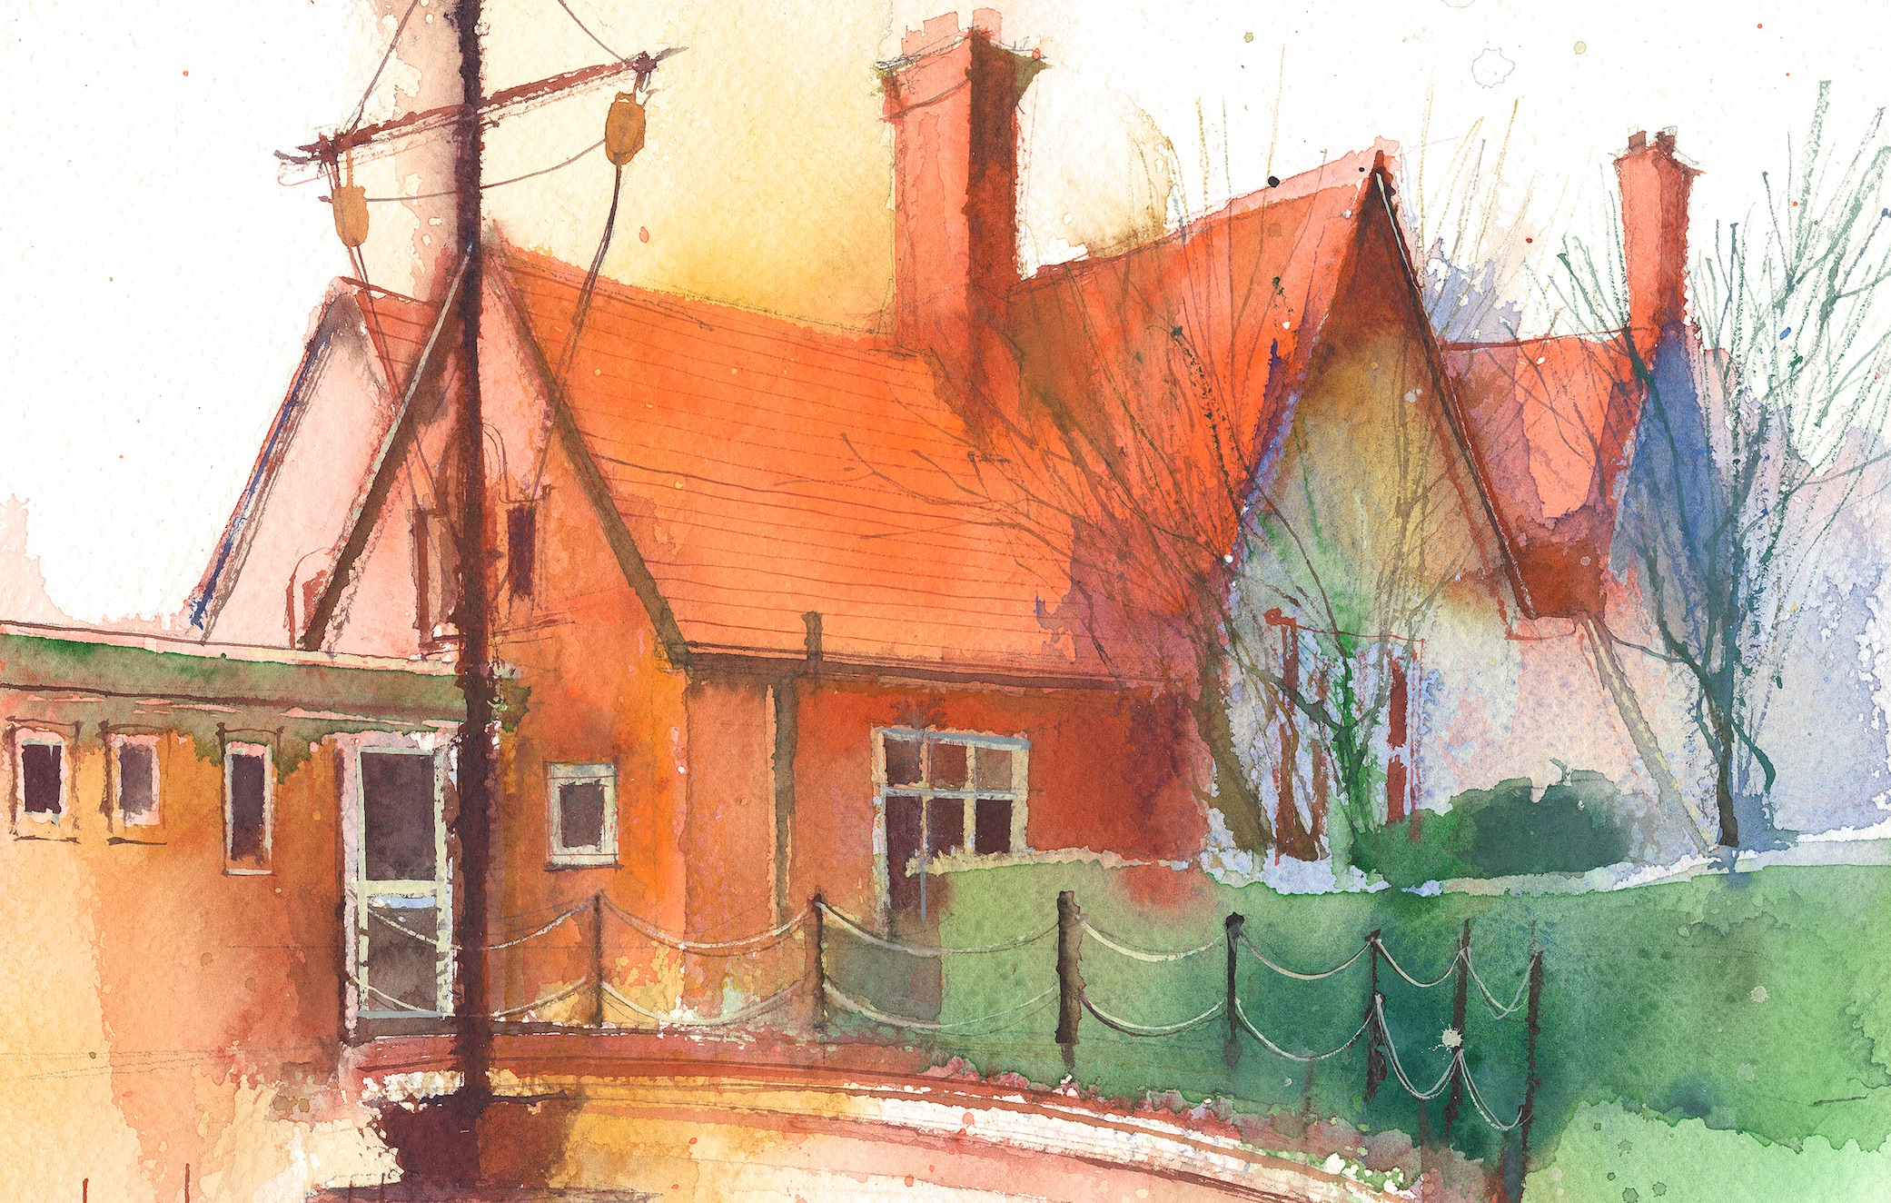

This timetable is available in the event that all Year 1 pupils are required to self-isolate at home. Please visit the Year 1 Remote Learning Page to
access any downloadable resources and activity sheets. The assessed task should be submitted to the teacher at the end of each day via Purple Mash.

 | Session 1: 09:00-10:30 |  | Session 2:10:45 – 12:15 |  | Session 3: 13:15 – 15:30 (Incorporating 15-minute break) | Assessed Task
Monday  11.01.21 | Literacy  By the end of this lesson your child should be able to:  *To use finger spaces, and simple punctuation.  *To write a simple list of instructions for someone to follow  We recommend the following resources and activities to achieve this objective:  *Re-cap on Lost in the Toy Museum by David Lucas.  The YouTube link to this story can be found here.  https://www.youtube.com/watch?v=4LeqZTm46KI  *In the book the toys all hid from Bunting the cat and left him notes to help him find them.  *Today we are going to discuss the concept of ‘instructional writing.  *We will look at a series of instructions, such as instructions for baking a cake.  *Instructions are normally in a list with each instruction numbered.  *They use something called imperative verbs. These are simple ‘bossy’ words that tell you to do something!  *Today can you hide a toy somewhere in the house and write some bossy instructions for your Mum and Dad to help them find the toy.  e.g.  1. Go upstairs.  2. Turn left  3. Open the door  4. Look under the bed  5. Lift up a box  *Don’t make it too complicated, but aim to write about 5 sentences.  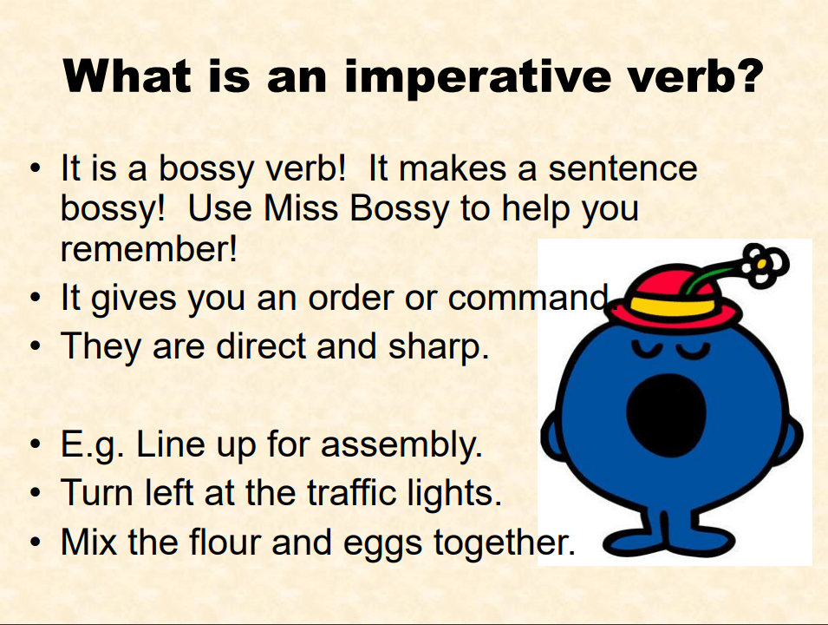  Phonics  Phonics takes place every day and is usually 45 minutes long. It is a fast paced process that involves a lot of repetition which is so important for embedding children’s learning.  By the end of this lesson your child should be able to:  *Reads words consistent with their phonic knowledge by sound blending.  *Spell words by identifying sounds in them and representing the sounds with a letter or letters.  We recommend the following resources and activities to achieve this objective:  This week in Phase 5 Phonics our focus is:  Sounds: ‘ie that says igh’  Words: oh and their  We will use a series of Phonics Powerpoints to support our learning. These can be found on the website.  Follow through the Powerpoint, stopping at regular points to complete the set tasks.  If you require additional tasks then I will set the following to undertake through the week. Please note the tasks below are optional. Undertaking the PowerPoints will give your child enough challenges and activities. Please don’t feel under any pressure to do these additional tasks.  - What’s in the Pie? Sorting game.  - Mr Adam’s Label Sort  - Royal playroom word sorting activity.  - Letter to the Queen writing activity.  - Read and Write books. |  | SUBJECT  By the end of this lesson your child should be able to: Add numbers together within 10.  We recommend the following resources and activities to achieve this objective:  Whilst we are learning from home, I have set some ‘White Rose Maths’ lesson videos for you to follow. These are the videos we will work from in school as well.  They contain starter activities before moving onto the focus of the lesson.  Each video talks you through the activity and models the different techniques we do at school.  During the video there are pause points, where they ask you to pause the video and have a go at the task yourselves.  Before starting the lessons please make sure you have a pencil, some paper and 20 objects for counting (cubes, lego pieces, cheerios, raisins!)  I hope you are becoming familiar with the techniques and skills the children are learning in school. This week we will stay within numbers to 10 and focus on addition.  In the lesson they suggest undertaking worksheets – I have not provided these as the video, paused to undertake the activities, is quite enough. I will attach optional challenges if you would like to tackle more.  Throughout the week there are five videos to follow.  Video 1 – Adding Together  Video 2 – Adding More  Video 3 – Adding More  Video 4 – Addition using Bonds  Video 5 – Finding a part  I have set an addition game as a To Do on Purple Mash for you to complete this week.  I will also attach the following additional activities to the website for you to tackle. These will be optional.  Number bonds workbook |  | History  By the end of this lesson your child should be able to:  I can use different sources to find out about toys from the past.  I can name two popular toys from the past.  I can ask a sensible question.  I can use information from a source to answer a question.  We recommend the following resources and activities to achieve this objective:  *Our History focus this term is The Time Machine  *Today we are going to climb into a time machine and travel back to the 1950s when their Grandparent’s were younger.  We will watch an old BBC programme called ‘Magic Grandad, where they travel back in time to 1950 to find out about toys from the past.  Magic Grandad: Toys - Episode 2 - 1950s - Bing video  *Do you have an elderly Grandparent or family friend that you could phone up and ask about toys they played with when they were younger?  *As with last weeks’ lesson, can you ask these questions-  What is it called? What is it made of? What do you do with it/how do you play with it? How does it work?  *The Oak National Academy have live lessons linked to this subject. Click on this link here.  https://classroom.thenational.academy/lessons/how-have-toys-changed-part-1-71h62c | Login to Purple Mash to submit today’s assessed task:  Maths  Play the ‘Addition to 10’ car race on Purple Mash.  Add the numbers together to move the car around the track.
Tuesday  12.01.21 |  |  |  |  | Science  By the end of this lesson your child should be able to:  Distinguish between an object and the material it is made from  Identify and name a variety of everyday materials including; wood, plastic, glass, rock  We recommend the following resources and activities to achieve this objective:  *Our Science focus this term is ‘Everyday Materials’  *Today we will remind ourselves of the 5 different material types; wood, paper, glass, plastic, metal.  *We will discuss the fact that objects are Man made (made by human beings) not Natural (straight from nature). E.g. do tables grown on trees or are they made!  *Our focus today will be on discussing how to describe an object using the following vocabulary;  Hard or soft  Transparent, translucent or opaque.  Waterproof or absorbent  *Can they go on a hunt to find an object made out of plastic in the room?  *Can they describe it using the vocabulary above?  *e.g. a ruler is made of plastic because it is hard, waterproof and you opaque because you can’t see through it.  *Repeat this activity for metal, paper, glass and wood  *The following lesson from The Oak National Academy will be helpful for this lesson. Lesson 3 - ‘How can I describe an object’? Click on this link here  How can I describe an object? (thenational.academy)  BBC Bitesize also have videos, games and activities linked to this topic. Click on this link here.  Materials – Year 1-2 / P3-4 Science - This Term's Topics - Home Learning with BBC Bitesize - BBC Bitesize | Login to Purple Mash to submit today’s assessed task:  Science  Can you find an object to match each of the material types;  Paper, wood, metal, glass and plastic.  Can you write some information about each object using the vocabulary from this weeks’ lesson?  Think about the following questions;  Is it hard or soft?  Is it waterproof or absorbent?  Is it transparent, translucent or opaque?
Wednesday  13.01.21 |  |  |  |  | R.E.  By the end of this lesson your child should be able to:  - understand the concept of something small (mustard seed) growing in the right conditions  - understand that a small amount of faith can grow into something greater like the mustard seed  We recommend the following resources and activities to achieve this objective:  Watch the parable of the mustard seed (Mark 4:30-32)  https://www.youtube.com/watch?v=eCZggO5qbjA  Watch time lapse of the mustard seed  https://www.youtube.com/watch?v=o8Npk5j5zII Focus on how small the mustard seed is at the start and what it grows into.  * Can you make your body grow like a mustard seed?  * What does a seed need to grow?  * What do Christians need to grow in the Kingdom of God?  * What is the message from the story that Jesus told? (We might be small but if we have faith in God we will grow to be strong just like the mustard seed grew into a huge tree)  Song: Faith as small as a mustard seed  https://www.youtube.com/watch?v=AFEUjy42xNk | Login to Purple Mash to submit today’s assessed task:  RE  Can you create a tree picture showing birds / insects living in the tree and write the sentence ‘God’s Kingdom is like a mustard seed’.  You could try this on Purple Mash Search for a ‘tree’ image to colour and add details to such as birds / insects living in the tree. Use the ‘Abc’ tool to type your sentence.  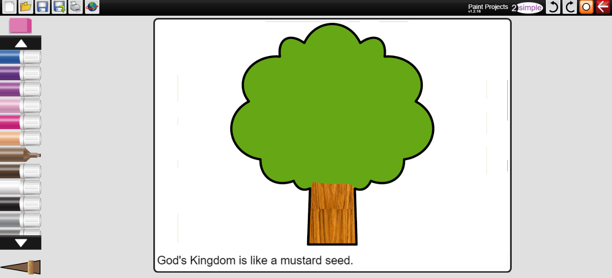
Thursday  14.01.21 |  |  |  |  | P.E.  By the end of this lesson your child should be able to:  - develop balance and co-ordination  - perform dances using simple movement patterns  We recommend the following resources and activities to achieve this objective:  * What are the 4 seasons of the year?  Look at slide 5 of PowerPoint, from the title what season might we be starting with?  Look at slide 6 or watch clip of ice dancer https://www.youtube.com/watch?v=TlXCk1LDlC0  * Does she change direction / travel on one level?  Warm up: move around to the ice dancing movement and create some ice statue shapes.  * Can you make low / tall / wide / balanced shapes?  Dance: Spend some time exploring different ways to jump and spin. Choose one of each that you like the best.  * Can you add interesting arm movements?  Look at slide 13, can you create a motif using a slide, jump and some travels (they can be in any order) Practice  If you can, try performing in front of a mirror or to someone and look / ask for things you did well. Is there anything you could improve on?  Perform  Cool down: Think of different winter activities you can act out (throwing snowballs, putting on winter clothes, skiing, building snowman) | Login to Purple Mash to submit today’s assessed task:  Literacy  Write a list of instructions for where you have hidden a toy.  Keep it simple.  Write about 5 sentences.
Friday  15.01.21 |  |  |  |  | Forest Schools  By the end of this lesson your child should be able to:  * Work and play co-operatively and take turns with others  We recommend the following resources and activities to achieve this objective:  *Go into the outdoor environment with your child and build dens together or create a minibeast hotel.  *What birds can you see/hear?  Can you make nests for them using the materials you find in the woods? | Login to Purple Mash to submit today’s assessed task:  Phonics  This week our sound was ‘ie’.  Can you send me a list of five ‘ie’ words and choose one of the words to put in a sentence?
Additional Tasks

We also advise your child to complete the following tasks this week:

- Practice spelling Phase 2, 3 and 4 tricky words. Can they write them without support? Can they put them into a written sentence?
- Handwriting practice on the letters b, e, f, g, h. Practice writing these letters sitting neatly on a line, in a controlled size and facing the correct way. Ensure children are secure with correctly forming this letter, then all others can follow. A handwriting sheet is provided in the attachments.

