Foundation 2 Weekly Timetable Week Commencing 18.01.21
To contact your child’s class teacher, please email foundation2@dawpool.wirral.sch.uk
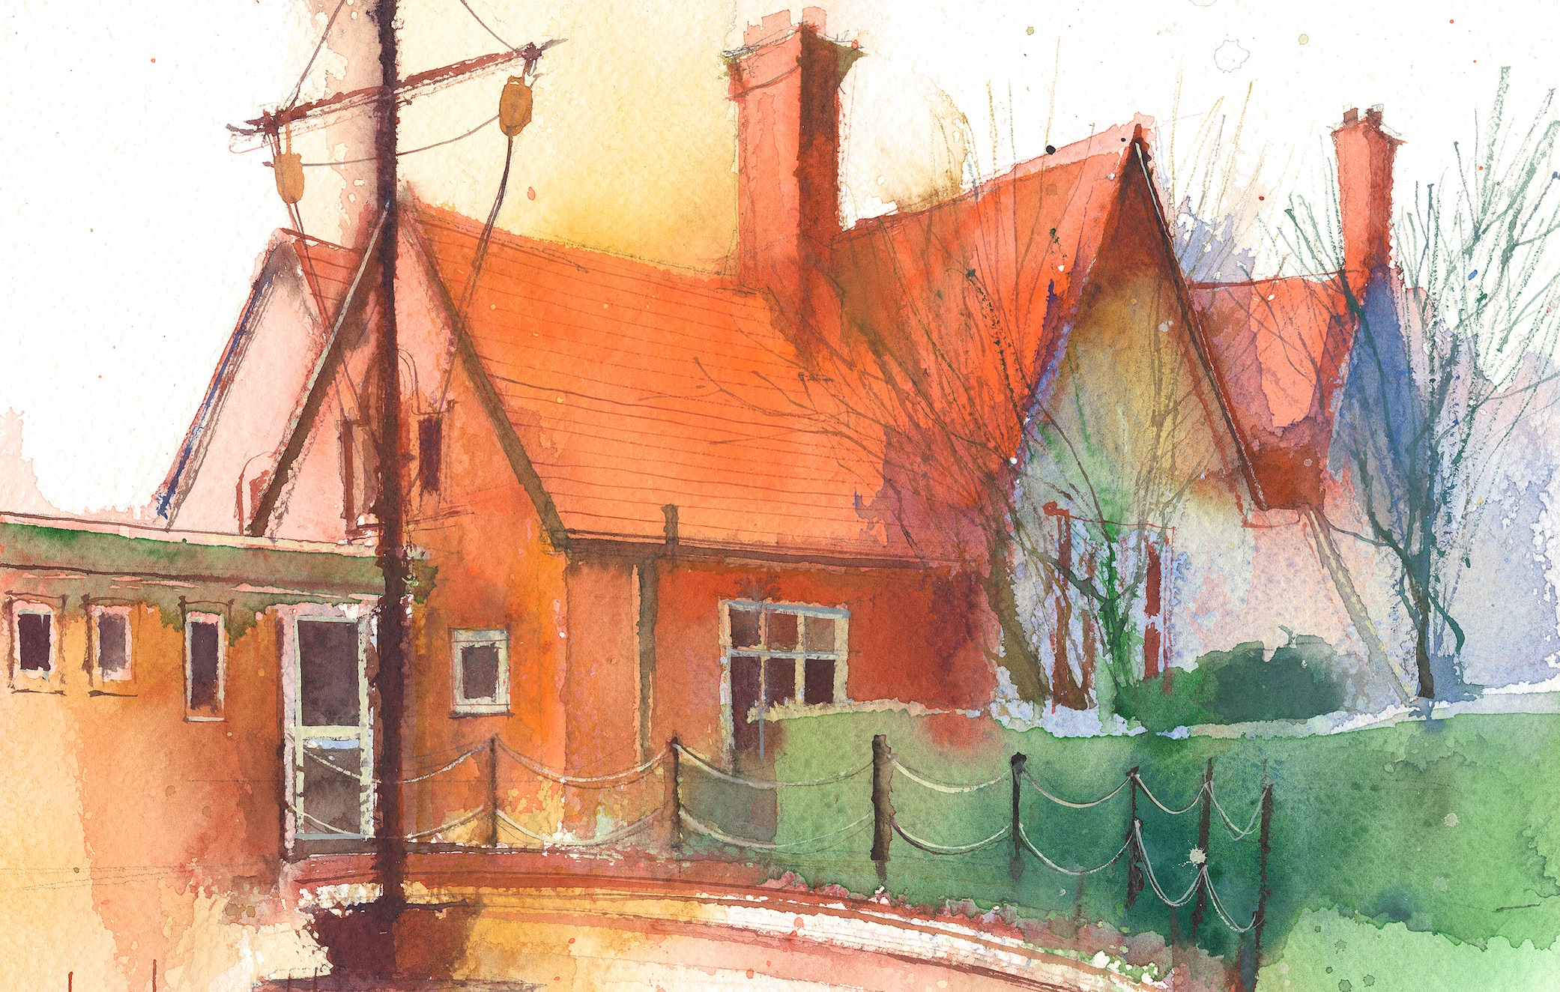

This timetable is available for pupils in Foundation 2 to require remote learning. Please visit the Foundation 2 Remote Learning Page to
access any downloadable resources and activity sheets. The assessed task should be submitted to the teacher at the end of each day via email/tapestry (setting up in progress)

 | Session 1: 09:00-10:30 |  | Session 2:10:45 – 12:15 |  | Session 3: 13:15 – 15:30 (Incorporating 15-minute break) | Assessed Task
Monday  18.01.21 | Phonics  By the end of this lesson your child should be able to:  -Read individual letters by saying the sounds for them  -blend sounds into words  - read tricky words  We recommend the following resources and activities to achieve this objective:  Re-cap all taught sounds  Set 1: s, a, t, p  Set 2: i, n, m, d  Set 3: g, o, c, k  Set 4: ck, e, u, r  Set 5: h, b, f, ff, l, ll, ss  Set 6: j, v, w, x Set 7: y, z, zz, qu ch, sh, th, ng  Tricky words – no, go, I, the, to, me, she, we, be, me  Sing Jolly phonics songs and actions - https://www.youtube.com/watch?v=_s-1sxzjPX8  Activity – sorting the ch words for the barn activity (make a list and draw pictures if not printing)  EX – write a sentence with a ch word in it. Don’t forget a capital letter and full stop! |  | Maths  By the end of this lesson your child should be able to:  Say 1 more than a given number  We recommend the following resources and activities to achieve this objective:  Watch Number Blocks ‘Just add one’https://www.bbc.co.uk/iplayer/episode/b08q39b4/numberblocks-series-2-just-add-one  Roll a dice and draw the spots to match the number. What is 1 more than that number? Write this as a number sentence.  4+1=5  5+1=5  Ask an adult to say and number and see how quickly you can say what 1 more is.  Extension – add 2 more to the number and write number sentences. |  | Topic  By the end of this lesson your child should be able to:  Listen to and respond to story.  Draw a story map  We recommend the following resources and activities to achieve this objective:  Introduce our new traditional tale – The Emperors New Clothes. Listen to the Oak Academy video below.  https://classroom.thenational.academy/lessons/to-listen-to-and-respond-to-a-story-6wtkjr?activity=video&step=1  Can you create your own story map? | Please email your additional tasks to the foundation 2 email address. Foundation2@dawpool.wirral.sch.uk  I look forward to seeing all of your activities.  Send me a picture of you story map for The Emperors New Clothes OR record yourself re-telling the story.
Tuesday  19.01.21 | Phonics  By the end of this lesson your child should be able to:  -Read individual letters by saying the sounds for them  -blend sounds into words  - read tricky words  We recommend the following resources and activities to achieve this objective:  Re-cap all taught sounds  Set 1: s, a, t, p  Set 2: i, n, m, d  Set 3: g, o, c, k  Set 4: ck, e, u, r  Set 5: h, b, f, ff, l, ll, ss  Set 6: j, v, w, x Set 7: y, z, zz, qu ch, sh, th, ng  Tricky words – no, go, I, the, to, me, she, we, be, me  Watch Mr Thorne does phonics  https://www.youtube.com/watch?v=RCRqtFBQ_2k  Print the sh activity sheets or make a list of the words and draw your own pictures of sh words.  Extension – you write a sentence and draw a picture to match with a sh word in it? |  | Maths  By the end of this lesson your child should be able to:  Combine 2 groups of objects to find the total  We recommend the following resources and activities to achieve this objective:  Oak Academy – combining groups  https://classroom.thenational.academy/lessons/combining-two-groups-71gkec?activity=video&step=1  Can you use objects to see how many different ways you can make 6?  How many different number sentences can you write to make 6?  2+4=6  6=5+1 etc |  | Topic  By the end of this lesson your child should be able to:  Talk confidently about winter and recognise the differences between hot and cold.  We recommend the following resources and activities to achieve this objective:  Re-cap The Emperors New clothes using the power point link. Can you talk about the characters, setting and main events?  Complete the spot the difference?  Can you find all of the differences between the pictures?  Extension – Write a list of things you can see in the picture. | Assessed Task  Please email your additional tasks to the foundation 2 email address. Foundation2@dawpool.wirral.sch.uk  I look forward to seeing all of your activities.  Can you send me a photograph of your number sentences or some groups of objects you used to make different totals?
Wednesday  20.01.21 | Phonics  By the end of this lesson your child should be able to:  -Read individual letters by saying the sounds for them  -blend sounds into words  - read tricky words  We recommend the following resources and activities to achieve this objective:  Re-cap all taught sounds -  Set 1: s, a, t, p  Set 2: i, n, m, d  Set 3: g, o, c, k  Set 4: ck, e, u, r  Set 5: h, b, f, ff, l, ll, ss  Set 6: j, v, w, x Set 7: y, z, zz, qu ch, sh, th, ng  Tricky words – no, go, I, the, to, me, she, we, be, me  Watch Alphablocks th - https://www.google.com/search?q=alphablocks+th&rlz=1C1GCEU_en&oq=alphablocks+th&aqs=chrome.0.69i59j46l2j0j46l2j0j69i61.7892j0j4&sourceid=chrome&ie=UTF-8  Write words on different pieces of paper and make snowballs. Throw the snowballs and then pick one to open and read  This  that  the  bath  moth  Complete the ‘th task sheet. |  | Maths  By the end of this lesson your child should be able to:  Understand and use positional language  We recommend the following resources and activities to achieve this objective:  Read the story ‘We’re Going on a Bear Hunt’ https://www.youtube.com/watch?v=2OI7fe766nk  – it has lots of positional language in it for the children to join in with. Make your own bear hunt in the garden or in your house – use language such as under/ over/ through, between, beside, around.  Maybe you can play hide and seek with a teddy? You could hide it for an adult to find and give them clues or ask an adult to hide for you and give you clues to find it. |  | Topic  By the end of this lesson your child should be able to:  Re-tell a familiar story  We recommend the following resources and activities to achieve this objective:  Re-tell the Emperors New clothes to a grown up.  Tell them what your favourite part was and why?  Have a look in your wardrobe and pick your favourite outfit out of all of your clothes. Can you try them and do a fashion show?  Extension – can you draw a picture of the clothes you picked and write what everything is?  |I’d look to see some photos of the fashion shows! | Assessed Task  Please email your additional tasks to the foundation 2 email address. Foundation2@dawpool.wirral.sch.uk  I look forward to seeing all of your activities.  Can you complete the ‘th’ task?  Pick the activity that you think is suits your child’s ability.  If you can’t print it then you can just have a look at the pictures, draw them and write the words.
Thursday  21.01.21 | Phonics  By the end of this lesson your child should be able to:  -Read individual letters by saying the sounds for them  -blend sounds into words  We recommend the following resources and activities to achieve this objective:  Re-cap all taught sounds –  Set 1: s, a, t, p  Set 2: i, n, m, d  Set 3: g, o, c, k  Set 4: ck, e, u, r  Set 5: h, b, f, ff, l, ll, ss  Set 6: j, v, w, x Set 7: y, z, zz, qu ch, sh, th, ng  Tricky words – no, go, I, the, to, me, she, we, be, me  Watch Mr Thorne does phonics – ng  https://www.youtube.com/watch?v=8v7Yl4phJcg  Put some objects containing the sounds your child has already learned into a large sock. Pull one out and sound and blend the word. Examples of objects could be: box, pen, mug, hat, sock, ring. Your child could then write a list of all the things they pulled out. |  | Maths – shape  By the end of this lesson your child should be able to:  Recognise 2D shapes and talk about their properties.  We recommend the following resources and activities to achieve this objective:  Play chopper squad on Topmarks.  Can you work out 1 more and 1 less than a number?  https://www.topmarks.co.uk/learning-to-count/chopper-squad  Complete the one more worksheet activity or use some of your favourite toys to represent this.  E.g. I have 2 cars and I add 1 more, I have 3 altogether.  Extension – adding more than and writing different ways of representing it. E.g number sentences |  | R.S.E  By the end of this lesson your child should be able to:  - notice how others feel  We recommend the following resources and activities to achieve this objective:  Discuss different emotions that people might feel (happy, sad, scared, excited) When do you feel these emotions? Try showing these emotions using your face. Explain it is ok to feel sad or angry but the important thing is to not stay this way  Talk about some of the things that help us when we feel different ways.  How can we show other people that we care for them? | Assessed Task  Please email your additional tasks to the foundation 2 email address. Foundation2@dawpool.wirral.sch.uk  I look forward to seeing all of your activities.  Can you sort the different face pictures into happy or sad emotions or can you tell how you would take care of someone who was sad?
Friday  22.01.21 | P.E.  By the end of this lesson your child should be able to:  - practise movements and join them together  We recommend the following resources and activities to achieve this objective:  Look at the dinosaur words used in the last lesson.  What was your favourite words / movements? Choose 3 dinosaur words.  Dinosaur music - https://www.youtube.com/watch?v=cV-p2DYK7Gc  Koo Koo Kangeroo – dinostomp-  https://www.youtube.com/watch?v=Imhi98dHa5w |  | R.E  By the end of this lesson your child should be able to:  - think about what makes a good king  - talk about how we should treat people  We recommend the following resources and activities to achieve this objective:  Revisit or re-watch the story of ‘Farmer Duck’. https://vimeo.com/56772821  Who were the characters in the story? How did the farmer treat the duck? How should he have treated the animals?  Talk about how the animals must have felt living on the farm.  Did they feel the same or different at the end of the story?  * How should a king treat people? Think about how you would treat people if you were a king or queen.  * Can you design and make your own crown? You can be as creative as you like! You will need it for the next lesson.  There are templates attached on the website in case you want to draw a design instead of make one. |  | Topic  By the end of this lesson your child should be able to:  Use hot-seating to learn more about the character and will write a thought and speech bubble  We recommend the following resources and activities to achieve this objective:  Complete the Oak Academy lesson below. Watch how they complete their own speech/though bubbles.  https://classroom.thenational.academy/lessons/to-roleplay-a-character-crt3jc?activity=video&step=1  Watching the activity is enough unless you want the extra challenge of writing your own. | Assessed Task  Please email your additional tasks to the foundation 2 email address. Foundation2@dawpool.wirral.sch.uk  I look forward to seeing all of your activities.  Ask someone to play this game with you. Take it in turns to think about how a dinosaur would move. Can you teach your partner to move like your chosen dinosaur? Can you move like your partners chosen dinosaur by copying their movements? Do your dinosaurs move in the same way?  * Can you draw a picture or take a photo of you practising the different dinosaur moves?

