Year 1 Weekly Timetable Week Commencing 19.1.26
To contact your child’s class teacher, please email schooloffice@dawpool.wirral.sch.uk or phone 0151 648 3412
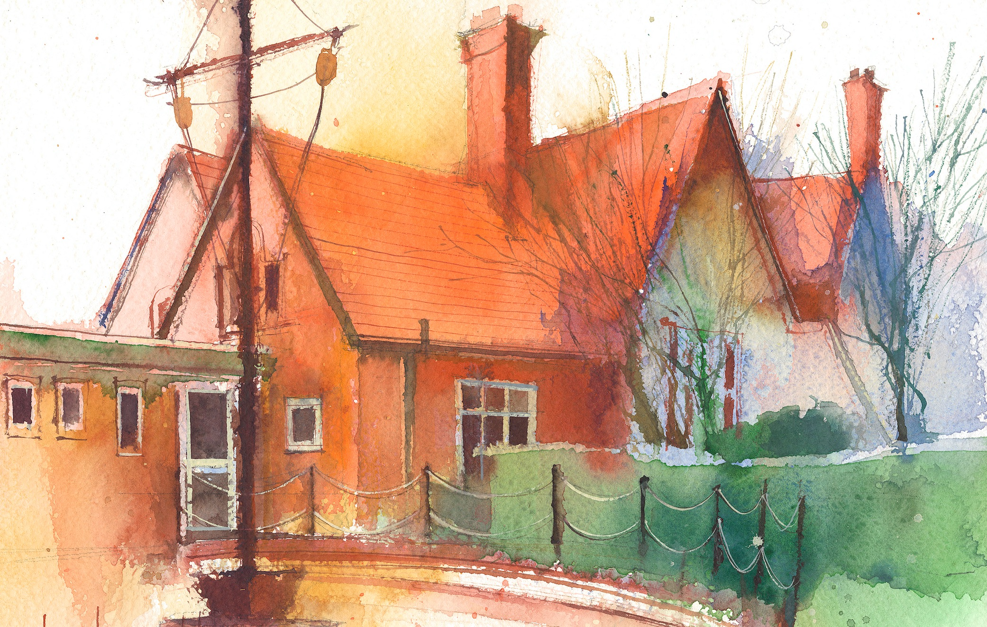

 | Lessons 09:00 – 10:30 |  |  | Lessons 10:45 – 12:15 |  | Lessons 13:15 – 15:30 (Incorporating 15-minute break) | Additional Tasks
Wednesday | Phonics: or as al (blending practise)  English: (WW lesson 1)  • Recall today’s section of Story Map in pairs  • Record Retell version in one/two sentences  • Write simple sentence/s using full stop and capital letter. |  |  | Maths: (lesson 15)To know how to take away.  ERIC/ GR - Blue 1, Green 1 |  | See Mrs Broadbent’s plan
Thursday | Phonics: or as al (segmenting practise)  English: (WW lesson 2)  •Recall today’s section of Story Map in pairs  •Write a sentence using ‘and’ to join two words. | Singing Assembly |  | Maths: (lesson 16) To know how to use a number line to take away.  ERIC/ GR - Blue 2, Red |  | Fin5  PE: (Gymnastics, session 3) The class will explore movements and balances in a curled way on the floor and on apparatus.  Creative Computing: (lesson 4) •I can plan a game using images that I have created myself.  •I can make a placing game using my own images.
Friday | Phonics: Tricky words: because, any  English: (WW lesson 3):  • Write a sentence using ‘and’ to join two words. | Celebration Assembly |  | Maths: (lesson 17) To know how to add or subtract 1 or 2.  ERIC/ GR - Yellow, Green 2 |  | Fin5  RE/Forest School: How did Jesus make friends?  Why did people make friends with Jesus? Read and act out The Calling of the Disciples (Luke 5: 1-11, Luke 5: 27–28)  Golden time! Mrs Ham brings in some special toys for the children to play with.

